SUPPLEMENTARY SUBMISSION TO THE PRODUCTIVITY COMMISSION BY BPD COMMUNITY
Speaking to Borderline Personality Disorder (BPD)

The BPD Community asks the Productivity Commission to consider that its Interim Report is written from a perspective of the medical model. BPD Community considers the medical model which underlies the current response to mental health, as flawed. BPD Community suggests that a complementary ‘recovery support’ model is more appropriate for BPD and possibly other mental illnesses.
INTRODUCTION:
BPD Community presented to the public hearing of the Productivity Commission on 18 November, in Melbourne. It was an impromptu presentation, BPD Community had intended to attend as an observer only. This submission is to address some of the issues raised in that presentation which we believe are central to the interim report and its recommendations.
We explore the current dominant mental health model, the medical model with its central focus on treatment, and offer an alternative perspective. This perspective, is more of a recovery support model. This perspective gives weight to social and relational supports as well as treatment support and sees them as complementary. Currently the social supports are seen as subsidiary, as adjuncts to treatment. Relational supports are rarely considered and when they are considered, they are subsumed within the medical model. All attention appears to be given to treatment, none to recovery.
BPD COMMUNITY:
We are a Victorian based independent, grassroots, peer led charity for all people affected by BPD. We have no real funding and a turnover of less than $15,000 a year. Our reach is greater than our turnover however and our influence is even greater. Our community of well over 400 consists of approximately 14% of people with BPD, 34% of family members (& friends) and 21% people who work in mental health (the remainder are supporters/sponsors).
Where possible, we develop collaborative relationships with other organisations to support our programs. For example, this year we held a 12 hour BPD Ambassador Training Program with the support of Mental Health Victoria. Star Health, a community health centre in South Melbourne, supports our regular Info Nights and our Family & Friends Program.

STIGMA:
Stigma and the subsequent discrimination in relation to BPD emanates from the mental health professions and the mental health system. Our research shows us that it has two main arms:
- Blamed:
The person with BPD is blamed. They are stereotyped and rendered irrelevant. They are blamed for their illness: labelled difficult, manipulative, liars and attentions seekers. Further, parents of BPD are stigmatised, stereotyped and sidelined. Parents are often deemed to be the cause of their children’s mental illness because of childhood abuse.
- Discredited:
The diagnosis is discredited. It is underdiagnosed, misdiagnosed or not diagnosed at all. There are arguments about the name BPD and whether it should be renamed Complex PTSD. People with BPD have difficulties in locating a professional who offers treatment and a belief that recovery is not possible for someone with BPD and that treatment doesn’t work is alive and well within the medical community.
The effects of this stigma are many, for example:
- Treatment: As mentioned above, it’s notoriously difficult to find treatment for BPD. One of the members of BPD Community, a mother, rang 43 Psychiatrists and Psychologists to find treatment for her young daughter. As soon as BPD was mentioned (2015), it was explained to her that there were no places available in the schedule. The waiting list at Spectrum has increased substantially and the approx. wait time for a diagnosis is a 6 months minimum. When asked in May 2016, Dr Sathya Rao of Spectrum, indicated by his estimation that there were about 4,000 people in Victoria, in both the public and private system who were being treated for BPD in a year. Not taking into account the appropriateness of that treatment.
- Diagnosis: A consultation with our carers in 2015 determined that the number one priority of carers is to get a diagnosis for their loved ones. Generally, it’s accepted that most people with BPD do not receive a diagnosis.
- Prevalence: BPD Community accepts the research submitted by the Federal United States government which indicates a prevalence of BPD of about 6% as of 2016. Unfortunately, the data relied upon in Australia dates back twenty years or so and ranges from 1 – 4%. Going by the updated figure of 6%, this equates to about 350,000 people in Victoria with BPD. If we allow two ‘carers’ for every person with BPD, that is 700,000 meaning one in six Victorians are directly affected by BPD.
- Systemic discrimination: As mentioned above, treatment for BPD is not widely available and many mental health professionals don’t understand the complexities of BPD and are therefore unable to support people with BPD. In addition to this, the mental health system is inadequate and not designed to accommodate people with BPD and their co-morbidities. Research shows that if you treat the co-morbidities and not the BPD, then the co-morbidities will reoccur. Successful, holistic treatment depends on BPD being successfully treated alongside any co-morbidities. Both these circumstances exacerbate the situation that people with BPD and their families find themselves in.
Concern One: Treatment
Whichever prevalence figure is applied, based on the estimate provided by Dr Rao, more than 90% of people with BPD do not have access to treatment.
- Based on a prevalence of 6%, approximately 1.14% of people with BPD receive treatment in a year.
- Based on a prevalence of 4%, approximately 1.66% of people with BPD receive treatment in a year.
- Based on a prevalence of 1%, approximately 6.66% of people with BPD receive treatment in a year.
Whether the treatment is research-based and non-effective, or recovery-focused and effective, is another concern. For example, if the treatment is directed at trauma, it requires careful consideration because it can re-traumatise the person with BPD, thus increasing their ill health and even further reducing their access to recovery.
Concern Two: Diagnosis
Without a diagnosis, access to information, resources and support is an ongoing struggle.
If a person with BPD has a therapist who withholds a diagnosis, the consumer then becomes dependent on that therapist. This disempowers the consumer. The consumer is inhibited in seeking complementary or alternative supports and may thereby be vulnerable to misinformation.
When the family of a person with BPD has access to relevant information they are in a position to learn how to improve their supportive relationship with their loved one and reduce their enabling behaviours. There are techniques specific to working with people with BPD that family and friends can learn.
Concern Three: Research into BPD
There are conflicting opinions about the use of the term BPD, with significant mental health professionals arguing that it should be renamed Complex PTSD. This is a divisive situation given many people with BPD do not identify as having experienced trauma, in particular childhood trauma. This perspective often translates into ‘blame the parent’, a situation experienced by many parents of someone with BPD. In some instances, insinuating that BPD stems from childhood trauma had led to allegations of abuse where none has occurred.
There are no up to date, accurate figures on prevalence of BPD in Australia. Most research into BPD is from a ‘medical model’ perspective to the exclusion of other perspectives. This disadvantages the research and continued learning on BPD and creates a narrowed view.
Concern Four: Poorly trained and supported mental health professionals
People with BPD are regularly turned away or dismissed when they seek help, including both from the Emergency Department or by a private practitioner. This constant rejection is debilitating and leads to a lack of trust in the system.
When a co-morbidity, e.g. drug and alcohol dependence, is treated without attention to the BPD, than the drug and alcohol dependence will in all likelihood, reoccur. When relapses occur, the person with BPD is likely to blame themselves for their continued failure to recover and less likely to seek help again.

When people with BPD are considered to be attention seeking ‘drama queens’, their cries for help will become attempted and successful suicide. A recent Spectrum study (yet to be published) that was conducted in collaboration with the Coroner’s Court of Victoria has demonstrated that BPD was the underlying cause in an estimated 10% of all suicides. The study also found that, on average, there were 50 BPD-related suicides in Victoria per year, amounting to one BPD suicide per week. Of those with BPD who died by suicide, 99% had presented to mental health services in the preceding 12 months and 88% had presented to mental health services in the preceding six weeks.
It’s the experience of BPD Community that most people who work in the mental health system are not skilled in being able to support people with BPD. Those that claim to be able to support people with BPD may not be equipped to do so. Training for mental health practitioners is available and is not extensive. Most importantly, BPD is not taken seriously by mental health planners.
RECOVERY SUPPORT MODEL
The Interim Report of the Productivity Commission appears to be written from within the medical model. Consequently, this perspective privileges the medical model and its treatment options. The result is that even when considering social supports, such as employment support or housing, they are considered adjuncts to treatment rather than being a part of the treatment itself. The issue of ‘Relational Support’ is considered within the context of the medical model and is therefore, also unsatisfactory. BPD Community suggests a different model.

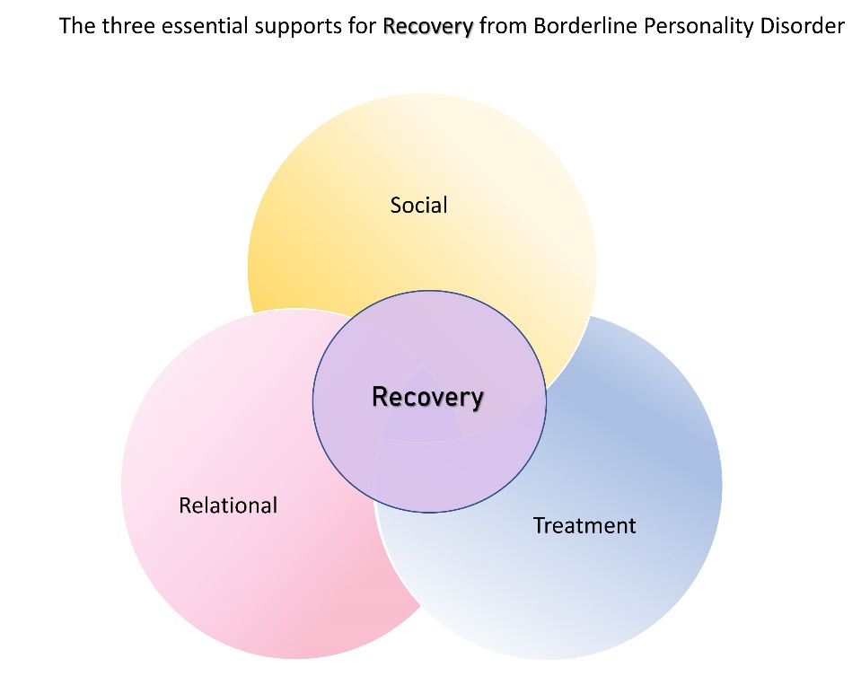

Treatment support:
To provide every person with BPD access to timely and effective psychological treatment now, is unrealistic; currently between 90 – 95% of people with BPD do not have access to treatment. It is important to note that medication does not help BPD, although appropriate medication interventions may help with co-morbidities.
Social Support:
Instead of housing and employment issues as being considered as subsidiary to the central focus of treatment, they should be given more than equal significance. Further, financial and budgeting support, household management support and all the other myriad of social supports should be recognised for their contribution to recovery.
Complementary treatment supports such as Art Therapy, Music Therapy and cultural supports have been shown to have a significant, positive impact. Physical exercise programs and medical focussed supports should be accessible.
Relational Support:
This is the forgotten component of recovery. When we consider relational support, we recognise that it often involves friends, however, the burden usually falls to families. Sometimes the burden is so great that families feel they need to protect themselves by withdrawing from contact with the consumer. Some families are dysfunctional and feel that they cannot offer support. Even if the family is able to support the consumer, the person themselves may reject this support. For recovery, a person with BPD needs to be supported by those they love and those who love them. This cannot be assumed to happen given the nature of BPD.
BPD has five domains of dysregulation: emotional, behavioural, relational, identity and cognitive. For a person with BPD to achieve recovery, all these domains need to be regulated. However, the current approach to ‘treatment’ and the medical model, almost completely overlooks relational support.
- The time a person with BPD spends with a mental health professional is small in comparison to the time spent with their family and informal supports. When a person with BPD leaves their therapist’s office, they return to live amongst those who love and support them. Oftentimes this is in their family home. When things go wrong, it’s the family who are called upon to provide the support required. Very often the support that is required is financial.
- When relational dysregulation occurs, families often bear the brunt of the dysregulation of the person with BPD. This often spans decades of trauma for the whole family as the family member with BPD grows into adulthood. Sometimes a person with BPD has been seen to be ‘difficult’ from infancy. The dysregulation of a person with BPD can undermine the family dynamics as siblings are overlooked for the needs of the person with BPD. When a parent is the person with BPD, the children bear the brunt of the dysregulation and the uncertainties that result. Relationships between spouses suffer when one person has BPD. These difficulties often result in mental health concerns for those who live with a person with BPD.

- A child raised by a person with BPD who has not recovered, grows up in a BPD environment where emotional dysregulation, for example, is normalised. The result can be subsequent and inter-generational familial dysfunction.
- BPD Community has developed a model of support for families and friends that is based upon psychoeducation and training in the core techniques to improve relationships with someone who has BPD. This model empowers the family to support their loved one with BPD and discourages enabling behaviours. This is specific to the needs of those who love someone with BPD. It is based upon the successful therapies that treat BPD. Generic mental health support programs do not address the importance of the BPD relationship building techniques.
- The mental health system with its stigmatising and discriminatory behaviour in relation to BPD, also stigmatises and discriminates against families of someone with BPD. This has been covered in part above. It is the experience of BPD Community that family members are desperate for support and psycho education so that they in turn can better support their loved ones with BPD. This is denied them when:
  - No diagnosis is given. With a diagnosis, information and support can be sought.
  - Families are blamed. When a family is blamed for the condition of their loved ones, they are excluded from the support they need and they can be prevented from providing support to their loved ones.
  - The specific needs of people with BPD and their families and friends are not understood or acknowledged. BPD is different to other mental illness especially because of the nature of relational dysregulation. Generic services to support families and friends do not meet the specific needs of BPD families and friends.
  - No support is offered to families. There are some supports available to families yet clinicians, organisations and services fail to refer families to specific BPD support programs.
CONCLUSION
The Productivity Commission’s Interim Report is fundamentally flawed because it privileges the ‘medical model’. BPD Community believes that the stigma and discrimination that exists in relation to BPD emanates from the mental health system and mental health professionals who are, in fact, seen as having the solutions to mental health problems. Even with the best intentions, individuals within this system will be compromised. Treatment options for people with BPD are extremely limited. Effective and timely treatment is only available to those who know how to find it and who can afford it. Further, the medical model is not concerned with recovery. Recovery from BPD is a realistic goal, however, currently the mental health system is too often a barrier to recovery.
BPD Community recommends a Recovery Support Model where the three components of treatment, social and relational supports are seen as complementary. Of these, social and relational supports should be a priority. A person’s mental health can progress when a holistic, encompassing approach is administered but if only treatment is considered, a person’s mental health is unlikely to sustain improvement.

SOLUTION
BPD Community recommends a flexible, cost effective approach to supporting the individual with BPD. This can be done through BPD informed ‘case management’ and co-ordinating treatment with social supports for people with BPD. Striving to identify gaps and working to fill the gaps in support is crucial.
Offering individual ‘life coaching’ and group peer support, to build the relational supports is essential. This would be complemented by a similar approach for families and friends of people with BPD, working to case manage specific psychological treatment, providing individual ‘coaching’ and most importantly peer led group support with a focus to improve relational skills and the psychological flexibility of the carers involved.
This community approach would be aimed at working with and within existing organisations in geographic areas. It is designed to create flexible BPD informed supports outside of a medical model, strengthening the three core components of recovery from BPD. It is designed to empower people with BPD and their families and friends. It is designed to support people with BPD in their journey to recovery.
This is the work that BPD Community has begun and works to develop.

Chairperson,
BPD Community

30 December 2019

bpdcommunityvic@gmail.com.au

https://www.bpdcommunity.com.au

