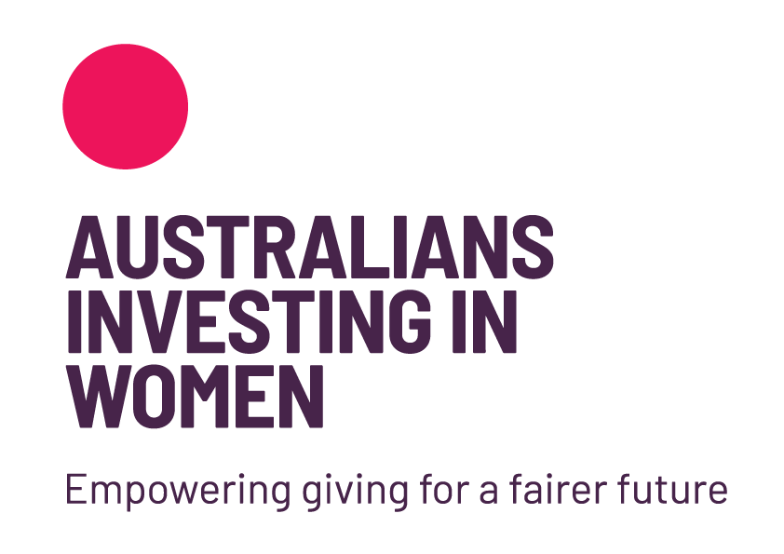

5 May 2023

SUBMISSION TO THE PRODUCTIVITY COMMISSION’S
REVIEW OF PHILANTHROPY
FROM AUSTRALIANS INVESTING IN WOMEN (AIIW)

ABOUT US
About Australians Investing in Women (AIIW): AIIW is a leading national NFP advocate for Gender-wise* philanthropy. Building on progress towards gender equality, we take an evidence-based approach and work in partnership with philanthropic, corporate and community leaders to strengthen society by catalysing investment in women and girls.

As a lean organisation we have very little capacity to produce a significant submission for consideration by the Commissioners and are therefore submitting the dot point summary below with an invitation to reach out if you would like further information.

ABOUT GENDER=WISE PHILANTHROPY
Gender-wise philanthropy is giving that applies a gender lens and gender analysis to every aspect of philanthropic practice. Gender-wise philanthropy has the potential to not only create positive change for women and girls but also to increase overall philanthropic giving. Here are some ways that gender-wise philanthropy can lead to more and better philanthropy:

- Increasing awareness: Gender-wise philanthropy can help to raise awareness about the importance of addressing gender inequalities and the impact that it can have on society. By highlighting the issue and the potential solutions, it can encourage more people to get involved and donate to causes related to gender equality.

- Setting an example: When philanthropists make a public commitment to gender-wise philanthropy, it can inspire others to do the same. Seeing prominent individuals or organizations prioritize gender equality can encourage more people to give to similar causes.

- Building networks: Philanthropists who support gender-wise philanthropy may also create networks of like-minded individuals who can collaborate and leverage their resources to create even greater impact. These networks can help to identify the most effective strategies and initiatives and provide support to organizations working in this area.

- Encouraging innovation: Gender-wise philanthropy can also encourage innovation in philanthropy. By prioritizing gender equality, philanthropists may be more likely to support organizations that are developing new and innovative solutions to address the issue.

Overall, gender-wise philanthropy can be a strategy to increase philanthropic giving by raising awareness, setting an example, building networks, and encouraging innovation. By prioritizing gender equality, philanthropists can not only create positive change for women and girls but also contribute to a more just and equitable society.

AREAS FOR CHANGE
- Our submission makes three points:
  - Gender analysis is a critical success factor in both growing giving and growing the impact of giving. There is evidence that women give a greater proportion of their income, and give differently from men – although there is limited analysis of gender in structured giving. And the nature of disadvantage – often the subject of giving – is highly gendered.

  - Existing categories for securing DGR 1 are inadequate (as is the 5 year timeframe for special listings). In particular the existing categories fail to recognize the importance of philanthropic infrastructure such as intermediaries, peak bodies and umbrella organisations like community foundations. The alternative option of obtaining a Special Listing in the Income Tax Assessment Act is a time consuming and costly process, and this proves to be prohibitive for many small NFP’s. Furthermore, when successful, the practice of granting DGR Item 1 status for a period limited to 5 years is unsatisfactory, frustrating and costly. It is particularly perplexing when viewed in the context of AIIW’s role advancing gender equality, when global estimates of achieving gender equality are estimated in hundreds of years.

- Existing taxonomies, measurement and reporting systems fail to adequately recognize gender. This limitation in data collection, analysis and understanding has the effect of limiting social impact as well as the growth of giving. There are several dimensions to this gender data gap. It is not possible, under the current system, to quantify the amount or share of philanthropic giving that targets women and girls. The system therefore fails to facilitate analysis and reflection on the equitable distribution of social investment which is enabled through forgone taxation and public revenue. In particular, the lack of gender data on philanthropic and NFP Annual Information Statements to the ACNC, limits the type of analysis and reporting on Responsible Persons, board and C-suite diversity - in both giving and doing organizations - that is an established expectation of corporate Australia and in society more broadly. Given the evidence of causal links between diverse leadership teams, the quality of decision making and organizational success, it is a missing ingredient for building confidence, and associated growth, in the social sector.

ALIGNMENT WITH TERMS OF REFERENCE
- In reviewing the Terms of Reference for the Productivity Commissions Review of Philanthropy we note, among other things, references to:
  - trends in giving and the drivers of giving
  - effectiveness of foundations in supporting giving
  - opportunities and obstacles to growing giving
  - effectiveness and efficiency in the use of donations
  - burden of regulatory framework
  - appropriateness of data collection and enhancing databases
  - ability to assess comparative effectiveness of NFP’s
  - alignment of DGR with public policy
  - flow of benefits from giving
and it is these points that underpin our submission, particularly in the context of the critical nature of gender data and analysis.

CONTEXT
- For more than a decade there has been a rise globally in the focus on women using their resources (including philanthropic giving) to advance gender equality. The Women’s Funding Network, Women Donors Network and Women Moving Millions were all established in the United States to foster giving to women and girls and drive a global movement of philanthropic support for gender equality. At around the same time AIIW was established in Australia (as Australian Women Donors Network) to increase investment in women and girls. We are the leading national advocate and education focused NFP promoting investment in women and girls that delivers greater gender equality.

- Social developments such as the global #metoo movement, women’s marches and Covid-19 pandemic have had the cumulative effect of highlighting the gendered nature of disadvantage and amplifying women’s voices. This growing recognition of the need for a gender lens on social issues has also flowed into the philanthropic sector.

- Gender is key among the many factors to consider in increasing philanthropy, i.e. there needs to be a strong focus on women, both as existing and potential philanthropists, as well as recipients of funding/social investment and drivers of social change in communities.
- Demonstrable impact and effectiveness is key to growing public confidence in the use of private funds for public good. If social impact initiatives fail to apply a gender lens, they will fail to maximise the full potential for impact – hence a gender lens is key to impact, confidence and demonstrating equity and inclusion.

RESEARCH
- Research by the Women’s Philanthropy Institute indicates giving is influenced by social norms – key findings are below and the full report is here.
https://givingcompass.org/partners/gender-and-giving/report-social-norms

‘

- KEY FINDINGS of the U.S. Research
  - Social norms and charitable giving are strongly linked. When people believe that others are interested in giving to women’s and girls’ causes, they have greater intentions to donate to these causes themselves.
  - There is a gender difference in the link between social norms and charitable giving. Men’s giving to women’s and girls’ causes is strongly tied to how they think men and women give. Women’s giving to women’s and girls’ causes is strongly tied only to how they think other women give.
  - People’s donation intentions are higher when they receive social norms messages about rising levels of giving. Focusing on the rising popularity of women’s and girls’ causes increases people’s intentions to donate to those causes, compared to focusing on current levels of giving.
  - Social norms messages about rising levels of giving are equally effective for men, who traditionally give less than women to women’s and girls’ causes.

JULIE REILLY OAM
CEO AUSTRALIANS INVESTING IN WOMEN

