**Submission to the**

**Productivity Commission’s Review of Philanthropy 2024**

**Submitted by Dr Phil Saj PhD CPA**

I make this submission with respect to Draft Recommendation 7.1. It is my view that there are no valid reasons for exempting Basic religious Charities (BRCs) from reporting financial information under the ACNC Act. This submission is based on research undertaken by me at the Adelaide Business School in 2022, in which I examined the nature of BRCs, their human resource capacities, extant financial reporting practices, and fundraising. A full report on this research is included as an attachment.

The research was undertaken in order to better understand BRCs, and to test the validity of the arguments on the public record that have been put forward to justify their exemption from reporting financial information under the ACNC Act. The rationale for such an investigation was twofold: Firstly, the exemption from financial reporting afforded to BRCs appeared to be at odds with one of the three objectives of the ACNC Act (2012), which is, ‘to maintain, protect and enhance public trust and confidence in the Australian not‑for‑ profit sector” (s. 15.5); an objective that is underpinned by principles of transparency and accountability, and which find form in the requirements of the Australian Charities and Not-for-Profit Commission Act 2012 (the ACNC Act) for charities to report key information to the regulator, and for the regulator to provide public access to information about charities through an online portal. Secondly, while the ACNC Act was developed through a process of widespread public consultation over a two-year period, there was no debate around this exemption; and nor were any reasons put forward for establishing such a charity category, or the way in which it was defined. Indeed, the concept of the BRC is unique to the ACNC Act and appeared only in a late draft of the ACNC Bill. The only justification on the public record for the existence of this category, and arguments for the exemption from reporting financial information, can be found in submissions by those who support it, principally bodies representing the Anglican and Catholic Churches in Australia, to the Parliamentary Joint Committee on Corporations and Financial Services, which examined the ACNC Bill when it was before the Parliament in in 2012; and the Commonwealth Government’s five-year review of the ACNC legislation in 2018. Extracts from these submissions are included in Appendix A of the attached report.

This submission comprises three parts: in Part 1, I outline the methodology applied; in Part 2, I provided a summary of my findings; and in Part 3, I discusses, in light of these findings, the arguments on the public record that have been advanced to justify the present exemption enjoyed by BRCs from reporting financial information to the ACNC.

**PART 1:** **METHODOLGY**

* 1. **Data Sources**:

The data on which this paper is based is the ACNC 2020 Annual Information Statement (AIS) Data (<https://data.gov.au/data/organization/acnc accessed August 7th 2022>), and the Australian Charities Report 8th Edition (ACNC, 2022). The population is the 8,319 charities that were listed on the above-mentioned database on August 7th 2022. Charities were identified by their Australian Business Number (ABN) and this number was used to search the ACNC portal in order to ascertain: (1) the activities undertaken by the charity; (2) its size; (3) the human resources deployed (paid and volunteer); and (4) the financial reporting requirements contained in its Governing Document. This information was taken from the charity’s Profile, Annual Information Statement and Governing Document. Where the BRC had a website (as indicated on its Profile), that too was examined. For BRCs that operated within a denominational structure, publicly available information, such as policies, reporting templates, and financial statements were also inspected.

**1.2: Classification of BRCs**:

BRCs were classified according to their size, and the activities they undertook.

**1.2.1: Size**: A BRC’s size (small, medium or large) was taken to be that which was self-reported on its 2020 AIS. In 2020, the following thresholds applied: small (annual revenue is less than $250,000); medium (annual revenue is at least $250,000 but less than $1m.); and large (revenue is $1m. or more).

**1.2.2: Activities undertaken by BRCs**.

A BRC’s activities were taken to be those that were self-reported under ‘Summary of Activities’ on its Profile; the ‘Description of the Charity’s Activities and Outcomes’ on its 2020 AIS; and the ‘Objects’ (or equivalent) clause in its Governing Document. In some cases where the BRC had a website, this was inspected in order to confirm information lodged with the ACNC. Ten distinct activities were identified. A description of each category and one example of a BRC in each category is provided below. The ten activities were:

1: Religious Charitable Development Fund

2: Other Fund

3: Property Trust

4: Non-Financial Support Provider

5: Trading Entity

6: Welfare Services Provider

7: Governance, Administration and / or Coordination

8: Religious Orders & Faith Based Movements

9: Parishes and Churches

10: Other Ministry

**Category 1: Religious Charitable Development Funds.** These BRCs provide financial services. They accept deposits from investors pay interest on such deposits, and lend money to religious institutions such as churches and schools for building and other purposes. An example from this category is Catholic Development Fund Diocese of Wollongong (ABN 74896491936).

**Category 2: Other Funds.** These BRCs hold financial assets, such as equities, bonds and cash, for the purpose of funding the activities of religious entities. An example from this category of BRCs is Priest's Remuneration Fund (ABN 99049307162)

**Category 3: Property Trusts**. These BRCs hold property that is used by churches and other denominational entities to conduct activities, and/ or to generate income. An example of BRC that holds property for use is, The Trustee for Forestville Parish - Acpt (1142) (ABN 57573017323).

**Category 4: Providers of Non-Financial Support.** TheseBRCs provide goods and/ or services to faith-based entities to assist them in furthering their objectives. An example of a professional services provider is Sydney Diocesan Services (ABN 69266342710).

**Category 5: Trading Enterprises.** These BRCs trade in the open market goods and/ or services that appear to complement the work of religious denominations. An example is The Corporation of the Roman Catholic Archdiocese of Brisbane - Holy Cross Funerals (ABN: 97591742721).

**Category 6: Welfare Service Providers**. These BRCs provide welfare services that are typical of many charities that are not BRCs such as student accommodation, after school hours care, and addiction counselling. An example of a medium-sized BRC that provides student accommodation is Petersham Baptist Church - Flo Harris Lodge (ABN 28834397879),

**Category 7: Governance, Administration and/or Coordination.** BRCs in this category undertook a range of activities that varied in nature and scope according to the denominational structure. An example is Sydney Diocesan Synod Fund (ABN 54022096494) is a BRC that performs an administrative function at a district level within a denominational framework.

**Category 8 Religious Orders and Faith Based Movements**. Religious orders comprise communities and/ or members that bind themselves through vows. An example from this category of BRC is The Maronite Order of the Blessed Virgin Mary (ABN 48170166309).

**Category 9 Parishes and Churches:** These BRCs comprise congregations who share a particular a faith and gather for worship in a specific locale under the leadership of a designated minister of religion. An example of this type of BRC is the Maronite Catholic Parish of Our Lady of Lebanon Harris Park (ABN 92475205390).

**Category 10: Other Ministry.** These BRCs promote a religious faith and facilitate religious observance, primarily through evangelising, but are not necessarily tied to a particular congregation or physical church. An example is Spirit Alive Australia (ABN 55548483116).

**PART 2: SUMMARY OF FINDINGS**:

**2.1: Number, Size and Activities Performed.**

In 2020, there were 8,319 BRCs listed on the aforementioned database. Of these, it was not possible to ascertain the activities undertaken by 147 entities, and 86 entities were listed as “Charity Status Voluntarily Revoked”. Consequently, the following analysis is based on a total of 8,086 charities that self-classified as a BRC. Tables 1-3 provide descriptive statistics.

**Table 1: BRCs for which an activity can be ascertained classified by activity and size**



Table 1 shows that the vast majority of BRCs (85.30%) are directly involved in religious observance as Religious Orders or Faith-Based Movements (Category 8); Parishes or Churches (Category 9), or through Other Ministries (Category 10), with more than 80% of them being small (annual revenue is less than $250,000). Table 1 also shows the extent to which charities classified as BRCs perform other functions. 989 BRCs (12.2%) are in some way resource providers (Categories 1,2,3,4 and 5). Of these 21 (.26%) are Religious Charitable Development Funds (Category 1); 104 (1.29%) are Other Funds (Category 2); 436 (5.39%) are Property Trusts (Category 3); 401 (4.96%) provide non-financial support to religious entities (Category 4) and 26 (.32%) are Trading Enterprises (Category 5). A further 161 BRCs (1.99%) are involved in Governance, Administration and /or Coordination (Category 7).

**TABLE 2: Proportion of Each Category by Size Tier**



Table 2 shows the composition of each of the three size tires by category. For example, it tells us that while only 34.13 % of large BRCs are Parishes and Churches, the overwhelming majority of medium BRCs (87.25 %), and small BRCs (81.93%), are Parishes and Churches. It also tells us that less than 50% of large charities are directly involved in religious observance (Categories 8, 9 and 10); and that 27.99 % of large BRCs are involved in resource provision (Categories 1,2,3,4 and 5). Interestingly, the proportion of small BRCs (12.92%) involved in resource provision is much greater than the proportion of medium BRCs (4.07%). Most medium BRCs (91.94%) and small BRCs (85.89%) are directly involved in religious observance (Categories 8,9 and 10).

Table 3 shows the composition of each category by size tier. For example, it shows that almost all (90.48%) Religious Charitable Development Funds are large BRCs; and almost all Property Trusts (93.35%) are small BRCs. It also shows that more than 50% of BRCs that perform Governing, Administration and/ or Coordinating roles are medium and small charities. Notably, very few (1.55%) large BRCs are parishes and churches; and only 15.17% of medium BRCs are parishes and churches. Overall, the very high proportion of small charities in the population of BRCs (82.41% as shown in Table 2) explains why, in all but four categories (1. 5, 7 and 8) the overwhelming majority of BRCs small.

**TABLE 3: Proportion of Each Size Tier by Category**



**2.2: Human Resource Capacity of BRCs**

BRCs are required to report in the AISs the following indicators of human resource capacity: (1) the number of full-time paid staff; (2) the number of part-time paid staff; (3) the number of paid casual staff; (4) the number of full-time equivalent (FTE) paid staff; and (5) the number of volunteers deployed. A comparison of the human resource capacities of charities in each of the ten activity categories is provided below in Table 4 (large BRCs); Table 5 (medium BRCs) and Table 6 (small BRCs).

**2.2.1: Large BRCs**

The highest levels of paid staff deployment (on all measures) were in large BRCs involved in Governing, Administration and Coordination (Category 7). This is perhaps not surprising given the wide range of staff required to govern or administer a diocese or presbytery.

Volunteer deployment also was highest in BRCs involved in Governing, Administration and Coordination (Category 7) and parishes and Churches (Category 9).

The human resource capacity indicated by the data in rows eleven to fifteen show that many BRCs in Categories 2 (Other Funds) and 3 (Property Trusts) have very low levels of paid or volunteer staff. This finding suggests that many BRCs in these categories are passive vehicles for holding property and/ or financial management.

**2.2.2: Medium BRCs**

Because many of the categories for medium BRCs had low counts, analysis is somewhat limited. However, for categories that had a count of at least ten BRCs, those in Categories 4,7,8 and 9 had the highest number of paid staff and those in Category 9, the largest volunteer cohorts followed by those in Category 7.

Medium BRCs with the lowest human resource capacity (both paid and volunteer) were those in Categories 2 and 3; with these BRCs also reporting the highest rates for having no paid or volunteer staff. This also suggests that many of these BRCs were passive vehicles for financial management and/ or holding property.

**2.2.3: Small BRCs**

The raw numbers for average deployment of paid staff also show BRCs in Category 7: Governing, Administration and Coordination to be the largest employers, with those in Category 9: Parishes and Churches the second largest employer.

Resource providers, Categories 2,3 and 4 in particular, had very low levels of paid staff, which is reflected in the data for every capacity indicator relating to paid staff. BRCs in these Categories also displayed relatively high ratios of volunteer to paid positions, with that for small BRCs in Category 3: Property Trusts being far higher. The dearth of paid human resources for small Property Trusts is also reflected in the indicators that show the proportion of BRCs with no person in a human resource class. For small Property Trusts the percentages of BRCs with no person in a paid capacity range from 98.87% to 99.75%, but only 7.37% have no volunteers. This shows that managing small property trusts requires much less time and attention than that required for other activities, that they are mainly managed by volunteer trustees. and are merely passive financial entities that hold assets.

**Table 4: Comparison of Human Resources Deployed by Large BRCs**

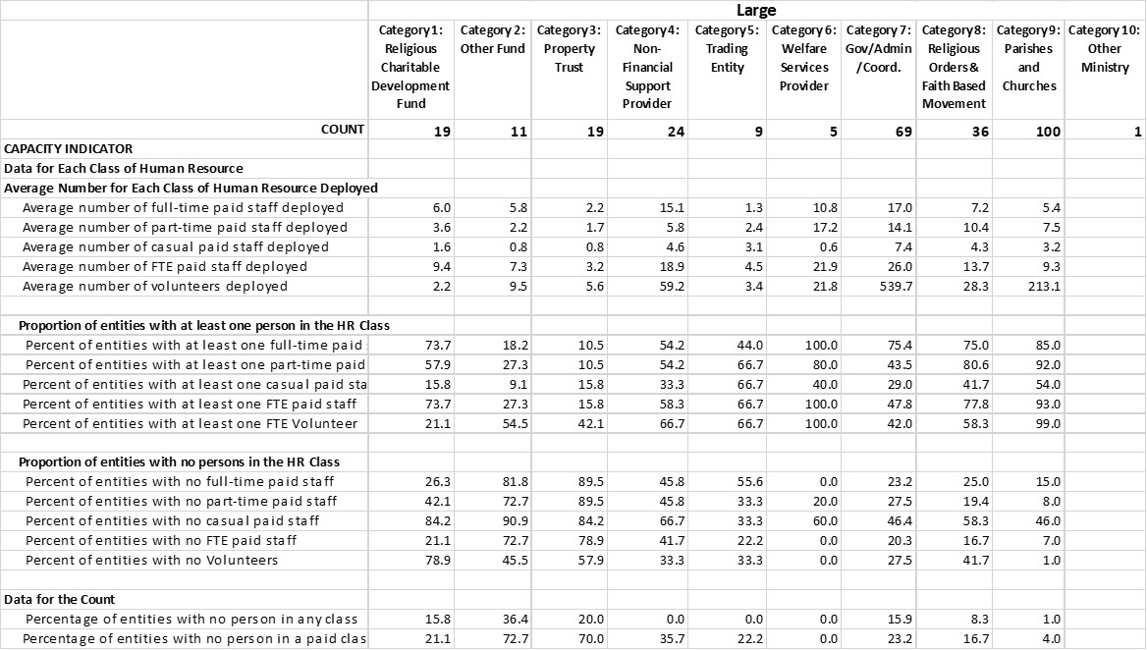

**Table 5: Comparison of Human Resources Deployed by Medium BRCs**

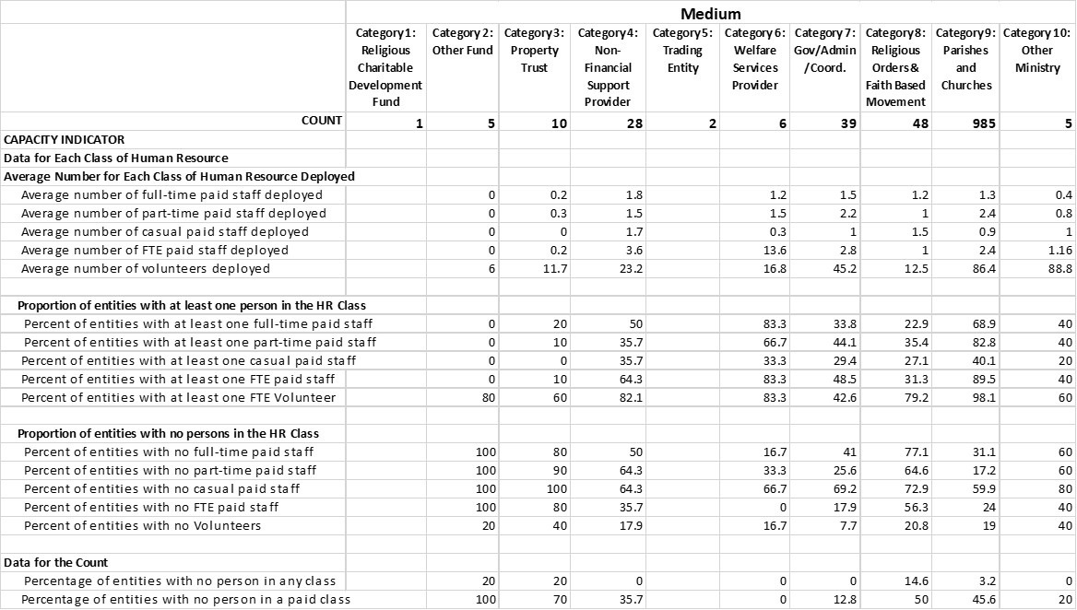

**Table 6: Comparison of Human Resources Deployed by Small BRCs**

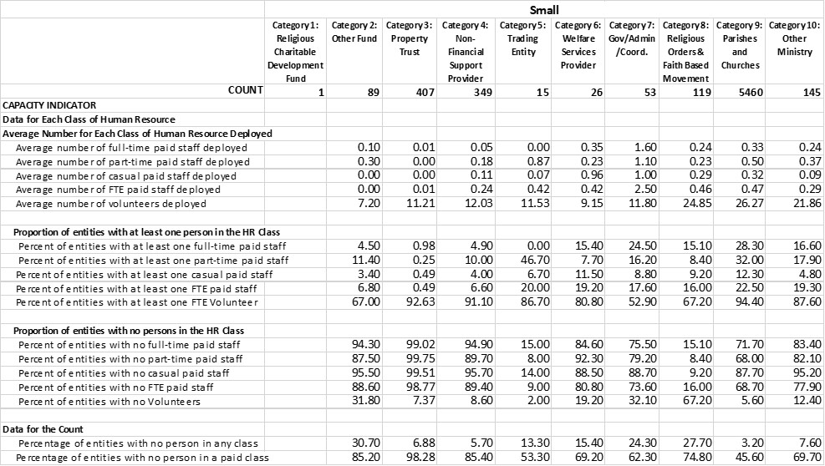

**3: Financial Reporting of BRCs that Operate Within a Denominational Structure[1].**

The overwhelming majority of BRCs operate within a denominational structure and are required, through their Governing Documents to report financial information to a denominational authority. Evidence of the nature and extent of such financial reporting was obtained by inspecting each BRC’s Governing Document, and where available, financial reporting requirements published by the related denominational authority. Examples of the financial reporting requirements of three denominational authorities, the Anglican Diocese of Sydney, the Uniting Church in Australia Synod of NSW and ACT Canberra, and the Lutheran Church of Australia are provided as Appendices 3, 4, 5 and 6 of the attached report. The evidence indicates that the financial reporting requirements of BRCs that operate within a denominational framework are significant and, for small BRCs at least, are far more extensive than those required under the ACNC Act. Three examples from the attached report are provided below.

1: Maronite Catholic Parish of Our Lady of Lebanon Harris Park (ABN 92475205390)

The Governing Document of Maronite Catholic Parish of Our Lady of Lebanon Harris Park, a large BRC, is titled, *Maronite Eparchy of Australia Parish Governance*. It includes the following financial reporting requirements:

1. Preparation of an Annual Financial Report, which is to be approved by the Parish Stewardship Committee, and reviewed by an external independent auditor. This report is to be provided to an annual general meeting of parishioners and to the Bishop through the Diocesan Financial Administrator.
2. Reporting collections to parishioners weekly and annually.
3. A report of the Parish Church Account is to be prepared in accordance with the standard diocesan Chart-of-Accounts and submitted to the Diocesan Business Office in an electronic format for the period to the end of each quarter.
4. A full report of the Presbytery Account is to be provided to the Clergy Fund Board on, at least, an annual basis.
5. If a Special Purpose Account is established These accounts form part of the parish’s temporal goods and are to be included in the financial reports to the Parish Finance Council.
6. Budget for parish, aged care, community and welfare services, report them to the Bishop’s Office.

2: Anglican Church of Australia Quakers Hill (ABN 48296443042) The Governing Document for this medium BRC, is an Ordinance of the Anglican Diocese of Sydney (the Diocese) that applies to all parishes within the Diocese. It is titled *Parish Administration Ordinance 2008.* This ordinance requires parishes within the Diocese to prepare, and have audited a Financial Report; and a Financial Reporting Package. The Financial Report comprises a Statement of Comprehensive Income, a Statement of Financial Position, a Statement of Changes in Funds (where applicable), and Notes to the Financial Statements. The Statement of Comprehensive Income, for example, may include up to 72 line items (as illustrated in Appendix 4 of the attached report). The [Financial Reports Package](https://www.sds.asn.au/2019-financial-reports-package)comprises a Wardens’ and Treasurer’s Report; a Wardens’ Declaration in relation to the Australian Charities and Not-for-profits Commission (ACNC); an Independent Assurance Practitioner’s Review Report (Auditor’s Report), a Property Income Worksheet (audited) and a Statement of Insurance Policies.

3: UCA - St Arnaud (ABN 62992953292).

The Governing Document lodged with the ACNC by Uca – St Arnaud, a small BRC, is titled, *The Uniting Church in* Australia *Constitution.* The financial reporting requirements are listed in the part titled, *Uniting Church in Australia Regulations.* They are*:*

3.8.7 Books of Account

(a) All funds of the Church shall be accounted for using proper, approved methods of accounting. The body responsible for funds shall keep proper books of account. The books of account shall include all receipts and disbursements received or made, all credits and debts owing or due and all other relevant matters necessary including a full explanation of the accounts .The body responsible shall, upon the request of the chairperson of the Church Council or other appointing body or the Synod Property Officer or any person authorized by any one of them, produce the books of account together with all supporting or relevant accounts, receipts, and documents for inspection, and shall permit extracts to be taken and copies to be made by any such authorised officer.

Audit

(c) The books of account shall be audited and certified by the auditors at

least once in every year and at such other times as may be required by the

chairperson of the Church Council or other body responsible as the case

may require.

To comply with the above noted regulations on financial reporting, Uca-St Arnaud is required by the Synod under whose authority it operates, the Uniting Church Synod NSW and ACT, to provide specific financial information in a format determined by the Synod. The template for this report is titled, Annual *Financial Return*. It is included in the attached report as Appendix 5. The introduction to the template reads,

*According to the Uniting Church in Australia Constitution and Regulations regarding the Presentation of Accounts, “at least once in every year Audited Financial Statements … shall be submitted to the Church Council or other appointing body of the body responsible for their administrative and control.” (Section 3.8.7).*

While the *Annual Financial Return* is a highly prescriptive and detailed financial report, churches are permitted to choose to report on either a calendar year or financial year basis, and, it appears, to report on either a cash or an accrual basis.

**4: Fundraising**

In 2020, 7.3% of BRCs indicated on their AISs that they undertook online fundraising. However, it became apparent while inspecting websites of BRCs to determine what activities they performed that it was certainly not uncommon for BRCs of all sizes to have an online facility to accept financial contributions. Such facilities include, for example, having a “Support Us” or “Donate” tile on their web page, which, when activated took one to an online facility to donate either my credit card or electronic funds transfer. An example of the wording above such a facility was, “*If you would like to donate to support our parish please send it through the details below”*. Accordingly, a small sampling exercise was undertaken by inspecting the websites of a random sample of small, medium and large BRCs in Category 9 (Parishes and Churchs) were inspected. The results are shown in Table 7.

**Table 7: Online Acceptance of Financial Contributions by Parishes and Churches**

|  |  |  |  |
| --- | --- | --- | --- |
| **Size** | **Percent of Parishes and Churches in Sample with an online facility to accept donations** | **Sample Size** | **Percent of Size Tier Sampled** |
| **Small** | 19.8 | 273 | 5 |
| **Medium** | 56.6 | 99 | 10 |
| **Large** | 75.0 | 20 | 20 |

Table 7 shows that the majority of large and medium sized parishes and churches directly solicited donations, and that almost one fifth of small parishes and churches did so. This represents 31.9% of parishes and churches. While it is possible that some online facilities to accept donations were put in place during the COVID-19 pandemic because members of congregations were unable to attend their churches in person, there was no evidence to suggest that contributions were limited to members. Rather, some were clearly open calls for donations. This issue requires further attention.

**PART 3**: **TESTING THE ARGUMENTS PUT FORWARD ON THE PUBLIC RECORD TO JUSTIFY**

**THE PRESENT EXEMPTION FORM REPORTING FINANCIAL INFORMATION**

As noted above, the only justification on the public record for the existence of this category,

and arguments for the exemption from reporting financial information, can be found in

submissions by those who support it, principally bodies representing the Anglican and

Catholic Churches in Australia, to the Parliamentary Joint Committee on Corporations and

Government’s five-year review of the ACNC legislation in 2018. Extracts from these submissions are included as Appendix 1 in the attached paper. Such arguments were largely made on three grounds : (1) accountability, (2) capacity and (3) burden grounds. In the following discussion, I test each of the main arguments against the evidence obtained in my research. I conclude that none of the reasons put forward for an exemption from financial reporting by BRCs under the ACNC Act is justified.

**Argument 1**

Most BRCs receive their financial support from their members, and it is unusual for BRCs to

make appeals to the general public. Consequently, only the members or other stakeholders

of the BRC, have an interest in the financial information, or the capacity to understand its

nature and relevance.

**Rebuttal**

1. BRCs receive concessions on taxes, such as Income Tax, Goods and Services Tax, Fringe Benefits Tax, and Payroll Tax; Local Council Rates; and levies on the supply of utilities. As a result of revenue forgone by governments, councils and suppliers of utilities, individuals, businesses and other organisations pay more.
2. Ministers of religion can salary sacrifice 100% of their income under s. 57 the Fringe Benefits Tax Assessment Act.
3. As noted above (Part 2, section 4) a significant proportion of BRCs do solicit funding from the public.

**Argument 2**

BRCs that operate within a denominational structure are subject to binding financial

reporting requirements of the denomination.

**Rebuttal**

1. This is true, and the research on which this submission is based has comprehensively document such requirements. However, the principles of transparency and accountability that underpin the ACNC Act are those relating to public rather than private relationships.
2. The research on which this paper is based has demonstrated that, especially for small BRCs, extant financial reporting practices of BRCs that operate within a denominational structure far exceed those of the ACNC Act. As such there is little impediment for BRCs to report financial information to the ACNC.
3. Many Small BRCs are required under denominational frameworks to be audited. Audits not required for small BRCs under the ACNC Act.

**Argument 3**

The present legislation strikes the correct balance by providing a high degree of

transparency about the activities, personnel, size, governance and responsible persons of

Basic Religious Charities, while recognising the unique nature of these charities by not

imposing an unnecessary compliance burden.

**Rebuttal**

1. While there is transparency about these matters, there is currently no transparency regarding financial information.
2. It is difficult to understand what is “unique” about BRCs.
3. As noted above, BRCs undertake a very wide range of activities;
4. With the exception of Category 8 BRCs (Religious Orders or Faith-Based Movements), it is possible to identify a charity performing identical activities that does not self-classify as a BRC.
5. Only 56% of charities having the sole objective of advancing religion (one of the criteria that defines a charity as a BRC) self-classified as a BRC.

**Argument 4**

Although other religious charities will also meet the criteria to be registered as a BRC, the

main types of entity that will be classified as BRCs will be local churches and parishes, which

have limited administrative capacity.

**Rebuttal:**

1. While it is true that a large majority (81%) ofBRCs are local parishes and churches. This still leaves 19% that are not, many of which have significant resource at their disposal.
2. The financial reporting requirements for BRCs operating within a denominational structure (the majority) are far more extensive (and, one might say, onerous) than those of the ACNC Act.
3. The human resource capacity of small parishes and churches is actually greater than that of small charities that are not BRCs, and which must report

financial information under the ACNC Act. This is shown in Table 8 (below).

Table 8 ( below) shows the human resource capacity of small Parishes and Churches (Category 9) alongside the human capacity of small charities that are not BRCs. .

**Table 8: Human Resource Capacity of Small BRCs compared with the Human resource Capacity of Small Charities that are not BRCs.**

|  |  |  |  |
| --- | --- | --- | --- |
| **CAPACITY INDICATOR** | **Small Parishes and Churches** | **Small Non-BRC Charities (adjusted)[2]** | **All Small Non-BRC Charities** |
| **Data for Each Class of Human Resource** |  |  |  |
| **Average Number for Each Class of Human Resource Deployed** | |  |  |
| Average number of full-time paid staff deployed | 0.33 | 0.12 | 0.36 |
| Average number of part-time paid staff deployed | 0.5 | 0.28 | 0.46 |
| Average number of casual paid staff deployed | 0.32 | 0.38 | 0.46 |
| Average number of FTE paid staff deployed | 0.47 | 0.4 | 0.73 |
| Average number of volunteers deployed | 26.27 | 24.12 | 24.15 |
|  |  |  |  |
| **Proportion of Entities with at Least One Person in the HR Class** | |  |  |
| Percent of entities with at least one full-time paid staff | 28.3 | 8.85 | 9.05 |
| Percent of entities with at least one part-time paid staff | 32.0 | 14.27 | 14.41 |
| Percent of entities with at least one casual paid staff | 12.3 | 10.79 | 10.92 |
| Percent of entities with at least one FTE paid staff | 22.5 | 12.54 | 12.69 |
| Percent of entities with at least one FTE Volunteer | 94.4 | 84.3 | 84.26 |
|  |  |  |  |
| **Proportion of Entities with No Persons in the HR Class** |  |  |  |
| Percent of entities with no full-time paid staff | 71.7 | 91.15 | 90.95 |
| Percent of entities with no part-time paid staff | 68.0 | 85.74 | 85.59 |
| Percent of entities with no casual paid staff | 87.7 | 89.22 | 89.08 |
| Percent of entities with no FTE paid staff | 68.7 | 81.77 | 81.63 |
| Percent of entities with no Volunteers | 5.6 | 15.71 | 15.74 |

**Argument 5**

Denominational financial reporting requirements are typically the same for all BRCs in that

denomination, irrespective of the size of the entity. Without the BRC category, a

denominational authority which wished to continue to use a standardised form of accounts

across all parishes would either need to require those parishes which are categorised as

small charities to also comply with the Accounting Standards, or require those parishes

categorised as medium or large to maintain two sets of accounts.

**Rebuttal**

1. Standardised reporting may have been required in the past, but not today. The accounting requirements for three major denominations showed:
2. BRCs can choose between cash and accrual accounting; and
3. Can present their financial reports in a prescribed format, or in a format of their choosing, so long as they include the information required by the denominational authority.
4. Under the ACNC Act,
5. Small charities do not have to apply accounting standards;
6. Medium and large charities can choose between preparing Special Purpose or General Purpose Financial Report (which does require the application of all relevant accounting standards, albeit with reduced disclosures)
7. If a charity chooses to prepare a Special Purpose Financial Report, it is required only to apply the following accounting standards, which focus on presentation: AASB 101; AASB 107: AASB108; AASB 124; AASB 1048 and AASB 1054.

**Argument 6**

Parishes would be required to obtain valuations for all of the real property (some of which is

heritage listed and/ or subject to special zoning rues), which would be an expensive and

complex exercise.

**Rebuttal:**

1. This is not true. The relevant Accounting Standard, AASB116 Property Plant and Equipment (at paragraph 31), provides those preparing financial statements with the choice to recognise assets at either cost or at fair value, and only if “fair value can be reliably measured”.
2. In one very large diocese examined during the present study, all property of Parishes and Churches is held in trust by a Trustee and revalued every three years by the Trustee.
3. Furthermore, an example was found where a parish included property held in trust (by a trustee) as an asset on its balance sheet.

**Concluding Comments**

Thank you for accepting my submission. I am more than happy to provide clarification on any matter raised in this submission or in the attached report.

Yours sincerely,

Dr Phil Saj

February 9 2024

1. Evidence of the extant financial reporting practices of BRCs presented here should be seen as indicative, rather than representative, because the information available was not uniform. For example, while financial reporting requirements of three major Australian Christian Denominations, the Anglican, Uniting and Lutheran Churches were available, those of the largest denomination, the Catholic Church, were largely unavailable.
2. Table 8 shows the human resource effort deployed by the complete population (25,072) small charities that are not classified as BRCs. However, because of data reporting problems the population of small non-BRC charities was adjusted to remove 45 entities that reported clearly erroneous figures, i.e. they reported a full-time staff complement of 10 or more persons. (These 45 charities, with the human resource figures they reported in their 2020 AISs are shown included as Appendix 7 of the attached paper.)