Communities built on philanthropy are bedrocks of social cohesion. Historically, institutions such as RSLs and Rotary Clubs were centres of community identity. They provided an outlet for generosity, a space for altruistic activity, and a place where people feel like they belonged.
Young Australia is much less engaged with these groups. Their place in our cultural identity has slipped significantly, and unless charity incentive structures are updated to align with what motivates younger Australians, we risk losing these kinds of institutions and the community value they create.
This is not to say that philanthropy no longer plays a role in modern Australia's community structure. It just comes in a different form. A key example of these new networks are effective altruism groups, which are now at the helm of the philanthropic community amongst young Australians, with representation in major universities and cities. Effective altruism is not alone in being connected to these demographics, “One for the World” groups are similar. While tax-deductible donations can be made to Rotary, they can’t be made to their modern equivalents.
Crucial for understanding the changing shape of the altruistic community is their shifting causes of interest. Rather than an internal or local focus, these groups consider global impacts and are concerned with long-term and catastrophic risk prevention. They also challenge the restrictive moral circles which governed historic philanthropic communities, by focusing on causes like animal welfare, the environment, and preventing human extinction.
We need reforms that seize on these trends and make sure the effective altruism clubs of today can become the Rotary clubs of the future. Strengthening community in this way requires reforming philanthropy to align with the interests and values of younger Australians. Recognising these shifting priorities is the key to both increased charitable donations and increased social cohesion.
I would like to raise with the Inquiry:
- The need to realign DGR status with the values of today’s Australians (2.ii, 3.ii, 5, 6)
- The maturity of international approaches to charity evaluation (3.ii, 6.iii)
I have donated to effective charities, and work to support local philanthropic and community groups. I’d like to do more of this over time. I think the changes I recommend in this submission would make it easier for me to be involved, and also help other Australians to donate more and participate more in their communities. The changes could almost dramatically increase the good we achieve through this work.
I am concerned about animal welfare, including in our agricultural sector. I know, both from public polling and from interactions with my friends, family and community, that this concern is widely shared by Australians and only growing.
I think the phrasing of the charitable purpose regarding animals in the Charities Act makes sense. “Preventing or relieving the suffering of animals” is a clear and laudable concept. However, the way that 4.1.6 of the Tax Act narrows that down to organisations whose principal activity is “providing short-term direct care to animals (but not only native wildlife) that have been lost, mistreated or are without owners” or “rehabilitating orphaned, sick or injured animals (but not only native wildlife) that have been lost, mistreated or are without owners” is obviously unreasonable.
The more impactful way to help animals is a holistic approach that seeks to prevent cruelty from occurring, pursues sensible regulation about how society at large treats animals, and also provides direct care to animals that fall through the cracks. Complex problems have complex solutions. Limiting DGR – a significant boost to the efficacy of charities who can access it – to only “bandaid solutions” limits the impact of the cause overall.
I sympathise with concerns that a dramatic expansion of DGR status could have impacts on the tax base. I think, if DGR is going to be expanded gradually, prioritisation should be based on where the most positive impact can be achieved per dollar, and with a view to aligning DGR status with the values of modern Australians.
Charity evaluators, in their work assessing the potential good that could be achieved by working on different causes, consistently agree that animal welfare is one of the most impactful ways to do good. As a proxy for interest in the community, Roy Morgan has found that the trend in vegetarian eating continues to grow, with 2.5 million people in Australia (over 12% of the population) now eating all or almost all vegetarian. About 1 Australian decides to go meat-free every 5 minutes. Obviously, not everyone who cares deeply about animal welfare is a vegetarian, but this indicates that a very significant portion of the Australian population is motivated by this concern. Despite how widespread this view is, the community is currently underserved by charity law. This limits the extent to which we can make tax-deductible donations and limits the positive impact we can achieve through our donations.
I’m excited by the terms of reference about charity evaluation. I think people can be cynical about charity because it’s hard to know if your donation has actually had an impact. I’ve valued the work of overseas charity evaluators because they provide trusted rigour around impact. This is important because high-impact charities can be 10 or 100 times more impactful than average charities. Some charitable programs can even do harm.
I would encourage the Productivity Commission to review:
Donors vastly underestimate differences in charities’ effectiveness by Caviola, L; Schubert, S; Teperman, E; et al. available online at http://hdl.handle.net/10871/122268, and
Don’t Feed the Zombies by Kevin Star in the Stanford Social Innovation Review, available online at https://ssir.org/articles/entry/dont_feed_the_zombies
The research is usefully summarised in two illustrations that depict how different the view of the impact of charity is between lay people and experts:
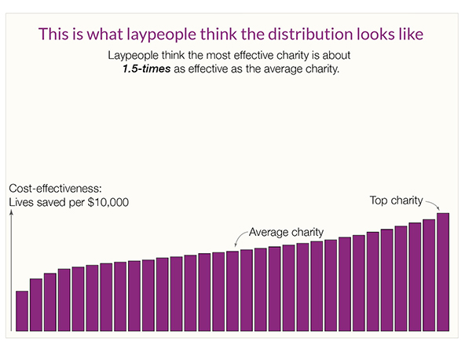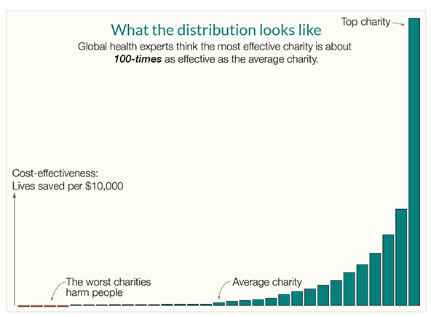
Kevin Star’s article usefully explains that there’s a kind of market failure in the charity sector, where donors aren’t part of the feedback loop and often have no meaningful way of knowing how much value beneficiaries get from their donations. The article outlines how an approach to impact-focused evaluation which he persuasively explains could achieve a “quantum leap toward a better world”.
While the above two sources focus on global health, the same effect occurs across countries and across causes. By way of illustration, Benjamin Todd’s recent article on 80,000 Hours shows a similar distribution of the impact of climate interventions (https://80000hours.org/2023/02/how-much-do-solutions-differ-in-effectiveness/) :
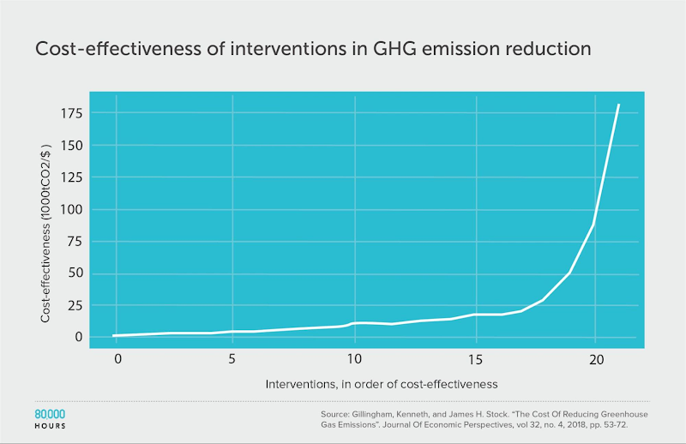
This insight is essential. While donors don’t and can’t understand how impactful their donation is, and charities have to raise funds in a market that doesn’t function, the sector will struggle. This problem is long-standing, but progress in the last 10 years on charity evaluation means it doesn’t have to continue.
Australia funding and promoting charity evaluation has the potential to fix the market failure, help Australian charities do far more good, and potentially make us a world leader.
Australia has the potential to create a world-leading philanthropic sector. We already know that the most effective charities can have a substantially greater impact than the average charity, but currently, there are no mechanisms in place to incentivise impact or empower donors to choose the best charities based on their impact.
By implementing the recommendations outlined in this submission, Australia can become a global leader in philanthropy. This could reverse the brain drain and attract more impact-focused charities to Australia, further enhancing the country's ability to make a positive impact on the world.

