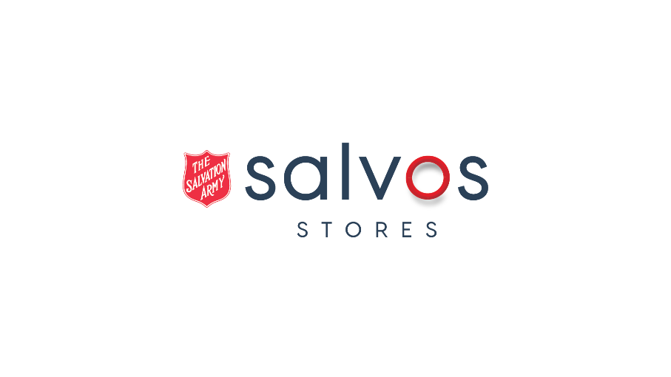

# **Opportunities in the Circular Economy**

The views expressed within are supportive of the views expressed by Charitable Reuse Australia and the shared views expressed by those represented in the submission by Charitable Reuse Australia.

Salvos Stores endorses these views as representative of the Charitable Reuse Industry, it’s impacts and its opportunities to bolster and shift toward the Circular Economy.

## The Future is Reusable

## Higher Order Interventions to Accelerate Circularity

* Behaviour Change Campaign for Good Stewardship
* Accessible Reuse and Repair Grant Funding
* Tax Incentives for Brands to Donate Excess Stock to Charity
* National Reuse Data Studies to Identify Reuse Policy Development and Targets

## About Us: The Salvation Army

The Salvation Army is one of the world’s largest Christian social welfare organisations with more than 1,650,000 members working in over 127 countries.

We have been in Australia for 130 Years. Currently we have more than 8,500 active officers and staff delivering in excess of 100 specifically designed social programs across Australia.

The Salvation Army is a Christian movement dedicated to **sharing the love of Jesus**.

We share the love of Jesus by:

* Caring for people
  + Being there when people need us most
  + We offer care and compassion as a sacred encounter with transformative potential
* Creating faith pathways
  + Taking a holistic approach to the human condition that values spirituality
  + We graciously share the Good News of Jesus and grow in faith together
* Building healthy communities
  + Investing ourselves in relationships that promote mutual flourishing
  + We find the wholeness God intends for us in community
* Working for justice
  + Tackling the social systems that harm creation and strip away human dignity
  + We join God’s work to build a fairer world where all can thrive

Recognising that God is already at work in the world, we value:

* Integrity
* Compassion
* Respect
* Diversity
* Collaboration

We commit ourselves in prayer and practice to this land of Australia and its people, seeking reconciliation, unity and equity.

In a typical week across Australia we provide*:

* 100,000 meals for the hungry
* 2,000 beds for the homeless
* 5,000 to 8,000 food vouchers
* 1,000 people with assistance in finding employment
* Refuge to 500 victims of abuse
* Assistance to 500 people addicted to drugs, alcohol or gambling
* Several thousand people with counselling
* 3,000 elderly people with aged care services
* 1,000 people in the court system with chaplaincy services
* Family tracing services with locate 40 missing family members

## About us: Charitable Reuse Australia

*Charitable Reuse Australia* champions the Circular Economy for a sustainable environment and an equitable society.

The charitable reuse sector diverts over a million tonnes of household items from landfill, saves 880,000 tonnes of CO2 emissions and raises almost a billion dollars a year for social good.

All of Australia’s major charity shops are members of *Charitable Reuse Australia* including Salvos Stores, Vinnies, Red Cross, Save the Children, Lifeline and dozens of others representing around 95% of the volume of the sector. The charitable reuse sector has been operating under circular economy principles for over 140 years since the first charity shop was established in Australia in the 1880s.

The *Charitable Reuse Australia* community also includes sustainability and stewardship partners including Planet Ark, Clean Up Australia, Seamless, ANZRP, Thread Together, GIVIT, Re-Love, Australian Bedding Stewardship Council, ReGroup, TOMRA Cleanaway and Bingo industries, as well as second-hand economy players like eBay and Garage Sale Trail.

All of Australia’s reputable commercial clothing collections companies are also partners in the *Charitable Reuse Australia* community including UTURN, Statewide, Recycle Care Australia, Allround Recycling, Australian Clothing Recyclers, SCR, One Ten, Rais Industries and Navarro Enterprises.

*Charitable Reuse Australia* is a catalyst for circular economy behaviour change, and acts as a broker with other stakeholders essential to the Circular Economy.

* Members: <https://www.charitablereuse.org.au/member-enterprises/>
* Supporters: <https://www.charitablereuse.org.au/our-supporter-organisations/>
* Partners: https://www.charitablereuse.org.au/capacity-building/corporate-social-enterprise-partners/

## Circular Economy Accelerator 1: Behaviour Change Campaign

Behaviour change is fundamental to the transition to the Circular Economy, and there is an opportunity for the Australian Government to take on an education role with Australian consumers and businesses to encourage behaviours at the top of the Waste Hierarchy.

Figure : The Waste Hierarchy (Charitable Reuse Australia)

What will the Behaviour Change Campaign include?

* Responsible donating messages to encourage consumers to donate pre-loved goods to charity, with its 86% resource recovery rate and where the products will get reused.
* Good stewardship messages to underpin current and future National Product Stewardship Investment Fund Programs, through sustainability and environmental impact.
* Education and advice for consumers on how to best care for products, prolong their life and how to dispose responsibly – aligned with Circular Economy principles.
* Encouragement for clothing and household brands to donate excess stock to charity for reuse.

What will it do?

* Begin the transition for ‘consumers’ to becoming ‘citizen consumers’ with environmental and social considerations improving their purchase and disposal decisions.
* The campaign will accelerate reuse, and in doing so, will create new jobs. The NSW EPA funded NSW Reuse Data Study shows that reuse creates 25x more jobs than recycling per tonne of material processed.

How much will it cost?

* Recently, the Government invested a $3 million national advertising campaign to boost volunteers nationally – a similar investment will kickstart the essential behaviour change that is essential for the transition to a Circular economy by 2030.

## Circular Economy Accelerator 2: Accessible Reuse & Repair Grants

Most government funding goes to recycling at the bottom of the Waste Hierarchy, artificially inflating its role. Funding for continuous improvement is overlooked, and absent from sectors like reuse, which have already created massive social, environmental and economic impact – and can deliver benefits that can be scaled.

What will this include?

* Funding for physical space and manpower, including wage subsidies, to scale preparation for reuse and maximise waste diversion.
* Incentives to support collections and sorting of reusable clothing and household items.
* Easily accessible repair hubs for communities within their council areas.
* Training and upskilling support for the job creation of people facing barriers.

What will it do?

* Increase the volume and impact of Reuse in Australia as a key driver of the transition to a Circular Economy by 2030.
* Provide a short to medium term accelerator boost to scale reuse and build capacity for sustained ongoing improvement and impact for reuse organisations.
* Create 25x more jobs than recycling per tonne of materials processed.

How much will it cost?

* Costs are dependent on the quantity of grant funding offered.
* The economic, environmental and social return on investment of each grant is directly measurable using the datasets from the completed NSW Reuse Data Study and/or other Reuse Data Studies currently being conducted and/or planned across other states.
* Reuse organisations and councils can also integrate the outputs of the Reuse Data Studies to demonstrate their impact, improve reporting and heighten the evidence-base for grant applications, which will increase the quality and quantity of relevant reuse and repair grants.

## Circular Economy Accelerator 3: Tax Incentives for Brands to Donate to Charity

A Deloitte Access Economics Report estimates that $2.5 billion worth of new products are wasted annually and never used, reflecting the overproduction of excess stock by clothing and household brands. There is an opportunity for the Government to encourage transparency and encourage the donation of unused, excess pre-consumer goods to the charitable sector where they will get used and contribute to the Circular Economy with environmental, social and economic gains.

What will this include?

* A Working Group to explore business tax incentives to encourage the donations of clothing and household items, expanding on the proposed tax incentive for food relief.
* The encouragement of transparency and visibility from brands to declare excess stock inventories and take responsibility for the waste they generate.
* Education and messaging to encourage the resale (reuse) of unsold excess stock through reuse and op shops in Australia.
* Government funding for a Cost-Benefit Analysis on the tax architecture required.

What will it do?

* Address the critical, hidden problem of overproduction and excess stock waste that is the nemesis of the Circular Economy.
* Maximise the value of resources in existing new products, to give them a first and second life through op shops and generate social and environmental benefits.
* Actively engage the Next Generation of consumers who are increasingly demanding environmental sustainability from household brands.
* Encourage active ESG awareness and reporting.

How much will it cost?

* Costs are dependent on the scope of the Cost-Benefit Analysis

## Circular Economy Accelerator 4: National Reuse Data Studies

Reuse sits at the top of the Waste Hierarchy as a highest and best use intervention to drive the circular economy, and yet it is unsupported by Australian government waste policies.

The NSW EPA has taken the lead to begin changing this, with their funding of the NSW Reuse Data Study that demonstrates the specific environmental, social and economic benefits of reuse.

NSW Reuse Data Study: <https://www.charitablereuse.org.au/wp-content/uploads/2024/06/Reuse-in-NSW-Executive-Report-2024.pdf>

The Tasmanian Waste and Resource Recovery Board is currently funding a harmonised TAS Reuse Data Study, and other states are likely to follow suit but Australia needs a National Reuse Data Study to quantify the national impacts of reuse, in order to inform the establishment of Reuse and Repair targets, to support circular economy policy development opportunities.

The benefit for the Australian Government is simple. We all know the Waste Hierarchy establishes preferred priorities based on efficacy. So the more higher order interventions like Reuse and Repair are actioned, the more effective the outcomes. The better the outcomes, the faster the Australian Government will reach its targets and accelerate its progress towards a circular economy by 2030. The faster we reach our targets - whether it is zero waste, CO2 emission reductions or better resource management, the closer we get to a circular economy. And it starts with working higher up the Waste Hierarchy, on interventions like Reuse and Repair.

**What is Reuse?**

Reuse is defined as the recirculation of fit-for-purpose goods in their original form to extend their life for as long as possible, extracting full value from these resources for maximum environmental, social and economic impact.

It includes outputs including waste diversion, landfill reduction, avoidance, good stewardship, and the reduction of C02 emissions, energy and water, through the displacement of a new like-for-like purchase. Adhering to the tenets of the Waste Hierarchy, Reuse also delays the need for recycling until products have reached the end of their useful lives.

Repair is a subset of Reuse, and this activity can also be defined as ‘Preparation for Reuse’, with Repair acting alongside Ruse to prolong the useful life of products.

**Economic Benefits and Job Creation**

The NSW Reuse Data Study shows that reuse creates 25x more jobs than recycling per tonne of material processed. Reuse creates 228 paid FTE jobs per 10,000 tonnes compared to just 9.2 jobs in Recycling and 2.8 jobs in Landfill per 10,000 tonnes.

In economies like Europe where Reuse is actively supported to maximise impact by European Governments, RREUSE estimates that 700 jobs are created for every 10,000 tonnes materials reused. RREUSE estimates that an additional 300,000 new jobs can be created in Europe through Reuse Targets.

<https://rreuse.org/job-creation-in-the-re-use-sector-data-insights-from-social-enterprises/>

**Social Benefits**

Beyond job creation for the Circular Economy, the biggest benefit for the Australian Government to support Reuse is the social impact it will create for Australia, and the millions of Australians in need. During this time of economic challenges, where many Australians are struggling with mortgage stress, rent payments and even household electricity bills – supporting Reuse can massively amplify the billion dollars a year that reuse charities generate to support those in need, through essential services like food, shelter, crisis support, mental health, and a wide range of illness and disability support.

The NSW Reuse Data Study shows that reuse and resale saves the NSW community $432 million every year.

**National Reuse Measurement Guidelines**

In partnership with Charitable Reuse Australia, Monash University has developed the *National Reuse Measurement Guidelines*, which provide a comprehensive methodology to measure reuse and quantify its environmental, economic and social benefits. All of the harmonised Reuse Data Studies are based on these guidelines.

In the Monash University approach, reuse is measured at the point of sale, which captures information about the quantity of items resold, the category of items, and their cost – and allows for the interpretation of data into average weights per category, average material composition and product life cycle assessments that are readily available.

Using this data and other reporting as outlined in the framework, the social, environmental and economic impacts of reuse can be demonstrated, including:

* Avoided virgin material consumption and greenhouse gas emissions savings
* Employment and volunteer opportunities – in a high job creation sector including scaling jobs for people facing barriers
* Skills development and work-readiness support – to capture the additional supports the charitable sector provides over and above typical training, to integrate people facing barriers
* Education and community engagement – to capture reuse workshops, events and training
* Total value of reused goods sold in the charitable and community reuse sector each year
* Total value of goods provided for welfare and in-kind to other organisations

Funding a National Reuse Data Study will provide the Australian Government with the evidence base to support Reuse, by quantifying its specific environmental, social and economic benefits to accelerate circularity.

**What Will it Cost?**

* $360,000+ GST to populate the National Reuse Measurement Guidelines in order to provide the evidence-base on the size of the reuse sector in Australia and its environmental, economic and social impact.

## Helpful Links:

* **Government Policy Gap Analysis**: https://www.charitablereuse.org.au/about/policies-and-projects/gap-analysis-of-government-policies/
* **Reuse Immersive**: https://www.charitablereuse.org.au/about/policies-and-projects/reuse-immersive/
* **National Reuse Measurement Guidelines**: https://www.charitablereuse.org.au/about/policies-and-projects/national-reuse-measurement-guidelines/
* **Resource & Waste Hierarchy:** https://www.charitablereuse.org.au/about/policies-and-projects/resource-and-waste-hierarchy/