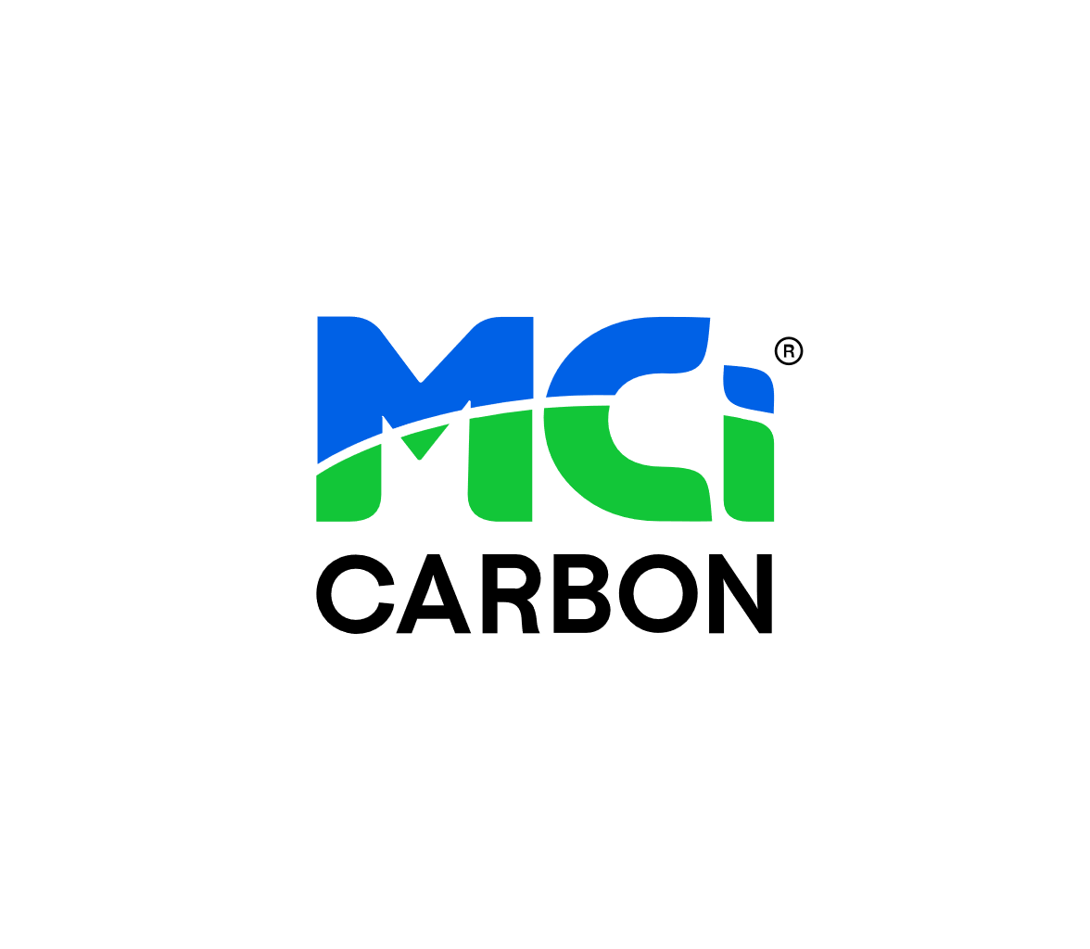

Opportunities in the Circular Economy

Submission to the Productivity Commission

On behalf of MCi Carbon Leadership Team

November 1, 2024

Introduction

MCi Carbon is a clean technology company at the forefront of the global carbon capture and utilisation (CCU) industry. The company transforms CO2 from industrial emissions into valuable building materials and products, providing an innovative pathway to decarbonise heavy industries such as cement, steel, mining, and manufacturing. MCi Carbon enables the circular carbon economy, directly supporting Australia’s transition toward more sustainable and efficient materials supply chains.

Our submission to the Productivity Commission’s inquiry into Australia’s opportunities in the circular economy focuses on demonstrating the scalability, cost-effectiveness, and environmental benefits of CCU technology in key sectors. We will highlight regulatory changes that can accelerate the adoption of circular materials, particularly the use of low-carbon and negative emissions materials in the built environment, as well as the critical role of local and state governments in facilitating this transition.

Our team welcomes the opportunity to submit to the inquiry, provide input into the National Circular Economy Framework and support the Australian Government’s target to achieve a circular economy by 2030. Both MCi Carbon’s technology and business model interact with almost all facets of the circular economy: the productivity and efficiencies in raw materials extraction, production and manufacturing of new products, and the utilisation of numerous waste streams from some of Australia’s biggest emitting industries. By enabling circularity in Australian mining, construction and manufacturing, we are extending and expanding our comparative advantages and advancing our competitiveness in carbon embodied materials and green metals.

Our work in the circular economy

MCi Carbon has been a long-term advocate for the opportunities CCU provides for Australian industries and the economies of our trading partners, enabling circularity and sustainability. Particularly, the company is scaling an engineered mineral carbonation solution, whereby CO2 emissions react with mineral rich feedstocks to create new carbon-embodied materials.

In 2016, the company commissioned a mineral carbonation Research Pilot Plant at the Newcastle Institute of Energy and Resources (NIER) which has informed the engineering design and construction of **‘Myrtle’**, our scale-up mineral carbonation demonstration plant and Australia’s CCU Flagship. This facility is set to be commissioned in December 2024 and will act as a rapid validator for a range of customers across emissions abatement and new materials.

The company has engaged in continuous advocacy efforts over the past decade with the Australian Government, state Governments, the European Commission’s CCUS Working Group, the USA Department of Energy, the IPCC, United Nations and World Economic Forum. Advocacy efforts have been focused on defining technology approaches for CCU, Carbon Dioxide Removal and negative emissions to ensure there is integrity in the landscape.

Focused work with the Australian Government has been in collaboration with advocacy group **CO2 Value Australia** and has interacted with the Federal Governments departments relating to climate change, environment, the circular economy, resources, industry and trade, as well as the NRF, PRF and NZEA. MCi Carbon secured a $14.5M Carbon Capture Technology Grant from DCCEEW in 2024 and a $14.6M CCUS Demonstration Fund Grant from DISR/DCCEEW in 2021. This sustained bipartisan support reflects the confidence in MCi Carbon’s technology and the belief that our solutions will be a cornerstone in Australia’s net zero future.

In 2021, MCi Carbon provided input into the [CSIRO CO2 Utilisation Roadmap](https://www.csiro.au/-/media/Services/Futures/21-00285_SER-FUT_REPORT_CO2UtilisationRoadmap_ExeSumm_WEB_210810.pdf) and work continues with the CSIRO to better establish the wider CCU industry in Australia.

MCi Carbon was originally founded upon a $9.12M grant from the Australian Government, NSW Government and Orica in 2013, and attracted a follow on $2.3M CRC-P in 2017. The company is proud to have been supported by the Australian Government consistently since 2013, representing what will be a 15-year partnership with Australian Government bodies through to 2029.

The Scope of Materials Productivity and Efficiency

Firstly, it is important to address the potential scope for materials productivity and efficiencies within the context of MCi Carbon’s CCU technology platform.

MCi Carbon is currently developing and scaling a technology that transforms captured CO2 from hard-to-abate industries, such as steel, cement and mining, into low-carbon construction materials, for use in cement and other industrial and manufacturing applications.

Our company has re-engineered the Earth's natural process of storing CO2 called *mineral carbonation*, or weathering. This process of absorbing CO2 into minerals usually occurs over millions of years geologically but MCi have sped up that process to a matter of minutes in an industrial setting.

Mineral-rich industrial waste streams, such as slags and tailings mine wastes, react with CO2 to create carbonates and silicates, and other saleable materials. Third parties may formulate these new products into cements, concretes, plasterboards, papers, glass, and other industrial products. In addition, MCi Carbon can enhance low-grade ultramafic rock, such as serpentinite. This beneficiation process is a key enabler for significant emissions reduction pathways and materials productivity and circularity.

As the world transitions to net zero and beyond, governments and pioneers of the built environment will search for methods to reduce embodied carbon in new infrastructure developments, MCi Carbon materials offer new pathways for building materials manufacturers to decarbonise their offering to developers.

This approach aligns with circular economy principles by closing the loop on CO2 emissions, turning industrial wastes into valuable resources that can be reused across the built environment, and is applicable across a range of emissions sources and end use cases, especially in industrial hubs such as the Hunter, Pilbara, Kwinana, Illawarra and Gladstone.

Our technology is scaling in Newcastle, informed by engineering data from our Mineral Carbonation Research Pilot Plant at the Newcastle Institute of Energy and Resources (NIER). Currently in late-stage construction, the Myrtle CCU Demonstration Plant is expected to capture 1000 tonnes of CO2 per annum and produce thousands of tonnes of low-carbon materials annually, providing tangible contributions to decarbonising Australia's construction sector. Commissioning is due to commence in Q4 2024. Commercial scale facilities are projected to be in operation from 2028-2030.

The scope for materials productivity and efficiencies enabled by MCi Carbon extends across multiple sectors and waste streams, achieving a range of circular business models.

Best Metrics to Measure Progress

To assess improvements in materials productivity and efficiency, MCi Carbon suggests using the following metrics:

* **CO2 Captured and Utilised:** The volume of CO2 emissions captured and repurposed into materials. New carbon-embodied materials have been created in the MCi Carbon Pilot Plant that contain up to 50% CO2 by weight.
* **Material Lifecycle:** The lifecycle of low-carbon materials compared to traditional materials, in terms of durability and reusability. This could include the % of industrial processes across a particular industry that are closed loop.
* **Reduction in Virgin Material Use:** The reduction in the extraction and use of virgin raw materials (such as natural aggregates) by substituting them with new low-carbon and negative emissions materials. This could be paired with an assessment of the emissions intensity of alternative virgin material extraction and processing (limestone v. serpentinite)
* **Emissions Reduction per Tonne of Material Produced:** The amount of CO2 emissions avoided using low-carbon and negative emissions products compared to conventional materials like concrete. This is particularly relevant for place-based circular economies. Sourcing materials for use in cement manufacturing may be localised due to the new localisation mineral carbonation can achieve.
* **Productivity of Industrial Wastes:** Represented by the % of current waste with $ value-add potential and the % of existing waste streams now used as a reactive feedstock.

Priority Opportunities for Australia

MCi Carbon sees significant opportunities to advance circular economy principles in Australia’s most emissions-intensive industries and hard-to-abate sectors: steel, cement, construction, mining and chemicals manufacturing.

MCi Carbon have conducted desktop assessments for integrating its technology in the steelmaking process, demonstrating that the technology using magnesium silicate feedstocks has the potential to be capture up to 90% of CO2 emissions from an integrated steelworks and provide an attractive return on investment. Magnesium silicate minerals are available in bulk quantities sufficient to support multi-million tonne per year abatement levels from a steelmaking site.

MCi Carbon has previously [collaborated with Bluescope Steel](https://www.bluescope.com/content/dam/bluescope/corporate/bluescope-com/sustainability/documents/2021_BlueScope_Report_Climate_Action_Report.pdf) on the use of slag to store CO2 and generate a value-add product. Basic Oxygen Steelmaking (BOS) slag contains high concentrations of reactive lime (CaO) and calcium silicate minerals suitable for carbonation. In 2020, MCi conducted a study using slag from the Port Kembla Steelwork’s BOS plant.

MCi’s technology is also compatible with concentrated CO2 sources and could be deployed as a component of a CO2 utilisation hub where multiple technologies are used to produce a range of products from CO2.

In this scenario MCi’s technology could be used to simultaneously abate CO2 whilst valorising waste electric arc furnace and basic oxygen furnace slags. The process would narrow and slow loops of carbon emissions across multiple supply chains and increase materials productivity.

The potential revenue from carbonated products, such as aggregates for construction made from calcium carbonate (CaCO3) and magnesium carbonate (MgCO3), is calculated based on:

* Steel Slag Available for Carbonation: A steel production facility generating 3Mtpa of crude steel produces approximately 330K tonnes of steel slag and 5.55Mtpa CO2 (at a ratio of 225 kg of slag and 1.85 tonnes of CO2 per tonne of steel).
* Market Price of Aggregates/Carbonated Products: The market price for construction aggregates or other similar carbonated products varies but [typically ranges from $15 to $50 per tonne](https://www.holcim.com.au/pricing), depending on market conditions and product quality.

Traditional methods of producing calcium and magnesium carbonates involve the quarrying of raw materials, transportation, and processing, which are both capital and energy intensive. Mineral carbonation reduces costs by using waste products like steel slag and captured CO2. This effectively eliminates raw material extraction costs.

For the 3Mtpa steel plant, capturing 73,000 tonnes of CO2 per year using slag as a reactive feedstock, this could result in revenues of $6M to $20M per year from the sale of carbonated products, depending on market conditions. This offsets the cost of the carbonation process in a substantial cost savings of $1 to $13 M per year going up by $2M per year when including $30/Net tonne carbon credits. A similar outcome could be achieved if using waste slag to capture CO2 emissions from a cement plant.

Steel slag, which would traditionally be discarded in landfills or used in low-value applications, is transformed into high-value products, such as aggregates for construction and concrete additives. This approach significantly reduces waste management costs and creates a new revenue stream.

Mineral carbonation also reduces reliance on raw materials, driving circularity in the steel production supply chain by ensuring materials are reused in a closed loop. Examples of this circularity are where the limestone produced from capturing CO2 using waste slag has the potential to replace some of the mined limestone used in cement production.

Environmental Outcomes

**CO2 Emission Reduction:**

The adoption of MCi Carbon’s technology can lead to a 90% reduction in CO2 emissions. For a facility producing 3m tonnes of CO2 per year, this reduces emissions to 300k tonnes annually, drastically cutting the carbon footprint of steel production.

MCi offers a CO2 reduction solution for Industries producing CO2 as part of their process e.g. Cement production and refractories; by locking in CO2 permanently into valuable products

Traditional production of CaCO3 and MgCO3 releases significant CO2 during quarrying and calcination, whereas MCi’s process locks CO2 into permanent materials, avoiding these emissions entirely. Therefore, some scenarios can create negative emissions materials.

Products from MCi’s technology can also replace more CO2-intensive traditional materials, increasing the CO2 avoidance further than the CO2 embodied in the products

**Resource Conservation:**

The use of steel slag replaces the need for quarrying raw materials, which would otherwise disturb land and ecosystems, contributing to habitat destruction and biodiversity loss. By using industrial by-products, the process preserves natural resources and reduces the negative impacts of extractive industries.

**Water and Air Quality:**

Traditional methods of quarrying limestone or dolomite can cause air pollution (from dust and CO2 emissions) and degrade water quality. Mineral carbonation significantly lowers these impacts by using non-toxic inputs, no chemical catalysts and avoiding large-scale resource extraction.

Social Outcomes

**Job Creation and Skills Development:**

The shift toward circular steel production creates new jobs in carbon capture and utilisation, material processing, and technology operations. This also requires investment in skills development and training for workers, promoting the green economy.

In steel-producing regions, integrating circular practices helps ensure the industry’s long-term viability by reducing its environmental impact and strengthening its social license to operate.

**Community Adoption:**

As awareness and acceptance of climate change and sustainability grows, communities and consumers are increasingly demanding low-carbon and sustainable products. This approach aligns with growing trends in green construction materials, boosting the acceptance and uptake of materials produced through circular methods.

What is the Circular Carbon Economy?

The **Circular Carbon Economy (CCE)** is an economic model designed to manage carbon emissions sustainably by capturing, utilising, and recycling carbon in a way that mimics a natural carbon cycle. Rather than simply reducing emissions, the CCE approach aims to create a closed-loop system where carbon is continuously reused and transformed into new products.

Circular economy solutions can be integrated into the resource extraction process to both decarbonise refining and create value from waste. Our materials may also be used for site remediation, providing a closed-loop solution for mining operations.

A previous case study for a customer showed the potential to capture 140ktpa of CO2 using serpentinite, with the added benefit to avoid mining more than 230ktpa of magnesite as well as avoiding the generation of 120ktpa geogenic CO2.

Our first global commercial customer RHI Magnesita currently sources magnesite from a mine in Hochfilzen, Austria. MCi Carbon is partnering with RHI Magnesita to capture and transform CO2 from their refractories manufacturing process into refractory bricks, critical for high-temperature processes exceeding 1,200°C in a wide range of industries, including steel, cement, non-ferrous metals and glass. This is a prime example of closing the loop on carbon emissions.

Mined magnesite for refractories production could also be replaced by magnesite produced from MCi’s serpentinite process, again reducing reliance on mined materials, reducing geogenic CO2 emissions and enabling circular economy.

In April 2024, RHI Magnesita facilitated [a visit from the EU Commissioner for Energy, Kadri Simson](https://www.rhimagnesita.com/eu-commissioner-for-energy-kadri-simson-visits-australian-carbon-capture-and-utilization-startup-mci-carbon-in-partnership-with-rhi-magnesita/), to the MCi Carbon Pilot Plant. RHI Magnesita has now committed to testing and scale-up of MCi Carbon’s technology in preparation for the commercial roll-out at Hochfilzen/Austria, a project planned for 2028 which will capture and transform approximately 50,000 tons of CO2 per year.

Barriers to Enhanced Materials Productivity and Prospective Approaches to Addressing Them

**Regulatory Uncertainty:** Current building codes and standards do not consistently prioritise or incentivise the use of circular materials. This lack of regulatory clarity creates uncertainty for builders and developers, making it harder for them to justify the upfront investment in sustainable materials. Currently, [MCi Carbon has been working with Smartcrete CRC and Transport for NSW](https://smartcretecrc.com.au/projects/low-carbon-footprint-supplementary-cementitious-materials-for-concrete-and-blended-cement-use-from-mineral-carbonation-r1p46/) on the potential use of amorphous silica produced from MCi’s mineral carbonation process in concrete infrastructure. The project aims to conduct rigorous performance tests, ensure conformity with standards, identify potential markets, and lay the groundwork for larger trials

**Perceived Cost:** Circular materials are often perceived as being more expensive due to initial production and procurement costs. Without financial incentives or clear long-term savings models, industries are hesitant to adopt these materials. Governments can strengthen green building codes by offering incentives for developers who meet or exceed circular material usage thresholds. These could include tax rebates, fast-tracked approvals, or enhanced ratings within programs such as Green Star or NABERS. MCi Carbon are current members of the Green Building Council for Australia (GBCA) and the Materials and Embodied Carbon Leaders Alliance (MECLA) and this sentiment is shared across these networks.

**Limited Awareness:** Many stakeholders in the construction and mining sectors are unaware of the environmental and economic benefits of circular materials like those produced by MCi Carbon.

Place-Based Circular Economy Activities

Regions like Newcastle, with its history in heavy industry and innovation, are well-positioned to become hubs for circular economy initiatives. Establishing industrial precincts focused on CCU technology can create synergies between industries, improving material flow and reducing waste. Newcastle is an ideal location to pilot circular economy innovations due to its strong industrial base and growing sustainability initiatives. By enacting local regulations that promote circular materials and industrial hubs focused on CCU technologies, Newcastle can become a leader in Australia’s circular economy transformation. Our team are actively discussing the use of low-carbon materials in field trials across the Hunter with local governments, businesses and industry stakeholders. These test applications could be used in public infrastructure, parks and carparks, etc.

MCi Carbon are involved in the Hunter Circular Economy Facilitators Group and the Hunter Joint Organisation Circular Economy Accelerator for Lake Macquarie. Outside of NSW, MCi Carbon are involved in the ACT Low Carbon Concrete Working Group.

MCi Carbon believes that achieving circularity in regional hubs across Australia reduces economic and social costs, and by utilising existing industrial facilities and infrastructure there is low or zero environmental costs.

Prospective Solutions

**Regulatory Frameworks:** Governments should introduce mandatory quotas for the use of circular materials in public infrastructure projects. Additionally, revising building codes to recognise and prioritize materials with lower embodied carbon would incentivize the use of MCi’s products.

**Financial Incentives:** Governments could provide tax credits, grants, or subsidies for companies that use or produce circular materials, helping to offset initial costs and encourage broader adoption.

**Education and Training:** Implementing education campaigns aimed at developers, architects, and builders will raise awareness about the benefits and availability of circular materials, driving demand.

Policy Actions Achievable Over the Near and Medium Term

**Public Procurement Policies:** Governments can immediately revise procurement policies to include requirements for circular materials in all public construction projects. This would rapidly increase demand for low-carbon materials and demonstrate their viability in large-scale applications.

**Tax Credits for Low-Carbon Materials:** Introducing tax credits for companies that use low-carbon or circular materials can be implemented within existing tax frameworks and would provide immediate financial relief to early adopters.

**Regulatory Changes in Building Codes:** In the medium term, building codes across Australia should be updated to reflect the importance of embodied carbon in materials, setting clear targets for emissions reductions and rewarding the use of circular materials.

**Circular Economy Hubs:** Governments should invest in establishing circular economy hubs, particularly in regions like Newcastle. These hubs would foster collaboration between industries, research institutions, and innovators like MCi Carbon, allowing for the development of new circular processes and technologies.

Policy Actions for Commonwealth, State, and Local Governments

**Commonwealth Level:**

Develop national circular economy standards and certifications for low-carbon materials, providing clear benchmarks for industries to follow. Offer national-level financial incentives for companies adopting CCU technologies or producing circular materials, stimulating investment across sectors.

**State Level:**

Introduce circular economy mandates in public infrastructure projects, ensuring that all state-funded developments incorporate a percentage of low-carbon or circular materials. Provide grants for companies in industries like construction and mining to offset the cost of transitioning to circular practices, including the adoption of MCi’s materials.

**Local Level:**

Cities like Newcastle can lead the way by adopting circular materials for urban planning and development, showcasing how local governments can create demand for sustainable materials through zoning laws and public procurement. Encourage the formation of local partnerships between industries, such as through industrial precincts, where circular material exchanges can occur, leveraging the waste streams of one company to provide inputs for another.

MCi Carbon believes that the potential to lift Australia’s materials productivity and efficiency through carbon capture and utilization is enormous. By embracing circular economy practices, particularly in construction and mining, Australia can enhance its economic competitiveness while reducing emissions. With the right regulatory frameworks, financial incentives, and place-based initiatives, Australia can lead the world in the adoption of circular materials, creating a more sustainable and resilient economy.

MCi Carbon has identified several barriers to widespread adoption of circular materials in Australia’s built environment. These include regulatory uncertainty, market perceptions of cost, and a lack of clear incentives for using circular products. Below are proposed regulatory changes that could accelerate the adoption of circular materials:

Economic Impact and Cost-Effectiveness of Circular Materials

MCi Carbon’s technology not only provides environmental benefits but is also economically competitive, particularly when considering lifecycle cost savings.

Carbon Pricing Benefits: Companies that adopt MCi’s low-carbon materials can avoid penalties under carbon pricing schemes, providing additional financial benefits. Net revenue per tonne of CO2 avoided or utilised in materials varies between US$0 - $350, with customer tecno-economic studies showing multiple business cases that demonstrate positive net revenues as facilities decarbonise. Uniquely, this revenue can remain positive without a carbon price.

Energy and Resource Efficiency: Energy intensity of our products is comparable or lower to conventional materials whilst achieving significant CO2 savings. Part of the mineral carbonation process is the heat activation of feedstock materials to increase reactivity. This is achieved using natural gas, with the flue gas emissions created from this process reutilised as a waste stream into the process itself. This feature will be an addition to the Myrtle facility, made possible by the Australian Federation Government $14.5m Carbon Capture Technologies Program grant awarded to MCi Carbon in July 2024.

Partnerships and Collaborations

MCi Carbon’s technology has been successfully scaled through strategic partnerships with key players in construction, mining, and research sectors. These collaborations highlight the broad applicability of CCU technology and its potential to drive Australia’s circular economy forward.

MCi Carbon's Role in Australia’s Circular Economy Future

MCi Carbon is uniquely positioned to help Australia realise its circular economy goals by 2030. Our technology offers scalable, cost-effective solutions that reduce CO2 emissions, create valuable materials, and integrate circular principles into some of the nation’s most critical industries. With the right regulatory support, MCi Carbon’s technology can drive significant advancements in materials productivity, resource efficiency, and emissions reduction.

We believe that by implementing the regulatory changes outlined in this submission, the Australian Government can accelerate the transition to a circular economy, benefiting not only the environment but also the nation’s economic growth and global competitiveness.