# Improving the role of River Basin Organisations in sustainable river basin governance by linking social institutional capacity and basin biophysical capacity

*Authors: Frederick Bouckaert1, Yongping Wei1, Karen Hussey1, Jamie Pittock2, Ray Ison3*

*1University of Queensland*

*2 The Australian National University*

*3Applied Systems Thinking in Practice Group, STEM Faculty, The Open University UK*

## Abstract

The river basin organisation (RBO) model has been advocated as organisational best practice for sustainable river basin management, despite scant evidence of its effectiveness to manage complex river systems. This review provides a framework which combines functional social-institutional capacities with basin biophysical indicators in a diagnostic tool to determine RBO governance performance. Each of these two capacities are represented by four groups of indicators respectively covering social learning capacity and biophysical capacity. The distance and alignment between capacity and measure of performance scores can be used to prioritise program planning and resource allocation for improving river basin governance, and to undertake periodic evaluations as part of a trajectory analysis. The diagnostic functional framework provides tangible indicators of performance around key concepts in river basin governance. It offers a first attempt to strengthen the position and effectiveness of an RBO in dealing with complex adaptive systems.

## Introduction

Governance of river basins is complex and context specific [1], nevertheless, many governance issues are similar around the world: drought (demand exceeds supply), flooding (supply exceeds demand) and water quality degradation (pollution, saltwater intrusion, turbidity, algal blooms, etc.) [2]. Emerging threats to sustainable development of our water resources include changes in hydrology, geomorphology, erosion, sedimentation, and connectivity driven by population pressure, economic development and climate change, and the resulting degradation of freshwater ecosystems and ecosystem services [3, 4].

Water crises are evident everywhere, with almost no river basin currently managed sustainably anywhere in the world – a fact which is increasingly recognized as being a failure in *governance* [5]. The crisis of river basin governance has been investigated from the perspectives of *collaborative governance* [6, 7] (adaptive governance [8, 9, 10] and social learning [5]), *social contracts* (covenant action [11], ecosystem asset management [12], partnership accountability [13]) and *top down regulation* (hydrocracy and overallocation [2], hierarchy theory [14**], politics of knowledge [15]). A central pillar in integrated river basin management (IRBM) has been the establishment of river basin organisations (RBOs), yet the efficacy of those organisations has received relatively little attention, except to the extent that scholars and practitioners alike agree that the objectives of RBOs are often ill defined and governance performance of RBOs are poorly measured [16]. River basins understood as systems exhibit the same characteristics that are captured in Ostrom’s Social-Ecological Systems framework [17], and the aim of this paper is to propose a diagnostic functional framework that can be used to strengthen the role of RBOs in sustainable river basin governance.

This paper is structured as follows. The issues section will highlight key governance issues including the role and position of the river basin organisation (RBO), and the various relevant conceptual frameworks and their limitations to address those governance issues. In the next section, a diagnostic framework is conceptualised for the role of RBO in integrated river basin management, including indicators, attributes and trajectory for implementing and using the framework. The discussion and conclusion section highlights the implications of the proposed framework. Finally, the next steps for a more detailed analysis and evaluation of the framework are suggested.

## Issues

A RBO can be described as an organisation that is made up of a number of rules related to authority, aggregation, boundaries, information and pay-off (distribution of benefits and costs) of a river basin [18, 19]. RBOs are an important component of integrated river basin management (IRBM) and aim to govern a basin’s geographic boundaries, using a bioregional approach and allowing a system-wide approach, combined with a coordination function across the often-numerous sub-catchment organisations that can exist in a basin, or even as part of a water transfer scheme. In this way, some RBOs can also exhibit strong elements of polycentric governance in practice [20]. Thus, as a coordinating institution, the RBO can also create the policy space where top-down regulation can meet bottom-up participation to address stakeholder user needs at various spatial scales, despite the wide array of agency it represents. Related integrated water resource management (IWRM) principles include stakeholder participation at local and catchment scales, the need for adaptive management (learning by doing) using an evidence based interdisciplinary approach, and management for sustainable and equitable triple bottom line outcomes (social, economic and environmental) [21]. The definition of IWRM provided by the Global Water Partnership is ‘a process which promotes the coordinated development and management of water, land and related resources, in order to maximize the resultant economic and social welfare in an equitable manner without compromising the sustainability of vital ecosystems’ [21]. Despite being critiqued by Biswas in 2004 [22] for having no tangible operational value, recent developments facilitating IWRM include downsizing technology, decentralization and subsidiarity, and increasing knowledge around adaptive management and social learning [23, 24, 25, 26]. RBO governance types and agency vary widely around the world, resulting in different implementation practices for their three core functions (regulating, planning and managing) [21].

RBOs have been criticised for many different shortcomings. For example, most RBOs have been superimposed on existing governance structures, which often bring them into conflict with national or state policies and institutional interactions when it comes to policy priorities and decision-making power [27]. RBOs can suffer from rigid institutional dependency pathways [28**], bureaucratisation [20], asymmetry of knowledge and power with regard to key stakeholders [15] and overdevelopment [29]. Feasibility and effectiveness of RBO performance remains elusive [15], objectives are often ill defined and success rates are poorly measured and contested [16]. Despite these criticisms, the global water management discourse often still favours strong RBOs as advocated by the Global Water Partnership (GWP) and the International Network of Basin Organisations (INBO) [21]. Nevertheless, RBOs occupy a central, leading role in the governance of river basins by their capacity to govern from an ecosystem perspective including the ability to respond to the controlling spatial and temporal scales at which biophysical processes occur [27]. In order to overcome governance shortcomings, approaches and tools are needed for strengthening the role of RBOs for sustainable river basin governance.

Water governance - as manifest through human intervention - aims at changing water cycles for societal or environmental purposes. The Global Water Partnership [21] defined water governance as ‘*the range of political, social, economic and administrative systems that are in place to develop and manage water resources, and the delivery of water services, at different levels of societ*y.’ This definition provides guiding principles for good water governance but does not address sufficiently the complexity of real governance regimes.

Indicators have been used as an important tool to act as ‘signposts’ to flag where effort can be made for improvement in the management systems of river basins. De Stefano (2010) [30] distinguishes two groups of indicators. The first, numeric indicators are usually based on scientific information on the bio-physical system and, it is argued, more ideally identify the impact of management. These include, for example, the indicators developed by OECD, the European Environment Agency (EEA), the World Bank and UNESCO. The second type of indicators provide qualitative assessment and are linked more closely to the question “what is good governance?”. The World Bank listed five components of good governance: public sector management, a competitive private sector, the structure of government, civil society participation and voice, and political accountability. According to Pahl-Wostl et al. [23], good governance should include “qualities of accountability, transparency, legitimacy, public participation, justice, efficiency, the rule of law, and an absence of corruption.” Hooper [31] in his work took a summary of existing qualitative indicators for integrated water resource management and developed an indicator system for river basin governance assessment with 115 indicators in total from ten aspects of water governance. This is the most comprehensive river basin governance assessment system in the literature.

The realisation that sustainable water management transcends implementation of technical scientific programs and is contingent on concerted actions from multiple stakeholders is well accepted and has focused on the complexity of human-environment interactions. Several interdisciplinary frameworks have emerged to explain the human-environment system relating to water governance. Most of these are grounded in process based conceptual frameworks, such as the Driver, Pressure, State, Impact, Response (DPSIR) framework [12], Management and Transition Framework (MTF) [32], Integrated Environmental Assessment (IEA) [33], Institutional Analysis and Development (IAD) framework [19] and social ecological system (SES) framework [17].

Admittedly, while these existing assessment indicators systems and conceptual frameworks include several important aspects for good river basin governance, there are also a number of problems with them. Firstly, these indicators and/or frameworks separate natural processes (as drivers) from policy processes (as the analytical concern) and either use structural end-point variables and linear projections to make predictions of future outcomes (DPSIR and IEA), or focus on a narrowly bounded linear action process in time (IAD, MTF). The SES framework on the other hand does not provide clear guidance on how the various indicators under its key four components relate to each other. This means they are unable to capture the dynamics between the complexity of policy processes and social-ecological policy contexts.

Secondly, by and large, governance capacity and basin biophysical/ecological understanding have remained two separate disciplines, and integration of governance processes and management outcomes has not been attempted. This often results in a siloed approach when reporting against triple bottom line (social, economic and environmental), resulting in seemingly competing objectives [34, 35]. In part, this can be attributed to methodological differences: social science [5, 20, 21] is converging on qualitative and descriptive assessments [11] whereas biophysical science often uses quantitative and mathematical estimations to measure and model outcomes at local, basin, national, regional or even global scales [10, 36, 37, 38**, 39]. This difference in approach presents challenges in combining performance indicators in an evaluation framework, required to track genuine progress in sustainable adaptive governance.

Thirdly, co-evolutionary processes as a structural feature of a water governance system are largely missing in existing frameworks. It is therefore not possible to understand the river basin governance system by analysing them as two separate components that can be aggregated in a final step: understanding these processes are a prerequisite for assessments of governance institutions.

In summary, the function of the RBO with regard to its agency in the ‘co-evolving system’ that a river basin represents has received relatively little attention. Current assessment indicators and conceptual frameworks are still quite far away from having an adequate knowledge base either from a normative or an analytical perspective on river basin governance assessment. Integrative approaches and performance tools are needed to strengthen the role of RBOs for sustainable river basin governance.

## A diagnostic framework for assessing the capacity of RBO in sustainable river basin governance

Adiagnostic framework for assessing the capacity of RBOs in sustainable river basin governance is proposed in *Figure 1.* It provides a means to analyse complex policy situations, based on functional process interactions of river basin governance within and between the social-institutional and biophysical systems of the basin; a mutual dependency exists which has its origins through coevolution [8, 9]. Instead of the social system being conceived as superimposed on the biophysical system, the self-emerging and interacting properties in both domains have equal weighting and can influence each other in unpredictable and unexpected ways, requiring flexibility and management of uncertainty in decision making [40**, 41].

Specifically, the way we conceptualise landscape and its use in policy implementation will have a direct mediating effect on the biophysical system, as is evidenced in decisions around maintaining riverbank vegetation and wetland connections, water diversions, dam building and river flow regulation [42]. These pressures will result in co-evolutionary biophysical adaptations which are not always predictable but which will impose further constraints on social-institutional evolutionary responses.

In this framework, the RBO is defined as the coordinating function of institutional capacity which governs the geographic domain of interest of a river basin, but is bounded by external governance contexts and external drivers.

The RBO context and external drivers (listed outside of the system domains, Figure 1) enable, constrain and define the RBO and the institutional capacity of the basin. In some cases where an RBO is yet to be established, this context will define its future structure and governance function, as in the case of the Chindwin River in Myanmar [43]. External drivers can be defined as those influencing factors over which the RBO has little control, such as population growth, large scale land use change, climate change or water demand. Inevitably, the governance and management of the river basin will have to adjust to some of these external factors with limited scope to influence them.

The boundary context for an RBO consists of those social-institutional settings that have created the RBO, such as the social values, the initial vision, associated legal frameworks, technology, national and international governance that collectively make up the social-historical context in which the RBO was defined. This of course is tightly coupled to the biophysical characteristics of the broader region. Within these settings, the basin governance and geographic boundaries are defined, and constitute the remit of the RBO. The boundary context can be influenced to a greater extent by the RBO, which often provides a feedback function as part of its broader accountability. The distinction is important, because the governance and management of the river basin forms the key focus of daily activity, whereas contextual issues will only arise from time to time, and may be linked to significant system or governance changes (tipping points).

The governance performance of the RBO consists of social institutional capacity and basin biophysical capacity which are two components of a co-evolved system (the middle intersection of Figure 1, within the adaptive management arrow circle). Each system consists of four functional indicator dimensions considered generic, irreducible, complementary and co-dependent; they influence each other in non-linear ways characteristic of complex, adaptive co-evolved systems. Within each functional indicator are nested attributes to assist characterising the river basin; they will be used by key stakeholders to define the eight indicators in ways that are specific to the basin context in question.

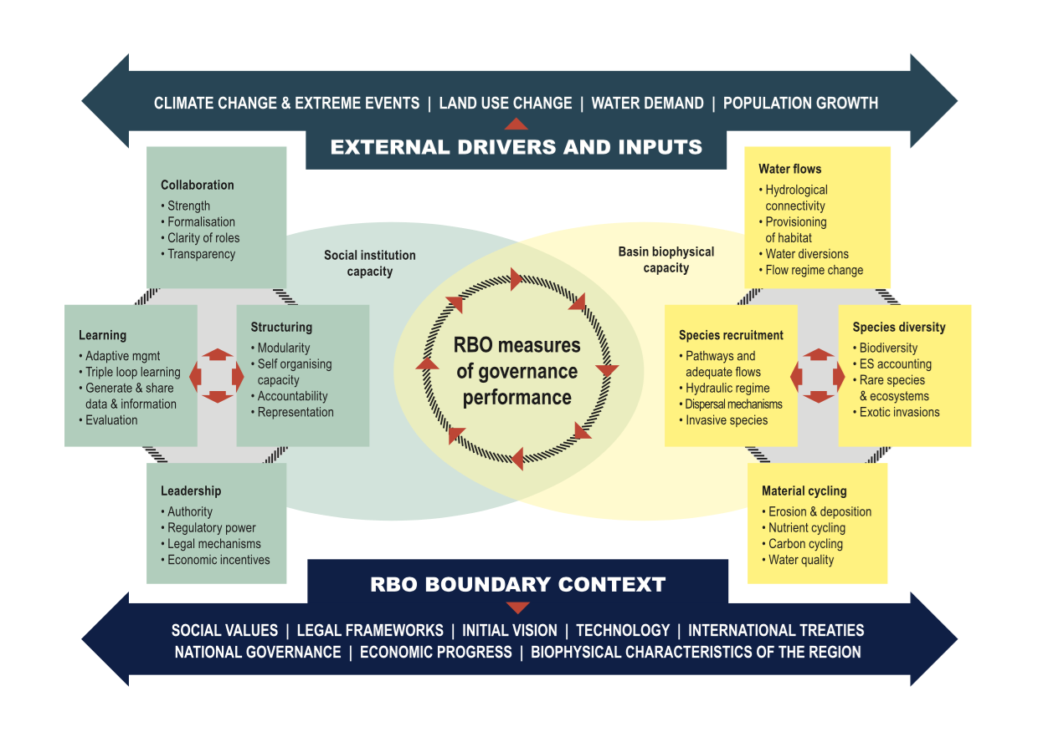

**Figure 1: A diagnostic framework for assessing the capacity of RBO in sustainable river governance**

*The social institutional capacity* includes the RBO and its agency, and the interactions with relevant stakeholder institutions. The institutional arrangements instigated by and surrounding the RBO, will to a large extent define its governance capacity. The indicators, which are adapted from organisational behaviour theory [44] and social networks [45] are **collaboration**, **structuring,** **learning** and **leadership**. **Collaboration** refers to the degree of connectivity of all relevant stakeholders and their capacity to participate in governance processes. Social learning dimensions and governance of integrated river basin management stress the importance of a participatory approach for inclusion of major stakeholders [15, 18, 19, 46, 47, 48]. Collaborative governance has been proposed as way forward to achieve this aim [6, 7], consisting of consensus building [49] and integrative learning [14]. *Strength*, *Formalisation*, *Clarity of roles* and *Transparency* are attributes of this indicator. **Structuring** refers to the institutional design of the RBO and stakeholder groups, noting that both formal and informal structures do exist. The attributes *Modularity* and *Self-organising capacity* refer to a deliberate attempt to create some redundancy in the governance structure, to ensure flexibility in times of rapid change [41]. *Accountability* and *Representation* are attributes of co-management [20], which is important to match spatial scales at the social and biophysical level. **Learning** is defined as those processes that improve knowledge for management of institutional and biophysical capacity; they include processes captured in the attributes *Adaptive management*, *Triple loop learning*, *Generate and share data & information*, and *Evaluation*. **Leadership** is directly related to decision-making and the capacity to steer governance in the intended direction, and includes attributes of *Authority*, *Regulatory power*, *Legal mechanisms*, and *Economic incentives*.

The *basin biophysical capacity* represents water and its ecosystem services delivered naturally or through human actions. The biophysical system consists of three nested spatial scales: local or reach (micro), catchment (meso) and basin (macro) scale. The hierarchy framework [14] emphasises that higher spatial levels constrain lower levels, but are influenced by emerging properties from lower levels. The generic biophysical indicators are defined based on ecosystem structure, function and services [4, 35, 36, 37, 38, 50] as **water flows**, **species diversity**, **species recruitment**, and **material cycling**. **Water flows** refers to longitudinal, lateral and vertical hydraulics and hydrology, and include the attributes *Hydrological connectivity*, *Provisioning of habitat*, *Water diversions/allocations*, and *Flow regime change*. **Species diversity** refers to the natural richness of freshwater ecosystems, including attributes for *Biodiversity*, *Ecosystem services[1]*, *Exotic invasions* (exerting a negative influence) and *Rare species/ecosystems* (biodiversity hotspots deserving special protection). **Species recruitment** differs from diversity in ensuring continuity through recruitment and dispersal (gene pool mixing). The attributes are *Pathways and adequate flows* (requirements), *hydraulic regime* (requirements), *Dispersal mechanisms*, and *Invasive species* (extent). **Material cycling** relates to the physical processes that enable and constrain ecology, defined here as consisting of attributes *Erosion and deposition*, *Nutrient cycling*, *Carbon cycling*, and *Water quality.*

There is a certain similarity between indicators in both domains, based on inherent properties of a complex system. **Water flows** has a parallel in **collaboration**; connectivity and distribution is key. **Species diversity** and **structuring** both refer to assemblage of elements of the system (species and stakeholders respectively). **Recruitment** and **learning** are both about renewal and continuation of the system. **Leadership** and **material cycling** are at once boundaries and driving forces to stimulate direction and progress in either a social or a physical domain.

When undertaking a diagnosis with this proposed framework, several steps should be taken, through consultation with scientists, policy makers and key stakeholders (Figure 2):

a) *Define and interpret context specific social institutional attributes* under the indicator classes **collaboration, learning, structuring** and **leadership**, and *biophysical attributes* under the indicator classes **water flows, material cycling, species diversity** and **recruitment**. This needs to be done at nested spatial scales (macro, meso and local scales) in a hierarchical structure. The extent to which the capacity of the biophysical system can be determined will depend on how well the attributes can be described, mapped, catalogued, classified and quantified. The number of attributes can be extended or expanded into multiple hierarchies, depending on the specifics of the governance model, and can include ecosystem services that water users are relying on for social and economic purposes (including livelihoods).

b) *Determine a* ***capacity*** ***score*** for each of the eight indicators, using ratings on a Likert scale, as provided in Table 1 below. A more comprehensive rubric describing the specific categories for each key indicator can be developed. Capacity is the current state or condition that exists for each of the indicators. An evidence based approach using multiple lines of evidence to determine biophysical condition will be a key element of the process [37]. Connect the indicator scores to obtain a profile (blue diagonals in Figure 2).

Table 1: criteria for scoring the indicators for the proposed diagnostic framework

**

c) *Determine a* ***measure of performance score*** for each of the eight system indicators to indicate an aspirational target, based on the priority management and governance issues to be addressed as part of the core sustainable management objectives, using the same scoring scale (orange diagonals in Figure 2).

d)***Prioritize management*** *effort*, based on comparing the relative distances observed in the capacity profiles between current capacity and target scores. This prioritisation is used for setting medium to long-term objectives. It is important to arrive at a consensus view which may be open ended, meaning that there is agreement to work on the commonly agreed indicators first without closing off options to consider other, perhaps more contentious ones at a future point in time as part of the adaptive learning cycle. In the example below, learning scores for current and target are converging, as is the case for species recruitment. In contrast, leadership and structuring show a large distance between current and target, suggesting that this requires prioritisation. In the biophysical profile, species diversity shows the largest distance, followed by water flows. These indicators need to be prioritised.

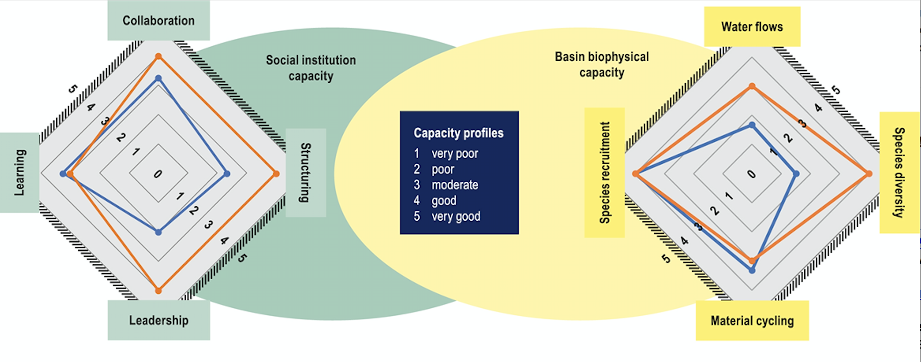

Figure 2: Illustrative example of how the proposed framework is used to assess the governance performance of RBOs. Capacity profiles for social institutional capacity (left) and basin biophysical capacity (right), with blue diagonals indicating current status of capacity and orange diagonals indicating objectives.

e) ***Trajectory analysis*** can be done in two ways. Firstly, a historical analysis can be undertaken to track the ratio of socio-institutional capacity versus biophysical capacity over time. Generally, this analysis evolves around major reform decision points and scores are allocated based on expert advice and qualitative published and grey literature. It is done in addition to the diagnostic profile (Figure 2), to obtain a more comprehensive baseline by validating and explaining the profile scores. An example of such trajectory is provided in the next section (Figure 3). Secondly, as a tool for future tracking of trajectory towards target scores, through regular evaluations, using the first (baseline) and successive diagnostic profiles and graphed similar to the historical trajectory curve. The scoring aggregation process should use the priority weightings derived from the diagnostic profile, to account for observed and expected non-linear changes resulting from feedback loops in successive evaluations. Rubrics which describe each of the scores are an important part of standardising the procedure over time.

## A trajectory example: the Murray-Darling Basin, Australia.

The Murray-Darling Basin is a significant basin in Australia, made up of the catchment areas of the Murray and Darling Rivers and their many tributaries, spanning 1 million km2, and comprising five state territories, each of which are responsible for water allocation, planning and implementation under Australia’s federal system of government.

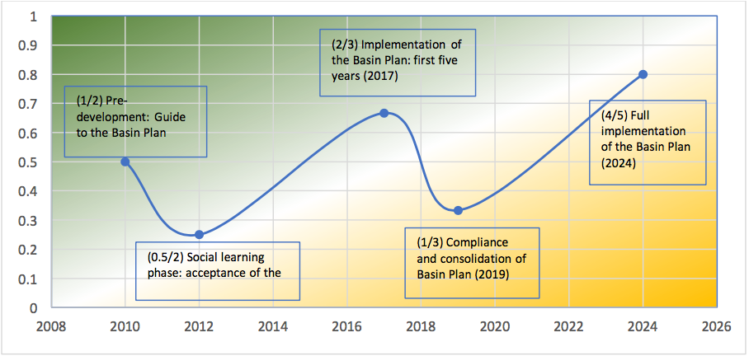

Figure 3: Development trajectory of the Murray-Darling Basin Plan, since pre-development in 2010 until 2017 (first five years of Basin Plan implementation). Full implementation is expected in 2024, when all state water management plans should align with the basin-wide water recovery and environmental watering strategy; the trajectory line from 2018 onwards is predictive.

The governance structure of the Murray-Darling Basin Authority carries a legacy of its predecessor the Murray-Darling Basin Commission and is hence a combination of hierarchical and collaborative decision-making; its successes are unclear in terms of achieving environmental watering (biophysical) or stakeholder engagement (institutional) and their co-evolutionary dynamics; this results in parallel efforts on both fronts that are poorly integrated and often confuse key stakeholders due to the lack of a clear narrative.

Figure 3 depicts a plausible trajectory analysis of the Murray Darling Basin since the conception of the Murray-Darling Basin Plan, legislated in 2012 [51] under federal powers instigated by the Water Act (2007) [52]. It maps the ratio of institutional over biophysical integrated score against time, listing scores and descriptors of the key events. In the lead up to it, the Guide for the Basin Plan (2010) [53] was prepared as a high level technical document prior to release to the basin stakeholders (pre-development phase). Based on the negative social-institutional response (some rural communities felt they were not properly consulted) the allocated score was 1 for institutional and 2 for biophysical capacity). An initial *decrease* in institutional capacity resulted in a key system change. At the signing of the Basin Plan social-institutional capacity was perceived to be at an all-time low (0.5 score) and the need for change was recognised. This was followed by a long period of gaining credibility (social learning phase), which coincided with the implementation of the Basin Plan as agreed by the state jurisdictions, resulting in an institutional score of 2 and a biophysical score of 3 at the 2017 interim evaluation of the Basin Plan. The key discourse evolves around the recovery of environmental water and efficient use of environmental flows to obtain environmental benefits, including upstream/downstream dependencies. The Basin-wide Watering Strategy sets out quantified ecological objectives to be obtained to maintain and improve the condition of vegetation, fish and birds in a given timeframe. State watering plans are integrated into this strategy, and environmental flow delivery is evaluated on yearly and five-yearly cycles, for which a trajectory analysis could be used. The first five-yearly evaluation now coincides with issues of lack of compliance, adequate regulation of water allocations, and lack of progress with State water resource plans by 2019, resulting in a decrease again of social-institutional capacity (score = 1). These issues will need to be resolved to restore community confidence in the effectiveness of the Basin Plan, and to revert to an upward trajectory (expected predictive socio-institutional score of 4, biophysical score of 5).

## Discussion and conclusions

In this paper, we propose a diagnostic functional framework that addresses the complexity of defining and attributing measures of performance in a river basin (Figure 1). This tool is designed for RBOs to use to maintain a steering course and correct for biophysical and institutional responses to management strategies. Figure 2 visualises indicator profiles for governance and biophysical outcomes, and Figure 3 a trajectory graph which aggregates capacity in both domains over time. Our approach recognises some inherent competitive tensions between functional indicators, such as between leadership and collaboration, which subsequently require balance and calibration. Sometimes, there will be a need for adaptability and flexibility, requiring disruption of existing practices, when the system is in an exploratory phase or readjustment of governance structure or policy direction occurs [40**, 41]. In Figure 3, this coincides with the trajectory change during the social learning phase and the compliance and consolidation phase. At other times stability, clarity and efficiency require long-term management plans based on quantitative modelling and validation. Rather than being rigid, the proposed framework is dynamic and allows revisiting initial planning and modelling, acts as a compass to keep steering governance and sustainable management to its intended course, adapting effort based on both biophysical and socio-economic feedback loops. This is informed by regular evaluations, the initial diagnostics, and the historical trajectory up to that point.

In summary, the proposed framework has the following potential advantages:

1. It distinguishes between those governance and management issues over which it has control in contrast with those that are part of its context and external drivers, thus making explicit the function, role and responsibility of the RBO in a context specific setting.
2. The four social-institutional indicators and the four biophysical indicators can be used to define capacity and measures of performance of a RBO. Making indicators relevant is done through the use of sub-indicators that are tailored to the basin context by agreement between stakeholders.
3. The distance between capacity and measure of performance in the diagnostics profile allows for the prioritisation of management strategies, and to track progress through regular evaluations. Progress can be mapped as trajectory analyses, illustrated for the Murray-Darling Basin Authority.
4. The method accommodates the combination of different sources of data and evidence, used in the categorical scoring. Both qualitative and quantitative information can be used, in a simple 5 scale scoring system.

The diagnostic framework represents the first attempt to strengthen the position and effectiveness of an RBO in dealing with complex basin systems. The next step will be to test the framework in a number of case studies around the world to ascertain its validity. Social network analysis [45, 54], organisational behaviour analysis [42], systems thinking [26] and program theory [55] will be explored to understand the underlying dynamics and develop methods for implementing and using the framework, in collaboration with decision makers, river basin organisation staff and relevant stakeholders.

## Acknowledgements:

This research is partly supported by an ARC Future Fellowship project (FT130100247). It is also made possible by an APA Scholarship and Global Change Scholarship awarded to the principal author of the paper.

## References

[1] Jaspers F, Gupta J: **Global water governance and river basin organisations.** In *The politics of River Basin Organisations*, edited by Huitema and Meijerinck. Edwards Elgar Publishing Ltd, 2004: 38-66.

[2] Molle F, Wester P: **River Basin Trajectories: an inquiry into Changing Waterscapes.** In *River Basin Trajectories: Societies, Environments and Development*, edited by Molle F, Wester P, International Water Management Institute 2009: 1-19.

[3] Alexandra J: **Risks, Uncertainty and Climate Confusion in the Murray–Darling Basin Reforms.** *Water Economics and Policy* 2017, **3**:1-21.

[4] De Groot R, Brander L, VanderPloeg S, Costanza R, Bernard F, Braat L, Christie M, Crossman N, Ghermandi A, Hein L, et al.: **Global estimates of the value of ecosystems and their services in monetary units.** *Ecosystem Services,* 2012, **1**: 50-61.

[5] Pahl-Wostl C: **A conceptual framework for analysing adaptive capacity and multi-level learning processes in resource governance regimes.** *Global Environmental Change* 2009, **19**:354–365.

[6] Ansell C, Gash A: **Collaborative Governance in Theory and Practice.** *Journal of Public Administration Research and Theory*, 2008, **18**:543-571.

[7] Benson D, Jordan A, Smith L: **Is environmental management really more collaborative? A cooparative analysis of putative 'paradigm shifts' in Europe, Australia and the United States.** *Environment and Planning*, 2013, **45**:1695-1712.

[8] Ison R, Blackmore C, Iaquito BL: **Towards systemic and adaptive governance: Exploring the revealing and concealing aspects of contemporary social-learning.** *Ecological Economics*, 2013, **87**:34–42

[9] Gual M, Norgaard RB: **Bridging ecological and social systems coevolution: a review and proposal.** *Ecological Economics*, 2010, **69**:707-717.

[10] Folke C, Hahn T, Olsson P, Norberg J: **Adaptive governance of Social-Ecological Systems.** *Annual Review of Environmental Resources*, 2005, **30**:441-473.

[11] Hooper B: **Covenant action to facilitate integrated river basin management.** *Water SA* 2008, **34**:456-460.

[12] Chesson J: **Sustainable development: connecting practice with theory.** *Journal of Environmental Assessment Policy and Management*, 2013, **15**:1-27.

[13] Hearne D: **The power of social contracts in strengthening institutions.** *The Source Magazine*, International Water Association, 2017, URL: <http://www.thesourcemagazine.org/power-social-contracts-stren...9&utm_medium=email&utm_term=0_b7ed475f49-d723eb4d51-161345485>

[14]** McLoughlin C, Thoms M: **Integrative learning for practicing adaptive resource management.** *Ecology and Society*, 2015, **20**:1-34.

The authors develop a Strategic Adaptive Management Reflexive Learning Network: integrative triple loop learning (Pahl-Wostl 2009), linked to incremental experimental learning, which needs to occur within the bounds of the ecological Hierarchy Theory (higher spatial levels constrain lower levels, but are influenced by their emerging properties) (Ahl and Allen 1996; Parsons and Thoms 2007) and the Panarchy theory (complex adaptive cycles consisting of the four cycles of exploitation, conservation, release and reorganisation) (Holling 2001; Gunderson & Holling 2002).

[15] Molle F: **Water, politics, and river basin governance: Repoliticising approaches to river basin management.** In *Nirvana concepts, narratives and policy models: Insights from the water sector, Water Alternatives,* Edited by Molle F,2008, **1**:1-8.

[16] Bos JJ, Brown RR: **Assessing organisational capacity for transition policy programs.** *Technological Forecasting & Social Change*, 2014, **86**:188-206.

[17] Ostrom E: **A general framework for analyzing sustainability of social-ecological systems.** *Science*, 2009, **325**:419-422.

[18] Huitema D, Meijerinck S (Eds): *The politics of River Basin Organisations*, Edwards Elgar Publishing Ltd; 2014.

[19] Ostrom E: **Background on the Institutional Analysis and Development Framework**. *Policy Studies Journal*, 2011, **39**:7-27.

[20] Huitema D, Mostert E, Egas W, Moellenkamp S, Pahl-Wostl C, Yalcin R: **Adaptive water governance: assessing the institutional prescriptions of adaptive (co-) management from a governance perspective and defining a research agenda.** *Ecology and Society* 2009, **14**. URL: http://www. ecologyandsociety.org/vol14/iss1/art26/

[21] Global Water Partnership 2009, *A handbook for integrated water resources management in Basins*, Elanders, Sweden.

[22] Biswas AK: **Integrated Water Resources Assessment: A Reassessment.** *Water International*, 2004, **29:**248-256.

[23] Pahl-Wostl C, Tabara D, Bouwen R, Craps M, Dewulf A, Mostert E, Ridder D, Taillieu T: **The importance of social learning and culture for sustainable water management.** *Ecological Economics*, 2008, **64**:484-495.

[24] Rogers P, Hall AW: **Effective Water Governance.** *TEC Background Papers No.7, Global Water Partnership,* 2003. URL: <http://www.gwpforum.org/gwp/library/TEC%207.pdf>

[25] Jackobson M, Meyer F, Oia I, Reddy P, Tropp H (Eds): *User’s Guide on Assessing Water Governance.**UNDP Water Governance Facility*, 2013, Stockholm, Sweden.

[26] Colvin J, Blackmore C, Chimbuya S, Collins K, Dent M, Goss J, Ison R, Roggero PP, Seddaiu G: **In search of systemic innovation for sustainable development: a design praxis emerging from a decade of social learning inquiry.** *Research Policy*, 2014, **43**:760-771.

[27] Cash DW, Adger W, Berkes F, Garden, P, Lebel L, Olsson P, Pritchard L, Young O: **Scale and cross-scale dynamics: governance and information in a multilevel world.** *Ecology and Society*,2016, URL: <http://www.ecologyandsociety.org/vol11/iss2/art8/>

[28]** Marshall GR, Alexandra J: **Institutional Path Dependence and Environmental Water Recovery in Australia’s Murray-Darling Basin.** *Water Alternatives*, 2016, **9**:679-703.

The paper explores institutional path dependence as a constraining factor with regard to future management choices for solving water recovery, using the Murray-Darling Basin as a case study. It explores concepts of polycentricity, iron triangles policy entrepreneurship, mental models of institutional players and formative moments.

[29] Lankford BA, Tumbo S, Rabaju K: **Water competition, variability and river basin governance: A critical analysis of the Great Ruaha River, Tanzania.** In: *River basin trajectories: Societies, environments and development*. Chapter 8, Edited by Molle F, Wester P, International Water Management Institute 2009:171-195.

[30] De Stefano L: **International initiatives for water policy assessment: a review.** *Water Resources Management,* 2010. doi:10.1007/s11269-009-9562-7.

[31] Hooper BP: *Key Performance Indicators of River Basin Organizations*. Alexandria, Virginia, US Army Corps of Engineers. Visiting Scholar Program 2006.

[32] Pahl-Wostl C, Holtz G, Kastens B, Knieper C: **Analyzing complex water governance regimes: The Management and Transition Framework.** *Environmental Science and Policy*, 2010, **13**:571-581.

[33] Norgaard RB, Kallis G Kiparsky M: **Collectively engaging complex socio-ecological systems: re-envisioning science, governance and the California Delta.** *Environmental Science and Policy*, 2009,**12**:644-652.

[34] Costanza R: **Ecosystem services in theory and practice.** In: *Valuing Nature: Protected Areas and Ecosystem Services*, edited by Figgis P, Mackey B, Fitzsimons J, Irving J, Clark P, Australian Committee for IUCN: 2015

[35] Costanza R, De Groot R, Sutton P, van der Ploeg S, Anderson S, Kubiszewski I, Farber S, Turner RK: **Changes in the global value of ecosystem services.** *Global Environmental Change*, 2014, **26**:152-158.

[36] Lindenmayer DB, Gibbons P, Bourke M, Burgman M, Dickman CR, Simon Ferrier S, Fitzsimons J, Freudenberger D, Garnett ST, Groves C, et al.: **Improving biodiversity monitoring.** *Austral Ecology,* 2012, **37**:285–294.

[37] Nicholls SJ, Peat M, Webb A: **Challenges for evidence-based environmental management: what is acceptable and sufficient evidence of causation?** *Freshwater Science*, 2016, 36:000–000. ©

[38]** Turak E, Harrison I, Dudgeon D, Abell R, Bush A, Darwall W, Finlayson CM, Ferrier S, Freyhof J, Hermoso V, et al.: **Essential Biodiversity Variables for measuring change in global freshwater biodiversity.** *Biological Conservation*, 2016. URL: <http://dx.doi.org/10.1016/j.biocon.2016.09.005>

Biodiversity is a complex ecological concept and difficult to capture in meaningful measurable variables. The authors propose 6 broad classes to measure biodiversity: genetic composition, species populations, species traits, community composition (alpha, beta and gamma diversity), ecosystem structure and ecosystem function. By pointing to the capacity for global modeling of the regional state of freshwater biodiversity the paper significantly advances our capacity for filling ecological knowledge gaps.

[39] Costanza R, d’Arge R, De Groot R, Farber S, Grasso M, Hannon B, Limburg K, Naeem S, O’Neill R V, Paruel J, et al.: **The value of the world’s ecosystem service and natural capital.** *Nature*, 1997,**387**:253-260.

[40]** Hearnshaw EJS, Cullen R, Hughey KFD: **Ecosystem Health Demystified. An ecological concept determined by ecological means.** *Proceedings of the 2nd national workshop of the ANU's Economics and Environment Network, 2005*, URL: <http://een.anu.edu.au/e05prpap/hearnshaw.doc>.

The authors describe freshwater ecosystems as complex adaptive systems and debunk the notion of ecosystem stability. They explore concepts of system theory, self-organisation, emergence, chaos and complexity and identify four stages of adaptation and their associated characteristics: exploitation, conservation, release and re-organisation, and their relation to resilience and connectedness. This paper is highly relevant with regard to human exploitation of freshwater resources.

[41] Duit A, Galaz V: **Governance and Complexity—Emerging Issues for Governance Theory.** *Governance: An International Journal of Policy, Administration, and Institutions*, 2008, **21**:311–335).

[42] Ison R: *Exploring systemic governance as coevolution*, presentation at University of Queensland; 2017.

[43]URL: <https://www.sei-international.org/-news-archive/3186>, 2017.

[44] Bowditch JL, Buono AF, Stewart MM: *A primer on Organisational Behaviour*, John Wiley & Sons Inc. 2008.

[45] Bruggeman J: *Social Networks*, Routledge, 2008.

[46] Dryzek J, Ayirtman S, Niemeyer S, Kanra B, Mendonca R, Marshall P, Kelly K, Lovell M: **Deliberative Democracy**. *Encyclopedia of political theory*, 2010, Sage Publications, Inc.

[47] Wald N: **Anarchist Participatory Development: A Possible New Framework?** *Development and Change*, 2015, **46**:618–643.

[48] Pittock J: **Lessons for climate change adaptation from better management of rivers.** *Climate and development*, 2009, **1**:194-211

[49] Innes JE, Booher DE: **Consensus Building and Complex Adaptive Systems.** *Journal of the American Planning Association*, 1999, **65**:412-423.

[50] Davies PE, Stewardson MJ, Hillman TJ, Roberts JR, Thoms MC: *Sustainable Rivers Audit 2: The ecological health of rivers in the Murray-Darling Basin at the end of the Millennium Drought (2008-2010)*, Murray-Darling Basin Authority, **72/12**; 2012.

[51] Commonwealth of Australia: *Water Act 2007 Basin Plan, 2012*. Extracted from the Federal Register of Legislative Instruments on 28 November 2012. F2012L02240.

[52] Commonwealth of Australia: *Water Act 2007* Canberra:2009. URL: https://www.legislation.gov.au/Details/C2010C00230

[53] MDBA: *Guide to the Proposed Basin Plan: overview. Volume 1*, Murray-Darling Basin Authority: 2010.

[54] Lazega E, Snijders TAB (Eds) *Multilevel Network Analysis for the Social Sciences. Theory, Methods and Applications*, Springer, 2016.

[55] Leeuw FL: **Reconstructing Program Theories: methods available and problems to be solved.** *American Journal of Evaluation*, 2003, **24**:5-20.

1. Ecosystem services and biodiversity are conceptually debated. Some scholars define biodiversity as the capital generating ecosystem services, others consider biodiversity a service in its own right [34]. In its broadest definition, it includes supporting, regulating, provisioning and cultural services [4], captured in all four indicators. As an attribute, we refer here to those services derived from plant and animal species that provide a benefit for humans.