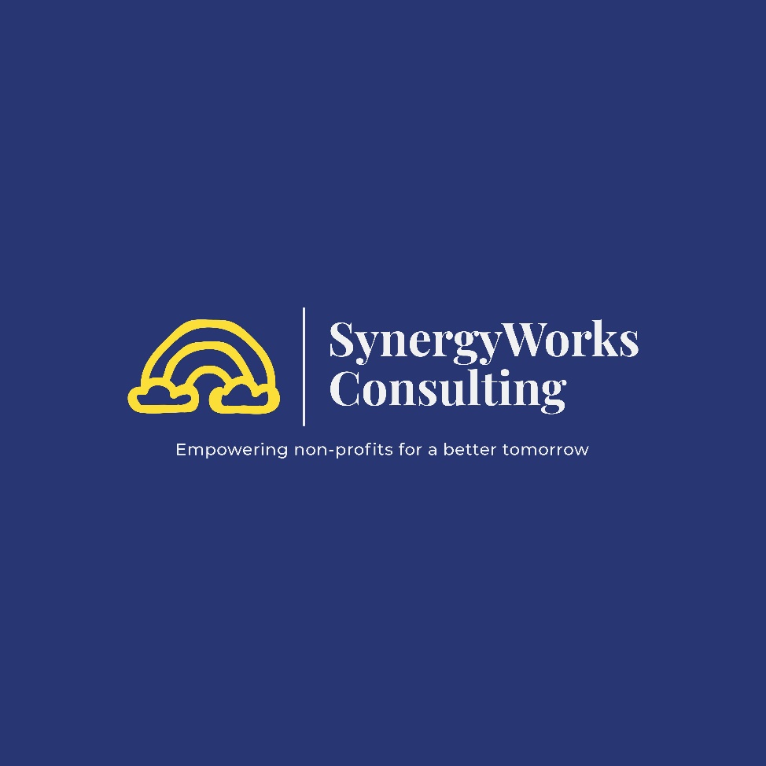

# **Submission**

Australian Productivity Commission Inquiry into Philanthropy – April 2023

**Table of Contents**

**Submission** 1

Acknowledgement of Country 3

Executive Summary 3

About SynergyWorks Consulting 3

List of recommendations 4

Rationale for recommendations 5

Apply in both legislation and policy, a broader definition of philanthropy in Australia 5

Amend the Australian Charities and Not-for-profits Commission (ACNC) Act 2012 to strengthen taxation incentives to facilitate collaboration among philanthropists 6

Enable taxation incentives for specific social enterprises as philanthropic that operate with a social or environmental purpose that aligns with national interests. 7

Recognise different definitions, perspectives, and norms relating to philanthropy among culturally and linguistically diverse (CALD) communities. 7

Establish a social impact investment market to attract private investment capital for social and environmental initiatives 9

Develop a standardised approach to impact evaluation and comparison across charities in Australia 10

Increase funding for smaller non-profit organisations (NFPs), simplify application processes, and provide training and support to help them secure philanthropic support. 11

Conclusion 13

Acknowledgement of Country

We acknowledge the traditional custodians of the lands on which we work, and we pay our respects to the Elders, past, present, and future, for they hold the memories, cultural and dreams of the Aboriginal and Torres Strait Islander peoples.

We recognise and respect their cultural heritage, beliefs, and continual relationship with the land, and we recognise the importance of young people, who are the future leaders.

Executive Summary

SynergyWorks Consulting (SynergyWorks) is pleased to submit recommendations to the Productivity Commission (the Commission) to identify and overcome obstacles hindering philanthropic giving in Australia. Philanthropic giving is crucial in supporting vulnerable Australians, building social capital, and strengthening communities. Our submission highlights the important role that philanthropic giving plays in promoting social and environmental goals.

Our submission provides a list of recommendations that align with the Commission's terms of reference to address barriers to giving and harness opportunities for growth. These recommendations aim to create a more enabling environment for philanthropy in Australia, promoting collaboration, innovation, and impact.

We hope our submission assists the Commission in identifying and addressing obstacles to increasing philanthropic giving in Australia. We would welcome any opportunity to participate further and engage with the Commission to advance philanthropy in Australia.

The submission includes detailed explanations for each recommendation, providing further elaboration on each suggestion.

# About SynergyWorks Consulting

SynergyWorks is a professional services provider that offers tailored solutions to not-for-profit, charities, and community organisations across Australia. With extensive experience in the field, they offer services such as fundraising and marketing advice, strategic planning, research projects, grant applications, and program implementation.

The motivation behind our submission to the Productivity Commission is recognising the financial stress that the non-profit sector is facing due to the economic downturn triggered by the COVID-19 pandemic.

Charities are experiencing a drop in the value of charitable donations at a time when they are needed most.

In April 2020, 47% of 366 surveyed charities reported a substantial drop in donation fundraising income. Analysis during the pandemic estimated that total giving would fall around 7.1% in 2020 and by a further 12% in 2021.

List of recommendations

**Policy**

1. Apply in both legislation and policy, a broader definition of philanthropy in Australia that includes collaborative philanthropy and specific social enterprises aligned with national interests.

**Taxation incentives**

2. Amend the Australian Charities and Not-for-profits Commission (ACNC) Act 2012 to better facilitate collaboration among philanthropists to achieve greater impact and effectiveness in addressing social and environmental issues. This will encourage philanthropists to work together towards common goals and improve resource allocation, resulting in more impactful philanthropic efforts.

**Philanthropy for social enterprises**

3. Enable taxation incentives for specific social enterprises as philanthropic that operate with a social or environmental purpose that aligns with national interests. This will incentivise private investment capital for social and environmental initiatives and create a more enabling environment for social enterprises.

**Engagement**

4. Recognise different definitions, perspectives, and norms relating to philanthropy among culturally and linguistically diverse (CALD) communities. This will promote better engagement with these communities and their philanthropic efforts.

**Social Impact**

5. Establish a social impact investment market to attract private investment capital for social and environmental initiatives. This will encourage investment in impactful initiatives that can achieve both financial returns and social/environmental impact.

**Equity and empowerment**

6. Develop a standardised approach to impact evaluation and comparison across charities in Australia. This will improve accountability and transparency in the philanthropic sector, resulting in more equitable distribution of resources and better outcomes for beneficiaries.

**Funding for smaller NFPs**

7. Increase funding for smaller non-profit organisations (NFPs), simplify application processes, and provide training and support to help them secure philanthropic support. This will empower small NFPs to achieve greater impact and address social and environmental issues in their communities.

# Rationale for recommendations

**Apply in both legislation and policy, a broader definition of philanthropy**

It is suggested, a broader definition of philanthropic activities in Australia should apply, which should include collaboration among philanthropists to achieve greater impact and effectiveness in addressing social and environmental issues. In addition to traditional charitable organisations, specific social enterprises that operate with a social or environmental purpose that align to their social and environmental issues in the national interest should also be considered under the Australian definition.

Philanthropy in Australia is a significant contributor to the social and economic development of the country. According to the Australian Charities and Not-for-profits Commission (ACNC), there are over 56,000 registered charities in Australia, with a total income of over AUD 155 billion[1].

However, traditional philanthropy models that focus on individual or institutional donations are no longer sufficient to tackle the complex social and environmental challenges that Australia faces. Collaborative philanthropy, which involves multiple stakeholders working together towards a shared goal, and social enterprises, which use business strategies to achieve social and environmental outcomes, have emerged as effective models for addressing these challenges.

Several studies have shown the effectiveness of collaborative philanthropy and social enterprises in Australia. For example, a report by the Centre for Social Impact found that collaborative philanthropy has the potential to create more impact by leveraging diverse resources and expertise. Similarly, a study by the University of South Australia found that social enterprises have the potential to create sustainable social and economic benefits[2].

Moreover, the Australian Government has recognised the importance of these models and has taken steps to support them. The 2016 National Innovation and Science Agenda allocated AUD 20 million to establish a Social Impact Investing Taskforce, which aims to increase the use of social impact investing and social enterprises in Australia[3]. Additionally, the 2021 Victorian Social Enterprise Strategy identified social enterprises as a key contributor to the economy and society and provided funding to support their growth. The Victorian social enterprise sector is recognised as the largest and most dynamic in Australia. There are currently more than 3,500 social enterprises trading across metropolitan and regional Victoria employing an estimated 60,000 people and contributing $5.2 billion to the Victorian economy each year[4].

However, there are still challenges in fully realising the potential of collaborative philanthropy and social enterprises in Australia. One of the key challenges is the lack of a comprehensive definition and regulatory framework that recognises and supports these models. The current definition of philanthropy in Australia is limited to donations from individuals and institutions and does not include collaborative philanthropy or social enterprises.

Therefore, it is important for the Commission to apply a broader definition of philanthropy that includes collaborative philanthropy and specific social enterprises aligned with national interests. This will provide clarity and consistency in regulatory and policy frameworks and ensure that these models receive the necessary support and recognition to create maximum impact. By applying a broader definition of philanthropy, the Commission can support the growth and effectiveness of these models and help to address the complex challenges facing the country.

**Amend the Australian Charities and Not-for-profits Commission (ACNC) Act 2012 to strengthen taxation incentives to facilitate collaboration among philanthropists**

As we look to address the pressing social and environmental challenges facing our world today, philanthropy can play a critical role in driving impactful and sustainable change. However, philanthropists in Australia are facing significant barriers to effective collaboration, limiting their ability to achieve the desired impact.

The COVID-19 pandemic has highlighted the need for collective action and collaboration in addressing these challenges, with 86% of philanthropic foundations in Australia acknowledging the importance of collaboration[5]. However, current taxation policies and regulatory frameworks are hindering this collaboration and hampering the potential for philanthropy to drive meaningful change.

A review of the Australian Charities and Not-for-profits Commission Act 2012 in 2020 found that the current tax incentives for philanthropy in Australia are complex and restrictive, limiting the ability of charities and not-for-profit organisations to collaborate effectively. Furthermore, research by the Centre for Social Impact has highlighted the urgent need for changes to the ACNC Act 2012 to provide more flexible and streamlined tax incentives for philanthropy collaboration[6].

As decision makers, we cannot ignore the urgent need for these changes. The time for action is now, to remove the barriers that are preventing philanthropists in Australia from working together towards common goals, improving resource allocation and driving greater impact in addressing social and environmental issues.

Philanthropy Australia's 2021 Budget Submission has called for amendments to the ACNC Act 2012 to provide greater tax incentives for philanthropy collaboration. This proposal must be reconsidered to unlock the full potential of philanthropy in Australia[7].

**Enable taxation incentives for specific social enterprises as philanthropic that operate with a social or environmental purpose that aligns with national interests.**

Private investment capital has significant potential for driving social and environmental impact, with the impact investing market growing to over USD 500 billion in 2019 according to a report by the Global Impact Investing Network (GIIN)[8]. Enabling taxation incentives for philanthropic investment in social enterprises would encourage more private investment towards social and environmental initiatives, which are aligned with national interests.

This would lead to increased funding for social enterprises, enabling them to scale up and achieve greater impact. Social enterprises often face challenges in accessing funding and resources due to their unique business model. Offering taxation incentives for philanthropic investment in social enterprises would create an enabling environment for these organisations, allowing them to operate more effectively and achieve greater impact. The UK's Social Investment Tax Relief (SITR) scheme has enabled over £50 million of investment in social enterprises since its introduction in 2014, demonstrating the potential impact of such incentives[9].

Enabling taxation incentives for specific social enterprises as philanthropic organisations would also align Australia with global trends and best practices. According to the GIIN, 44% of impact investors in 2019 were investing through philanthropic organisations. Examples from other countries include the US New Markets Tax Credit and the Canadian Community Investment Tax Credit, both of which offer taxation incentives for investment in social enterprises[10].

By enabling taxation incentives for specific social enterprises as philanthropic organisations, Australia can harness the potential of private investment capital for social and environmental impact, create a more enabling environment for social enterprises, and align with global trends and best practices.

**Recognise different definitions, perspectives, and norms relating to philanthropy among culturally and linguistically diverse (CALD) communities.**

To recognise different definitions, perspectives, and norms relating to philanthropy among CALD communities in Australia, there are several initiatives that have been undertaken by first world nations, such as:

Promoting diversity and inclusion in philanthropy

Many first world nations have recognised the importance of diversity and inclusion in philanthropy and have undertaken initiatives to promote it. For example, in the UK, the Diversity, Equity and Inclusion (DEI) initiative was launched in 2020 to support philanthropic organisations to develop more diverse and inclusive practices.

Developing culturally relevant philanthropic practices

To recognise and respect the diverse cultural and linguistic backgrounds of CALD communities, some first world nations have developed culturally relevant philanthropic practices. For example, in the US, the Native Americans in Philanthropy (NAP) initiative was launched in 1989 to support philanthropy that is responsive to Native American cultures and traditions.

Leverage diaspora communities

Diaspora communities can act as bridges between CALD communities and mainstream philanthropy organisations. They can help to provide a better understanding of the cultural norms, beliefs, and values of different communities, and help to identify philanthropic priorities and approaches that are relevant to them. Diaspora communities can contribute to philanthropy in Australia through their own giving and community-based initiatives.

Many diaspora communities have a strong tradition of giving, and they may have specific cultural and religious practices around philanthropy that could be shared with broader Australian society. Diaspora communities can also leverage their transnational networks and connections to mobilise resources and support for philanthropic initiatives in Australia and their countries of origin.

Diaspora communities can play a leadership role in advocating for greater recognition and support for philanthropy among CALD communities in Australia. They can work with philanthropy organisations, government, and civil society to promote culturally sensitive and inclusive approaches to philanthropy that reflect the diversity of Australian society[11].

Engaging with CALD communities

To ensure that philanthropy is responsive to the needs and aspirations of CALD communities, some first world nations have engaged with these communities directly. For example, in Australia, the Giving Australia 2016 report identified the need for philanthropic organisations to engage with CALD communities to better understand their perspectives on philanthropy and to develop more effective philanthropic initiatives.

Building capacity within CALD communities

To support philanthropic initiatives within CALD communities, some first world nations have undertaken capacity-building initiatives. For example, in the UK, the Trust for London initiative was launched in 2019 to support grassroots organisations in developing their capacity to engage in philanthropy and to support social change initiatives within their communities[12].

These initiatives recognise the importance of diversity and inclusion in philanthropy and seek to develop more culturally relevant and responsive philanthropic practices. By engaging with CALD communities directly and building their capacity to engage in philanthropy, these initiatives support the development of more effective philanthropic initiatives that are responsive to the needs and aspirations of diverse communities.

**Establish a social impact investment market to attract private investment capital for social and environmental initiatives**

There is evidence from both Australia and overseas that establishing a social impact investment market can attract private investment capital for social and environmental initiatives.

According to a report by the Responsible Investment Association Australasia (RIAA) published in 2019, the impact investing market in Australia and New Zealand had grown to AUD 5.8 billion, representing a 74% increase from the previous year. The report also revealed that 97% of respondents surveyed reported that their impact investments had met or exceeded their expectations, indicating a positive financial return[13].

In addition, the report identified a significant increase in the number of impact investing products available in the market, including green bonds, social impact bonds, and community investment notes.

This growth in impact investing products has also been accompanied by a shift in the investment approach, with a greater focus on measuring and reporting on social and environmental outcomes alongside financial returns.

Furthermore, the report highlighted several successful impact investment initiatives in Australia, including the Impact Investment Group's Social Infrastructure Fund, which has invested in social infrastructure projects such as affordable housing and community facilities, and the Clean Energy Finance Corporation's investments in renewable energy projects[14].

There is also growing interest among Australian philanthropists in exploring social impact investing to achieve greater impact and effectiveness. The Australian Philanthropic Services Foundation has launched an impact investing program[15] to help philanthropists navigate the social impact investing landscape and identify high-impact investment opportunities. In addition, the Australian government has recognised the potential of social impact investing to address social and environmental issues and has taken steps to support the growth of the social impact investment market.

Overseas, there are also several examples of successful social impact investment initiatives. For instance, in the UK, Big Society Capital has been established as a social investment wholesaler, and since its launch in 2012, it has committed over £1.5 billion to the social investment market[16]. In the United States, the Social Impact Investment Taskforce was established in 2013 to promote social impact investment, and in 2019, the US government passed the Investing in Opportunities Act, which provides tax incentives for investment in designated Opportunity Zones.

The establishment of a social impact investment market can be of significant benefit as it can complement and substitute traditional philanthropic endeavours. Evidence from Australia and overseas demonstrates that social impact investing can attract private investment capital for social and environmental initiatives, with a focus on measuring and reporting on both financial and social outcomes.

**Develop a standardised approach to impact evaluation and comparison across charities in Australia**

In Australia, there is a growing need for donors to have access to accurate and reliable information about the impact of charities to make informed decisions about where to direct their funds. However, there is currently no standardised approach to impact evaluation or comparison across charities in Australia, making it difficult for donors to assess and compare charities based on evidence of effectiveness.

A report published by the Australian Charities and Not-for-profits Commission (ACNC) in 2018 found that 56% of donors believed that it was difficult to compare charities and assess their impact. Furthermore, 48% of donors expressed a desire for more information on the impact of charities, and 40% indicated that they would be more likely to donate if they had access to better information about the impact of charities.

In response to this need, some organisations in Australia have begun to provide impact evaluations and other forms of evidence of effectiveness to donors. For example, the Effective Altruism Foundation Australia (EAFA) provides research and recommendations on charities that are making the most effective use of donor funds[17]. Similarly, the Australian branch of the charity evaluator GiveWell provides evaluations of charities that are working to improve health and reduce poverty in developing countries.

Despite these efforts, there is still a lack of a centralised, standardised approach to impact evaluation and comparison across charities in Australia. This has led to calls for the development of an independent impact evaluation comparison site, similar to GiveWell and Charity Navigator in the United States, to help donors assess and compare charities based on evidence of effectiveness.

Moreover, a study by the Australian Council for International Development found that the lack of standardisation in impact measurement in the international development sector is a significant barrier to effective aid delivery. The study found that the lack of standardised measures made it difficult to compare the effectiveness of different aid programs and assess their impact[18].

The UK's Social Enterprise Mark provides an excellent example of how a standardised approach can increase transparency and accountability[19]. A study by the UK Cabinet Office found that the Social Enterprise Mark has helped to increase the number of social enterprises in the UK, leading to more jobs and a more sustainable economy[20]. The Social Enterprise Mark has provided donors with a clear signal of which organisations are operating with a social or environmental purpose and are transparent and accountable in their operations.

**Increase funding for smaller non-profit organisations (NFPs), simplify application processes, and provide training and support to help them secure philanthropic support.**

In the Australian context, there is a growing trend of wealthy individuals engaging in philanthropic activity, and while this can be beneficial for non-profits in terms of resources, it is often a fickle and unreliable source of funding. Non-profits must continuously seek out new donors and funders to sustain their operations, and if a major donor decides to withdraw their support, the non-profit can be left in a precarious financial situation.

The focus on philanthropy can also distract from the need to address systemic issues through public policy changes. Non-profits may spend a significant amount of time and resources courting wealthy donors and crafting grant proposals, rather than advocating for policy changes that could have a broader impact.

The power dynamics inherent in philanthropy are also a concern, as wealthy donors have significant influence over which causes and organisations receive funding, which can lead to a concentration of resources in certain areas and a neglect of other important issues. This can limit the diversity of organisations and causes that receive support and may not reflect the needs and priorities of the communities that non-profits serve[21].

Additionally, the lack of transparency and accountability in philanthropy, particularly with private foundations, can lead to a lack of oversight and potentially allow for misuse of funds or conflicts of interest.

In Australia, it is particularly challenging for small NFPs to obtain philanthropic support, with just 2% of organisations receiving 50% of all philanthropic income[22]. This trend is consistent with other first-world countries, such as the United States and Canada. These findings suggest that policy reform is needed to address the challenges facing small NFPs and promote a more equitable distribution of philanthropic support.

To ensure that small NFPs are not left behind, policymakers should consider measures such as increasing funding for smaller organisations, simplifying application processes, and providing training and support to help them secure philanthropic support. By promoting a more equitable distribution of philanthropic funding, policymakers can help small NFPs achieve their missions and contribute to the well-being of their communities.

Suggested reforms that could be considered by the inquiry are:

Increase transparency and accountability

Philanthropic organisations should be more transparent about their funding processes and decision-making criteria. They should also be accountable for the impact of their funding and ensure that it reaches the intended beneficiaries.

Create incentives for philanthropic organisations

Policymakers could offer incentives to philanthropic organisations to encourage them to support smaller NFPs. For example, tax breaks or other financial incentives could be offered to organisations that provide funding to a more diverse range of NFPs, including smaller and newer organisations.

Provide training and support

Small NFPs often lack the knowledge and resources to navigate the complex philanthropic funding landscape. Policymakers could provide training and support to help these organisations develop strong proposals and build relationships with potential funders.

Foster collaboration

Policymakers could encourage philanthropic organisations to collaborate with each other and with NFPs to pool resources and expertise. This could help smaller NFPs access funding and build capacity.

Promote diversity, equity, and inclusion: Philanthropic organisations should prioritise diversity, equity, and inclusion in their funding decisions to ensure that funding is distributed fairly and reaches underrepresented communities.

Conclusion

SynergyWorks Consulting's recommendations to the Productivity Commission highlight the importance of philanthropic giving in promoting social and environmental goals and supporting vulnerable Australians.

The recommendations aim to create a more enabling environment for philanthropy in Australia, promoting collaboration, innovation, and impact. The implementation of these recommendations can help to identify and address obstacles to increasing philanthropic giving in Australia, resulting in more equitable distribution of resources and better outcomes for beneficiaries.

1. Australian Charities and Not-for-profits Commission (ACNC), "Charities and giving in Australia 2020", https://www.acnc.gov.au/tools/research/charities-and-giving-australia-2020.
2. Centre for Social Impact, "Collaborative Philanthropy in Australia", https://www.csi.edu.au/wp-content/uploads/2016/10/2016-Collaborative-Philanthropy-Report-FINAL-20-10-2016.pdf.
3. Australian Government Department of Industry, Innovation and Science, "National Innovation and Science Agenda", https://www.industry.gov.au/sites/default/files/2018-03/national_innovation_and_science_agenda.pdf.
4. State Government of Victoria, "Victorian Social Enterprise Strategy”, https://www.vic.gov.au/system/files/documents/2021/09/Victorian-Social-Enterprise-Strategy.pdf.
5. Australian Communities Foundation "Philanthropy and COVID-19 in Australia" 2020
6. Centre for Social Impact conducted, “Unlocking Philanthropy's Potential: Barriers to Collaboration in Australia."
7. Philanthropy Australia's 2021 Budget Submission called for amendments to the ACNC Act 2012 to provide greater tax incentives for philanthropy collaboration. This can be found on the Philanthropy Australia website: https://www.philanthropy.org.au/tools-resources/submissions/2021-22-budget-submission/
8. https://thegiin.org/research/publication/impinv-survey-2020/
9. https://www.gov.uk/government/collections/social-investment-tax-relief
10. https://www.baystreet.ca/commodities/6323/Canada-Becomes-Global-Leader-In-Green-Tax-Credits
11. https://www.lmcf.org.au/getmedia/54892541-d9b2-40f6-81cf-ba85ea702eb9/LMCF_Diaspora_Report_ONLINE.pdf.aspx
12. https://tfl.ams3.cdn.digitaloceanspaces.com/media/documents/Citizenship_and_Integration_Initiative_interim_report_10.pdf
13. Responsible Investment Association Australasia (RIAA). (2019). 2019 RIAA Impact Investment Forum Investor Survey.
14. https://www.impactinvestmentfund.com.au/products
15. https://www.australianphilanthropicservices.com.au/givers/aps-foundation/
16. https://bigsocietycapital.com/about-us/
17. https://effectivealtruism.org.au/about-ea/
18. Australian Council for International Development. (2015). The impact measurement challenge in international development
19. https://www.marjon.ac.uk/about-marjon/social-enterprise-mark
20. Cabinet Office. (2015). Social enterprise market: Assessment report
21. Phillips, R. (2019). Why small charities need a helping hand. Pro Bono Australia.
22. Prime Minister's Community Business Partnership. (2017). Philanthropy and Philanthropic Foundations in Australia