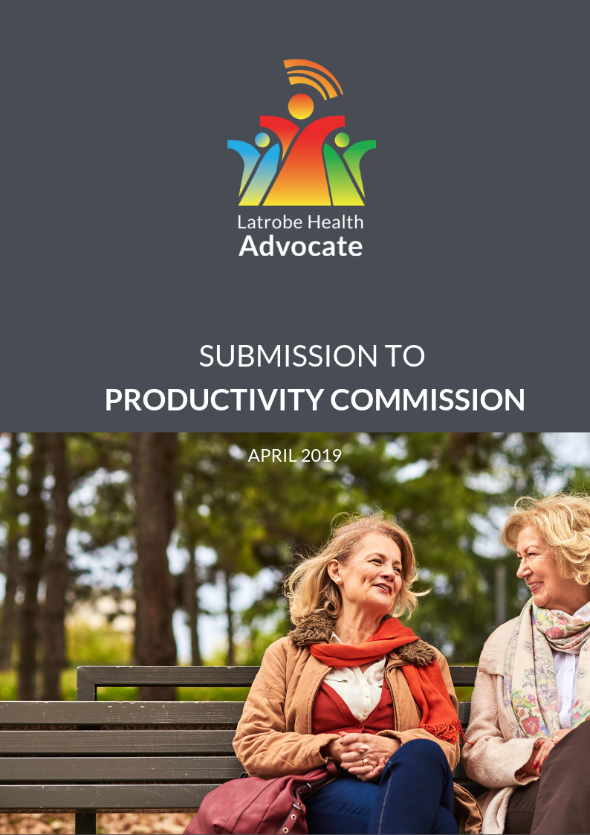



A note from the Latrobe Health Advocate.

TO:

Steven King, Presiding Commissioner  
Julie Abramson, Commissioner  
Harvey Whiteford, Associate Commissioner

I was appointed by the Victorian Minister for Health in May 2018, to offer independent advice on behalf of Latrobe communities to improve health and wellbeing service systems.

I am pleased to provide this submission to the Productivity Commission as it enquires into the effect of mental health on people’s ability to participate in and prosper in the community and workplace, and the effects it has more generally on our economy and productivity.

It is encouraging to see that this inquiry looks beyond the health sector, taking into account education, employment, social services, housing and justice as it considers the role that mental health plays in supporting people to participate in and prosper in their communities. Together with the Royal Commission into Mental Health in Victoria, it provides an opportunity to improve the mental health of individuals and the success of communities.

The Latrobe Health Innovation Zone was designated by the Victorian government to support communities in Latrobe to improve their health and wellbeing. It is a place where the community is being empowered to lead and influence change. Mental health has been the main issue that the community has raised with me, they have illustrated their understanding of the matters that impact on their mental health and are seeking to improve their circumstances and mental health.

Many of the health and social issues affecting people in Latrobe are documented from an international and national perspective. This submission goes some way to articulating, from the voice of communities how the issues manifest and how communities describe the problems they face in their own words.

I acknowledge the people who have contributed to this submission through putting forward ideas on how services can be delivered differently.

I look forward to presenting the voices of Latrobe communities to the Productivity Commission and invite you to Latrobe to hear directly from the people whose voices are included here.

Jane Anderson

Latrobe Health Advocate

Recommendations from the Latrobe Health Advocate.

1. Improve the pathways to employment for people with a multicultural background, and those experiencing disadvantage and identify what can be done to accelerate their transition into the workforce.
2. Provide mental health and social supports for job seekers, recognising the impacts that the job seeking process itself can have on an individual, their family and social network.
3. Consider ways other than employment, to help local communities provide what is described by people as a ‘sense of purpose’ or ‘reason to get out of bed’.
4. Invest in strategies that capitalise on the goodwill of Australian societies with a view to strengthen community connectedness and social cohesion, particularly in rural and regional areas.
5. Reflect on the dominance of the existing medical model in Australia’s mental health system and consider what treatments are offered to people that present with loneliness and social isolation. Perhaps the answer lies in social prescription.
6. Recognise the positive mental health benefits generated by local clubs, groups, and social networks and invest accordingly. Design policies and funding models that articulate and measure social connectivity, noting its positive impact on mental health.
7. Recognise the value of local communities and bring them into decision making processes. Design policies and funding models that enable organisations at all levels to be responsive to communities putting them at the centre of interventions and solutions.
8. Reflect on the mental health impacts of workplace culture on both individuals and societies. Consider ways for company directors and businesses to measure their culture and the impact that it has on mental health and wellbeing of workers, families and communities.
9. Identify, from a national perspective, ways to embed policies, practices and support mechanisms within Australian workplaces that raise awareness of early warning signs and prevent or minimise the impacts of mental ill health.
10. Assess existing investments into mental health, looking beyond the traditional health and government sector. Broaden the definition of the mental health system taking into account the positive mental health benefits generated at a local community level.
11. Understand more deeply the existing pressures and expectations on GPs and consider ways to boost mental health supports in the GP setting and ways to reach out to communities with GPs and mental health professionals available at times and places convenient to them.
12. Identify a broader range of national, state, regional and local economic and social policies, strategies and plans that have the potential to positively impact on mental health outcomes. Articulate their benefit from a mental health perspective and design funding models accordingly.

Introducing the Latrobe Health Innovation Zone.



The local government area of Latrobe City is located approximately 150kms east of Melbourne. It is recognised as one of Victoria’s major regional centres and is one of six local government areas that make up the broader Gippsland region.

Latrobe is home to 73,929 residents and 5,019 businesses. Latrobe City is made up of four central towns; Churchill, Moe, Morwell and Traralgon, and several rural townships; Boolarra, Glengarry, Toongabbie, Tyers, Traralgon South, Yallourn North and Yinnar.

Latrobe has traditionally been recognised as the centre of Victoria’s electricity industry with local coal mines and power stations providing significant employment opportunities and contributing to the local economy for much of the past century.

In 2014 a fire ignited and took hold in the Hazelwood Coal Mine, it lasted for 45 days. Latrobe communities were significantly impacted by this event and subsequent Hazelwood Mine Fire Inquiries were held. These inquiries found that the health profile of the Latrobe Valley is poorer compared to other local government areas in Victoria and the average for the state. The Inquiries established that there was a strong case for the health of the Latrobe Valley to be substantially improved.

In response to the 2014 -16 Hazelwood Mine Fire Inquiries I and II the Victorian Government designated the Latrobe City local government area as a Health Innovation Zone, the first of its kind in Australia. This designation included the establishment of the Latrobe Health Assembly and appointment of the Latrobe Health Advocate.

The Latrobe Health Advocate and Latrobe Health Assembly are key structures within the Latrobe Health Innovation Zone to empower communities to have influence on health promotion, health planning, priority setting and service and program design.

The report provides some insight into the factors affecting the mental health of people in the Latrobe Health Innovation Zone, in their own words. It provides an opportunity to consider what is occurring within regional and rural areas and how this relates to the broader national policy context.

Introducing the Latrobe Health Advocate.



Jane Anderson was appointed by the Victorian Minister for Health to the role of Latrobe Health Advocate in May 2018. The appointment of a Latrobe Health Advocate is a key recommendation from the Hazelwood Mine Fire Inquires. These inquiries highlighted the need to work differently to address the health inequalities and entrenched disadvantage experienced by Latrobe Valley communities.

The Latrobe Health Advocate provides independent advice to Government on behalf of Latrobe communities on system and policy issues affecting their health and wellbeing. The Advocate provides community-wide leadership for the Latrobe Health Innovation Zone by enabling, mediating and advocating for health improvements through health and broader system improvements and change.

To deliver on these objectives the Advocate:

* Researches, monitors and reports on current and emerging issues affecting the health and well-being of Latrobe Valley residents.
* Provides strategic advice and informed and collaborative leadership on health-related matters in the Latrobe Valley.
* Enables, advocates and mediates system change and improvement to address barriers or improve opportunities for good health and wellbeing in the Latrobe Valley.
* Provides leadership and an independent public voice to engage directly with the community, particularly more marginalised members, about health matters.
* Actively engages and adopts a collaborative approach with stakeholders across the community in executing her terms of reference, namely:
  + - Community members.
    - Business.
    - Industry.
    - Agriculture.
    - Health Services.
    - Community organisations.
    - All levels of government.
* Engages and works collaboratively with the Department of Health and Human Services, the Latrobe Health Assembly and the Hazelwood Long-Term Health Study Ministerial Advisory Committee as relevant.

Engagement with Latrobe Communities.

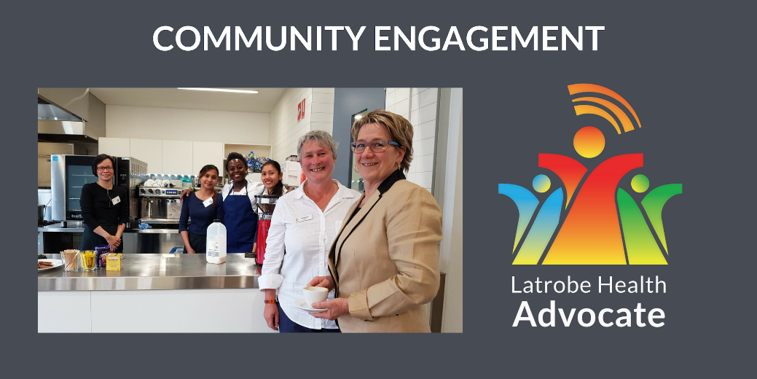

Since commencing in the role, the Advocate has maintained a commitment to engaging with Latrobe communities, hearing their views and aspirations for health and wellbeing. The approach to engagement is authentic with a commitment to reaching out to communities at times and locations convenient to them, listen generously, provide feedback and importantly, take action.

Stories, concerns and aspirations from people in Latrobe are listened to and then shared by the Advocate with key stakeholders and decision makers within local organisations and all levels of Government. This amplification of community voice forms the basis of conversations and decisions about systems change and innovation, with the intention to improve health and wellbeing outcomes in Latrobe.

The Advocate has engaged with communities across all towns in Latrobe, hearing from people from across the lifespan that represent a broad range of demographics. A deliberate effort has been made to reach out to those that may not usually have their voices heard.

Engagement techniques have been formal and informal, in person, through the local media and online. The Advocate has had conversations with people on the buses and at bus stops, at community events and activities, in their workplaces, at neighbourhood houses, at local gathering places such as community gardens, multicultural centres and men’s sheds, and online via social media and other digital platforms.

In the year to date more than 500 people from Latrobe have interacted with the Advocate. Mental health and wellbeing is consistently raised and is the number one issue that people want to talk about. Latrobe communities have demonstrated that they care about the mental health and wellbeing of themselves and each other. They have identified a broad range of factors that impact mental health and wellbeing including education, employment, social inclusion and community connectedness.

This submission has been informed by the voices of people in Latrobe communities about their own mental health and wellbeing and what is important to them. As part of an ongoing commitment to engagement, this submission will be shared back with Latrobe communities to provide feedback and to demonstrate that their voices matter.

Mental health and wellbeing is a priority for Latrobe.

Thematic analysis of conversations between Latrobe communities and the Advocate highlights that mental health and wellbeing is a priority area of concern. Most of the time, when concerns about mental health are raised they are associated with other factors such as social support, alcohol and drugs or broader determinants of health such as education and employment.

People have talked about the importance of having mental health support services that are approachable, professional and sympathetic. There is a common concern for the mental health and wellbeing of younger people and a recognition of the importance of the home and school environment.

People in Latrobe have expressed their desire to reduce the stigma associated with mental illness through a more inclusive culture, awareness campaigns and community events.

People have talked about the connection between employment and good mental health and some of the challenges facing skilled migrants who are looking for work. Job security has been identified as a key issue that impacts mental health and wellbeing, with concerns raised about an over casualised workforce and the stress and anxiety related implications of this.

It is worth noting the connections between mental health and wellbeing, and other issues raised by people in Latrobe including;

**Access to services**People have talked about the availability, affordability and location of medication, doctors, health services and specialists. They shared concerns about having to wait too long and having to retell their story too often.

People have specifically mentioned that they are looking for improved access to doctors, prostate cancer support nurses, paediatricians, haematology nurses, geriatric services, child psychologists and clinical psychiatrists.

**Social inclusion**People have spoken of the importance of family, friends, neighbours and communities being able to come together. Their aspirations for more community events and activities designed for specific age groups and communities.

People want to see more supports for people with a disability, young parents and new arrivals. They have shared suggestions about creating community gardens and asked questions about the accessibility of local sporting clubs.

**Alcohol and drugs**

People talked about the impact alcohol and drugs can have on individuals and community and the negative implications of drug addictions.

**Employment**

People discussed the need for more job opportunities and the importance of gaining qualifications and work-related licences. Often discussions about employment were associated with mental health and wellbeing.

People expressed concerns about the lack of opportunities and the disconnect between skills, training and jobs. People identified that there are barriers for skilled migrants who are looking for work.

**Volunteerism**People have talked about the value of volunteering and the benefits for individuals and communities. They identified some challenges for volunteers including out of pocket expenses and the difficulty that some people experience when they want to join a new group. People have said that local organisations need to manage and support their volunteers effectively.

In preparation for this submission the Advocate sought to understand some of these issues more deeply, from a community perspective. In recent conversations and online interactions with Latrobe communities the Advocate encouraged responses to four key questions;

1. **What are the health benefits of education and employment for people in Latrobe?**
2. **How might families, friends, neighbours and colleagues support people in Latrobe to enjoy good mental health?**
3. **How might workplaces and governments support people in Latrobe to enjoy good mental health?**
4. **Besides traditional service providers, who else might support people in Latrobe to enjoy good mental health and why?**

Community responses to these questions, along with recommendations from the Advocate are summarised on the following pages.

What are the health benefits of education and employment for people in Latrobe?

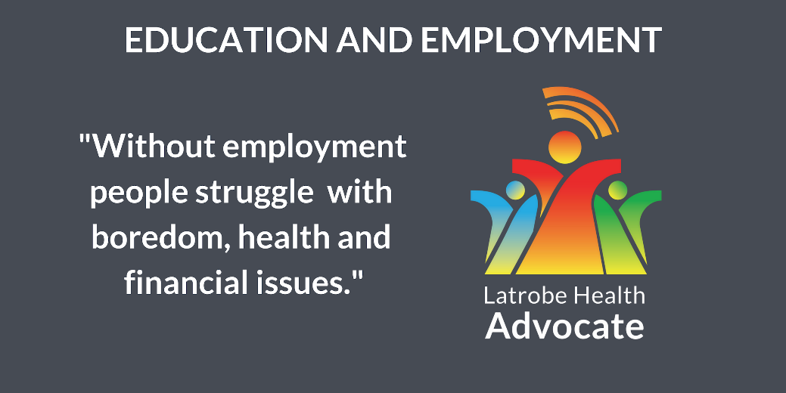

The Productivity Commission discussion paper recognises the importance of looking beyond the health sector to identify long term solutions and improved mental health outcomes for Australian communities.

Both education and employment are known social determinants of health and it is recognised that they interrelate. Unfortunately, in Latrobe unemployment is higher than in any other Gippsland local government area and is in fact the third highest in Victoria. This manifests, not only in people not participating in the workforce, it has been described as creating a sense of hopelessness for individuals and their social networks. 8.6% of people in Latrobe, which equates to approximately 6299 people are receiving income support.

People in Latrobe understand the connection between education, employment and mental health and have shared their experiences and frustrations about some of the challenges associated with training and job seeking.

People from multicultural backgrounds, with valuable skills and qualifications have identified their own challenges in gaining employment and the negative impacts the job seeking process can have on their mental health.

A number of people have expressed the view that they want to work and contribute to their family and society. There is a general desire to see more education and employment opportunities afforded to young people, new arrivals and other job seekers.

People have described education and employment as something that gives a person a sense of purpose. Often, when Latrobe communities describe their concerns about young people, social isolation and community safety it is associated with unemployment.

|  |  |
| --- | --- |
| Latrobe Community Voice | |
| “…without employment, people struggle with boredom, health and financial issues.” | “Social inclusion, social connection, positive for mental health, provides opportunity for skills and knowledge acquisition, create partnerships, networks and friends, helps individuals and families off the poverty line and benefit/emergency relief reliance, enhances resilience…” |
| “Being educated empowers the community.” | “Self-confidence, showing others in their social circles that employment and education is possible and worthwhile.” |
| “Physical wellbeing by being productive and active. Mental wellbeing by having a sense of purpose.” | “For those who live and work in Latrobe City the health benefits of living close to where you work and having short commute times cannot be underestimated.” |

Recommendations

1. **Improve the pathways to employment for people with a multicultural background, and those experiencing disadvantage and identify what can be done to accelerate their transition into the workforce.**
2. **Provide mental health and social supports for job seekers, recognising the impacts that the job seeking process itself can have on an individual, their family and social network.**
3. **Consider ways other than employment, to help local communities provide what is described by people as a ‘sense of purpose’ or ‘reason to get out of bed’.**

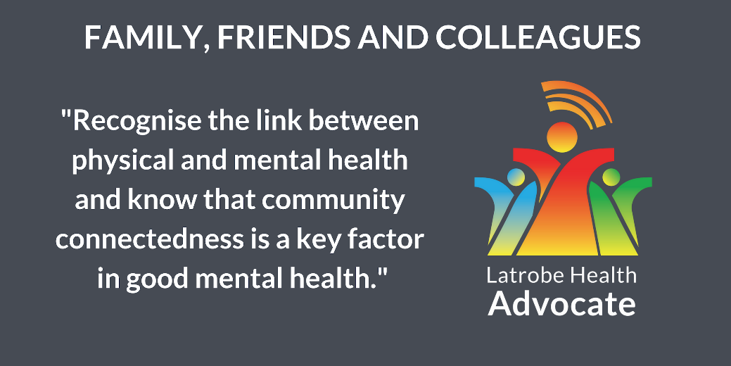How might families, friends, neighbours and colleagues support people in Latrobe to enjoy good mental health?

The Productivity Commission seeks to identify ways to improve mental health and wellbeing by encouraging social participation and inclusion. Latrobe communities have identified the importance of social inclusion. It has been the third most commonly raised issue with the Advocate.

Latrobe communities have said that people may experience social isolation or exclusion for a range of reasons which may include physical or geographical separation, inability to access social events and activities, a lack of events and activities on offer to suit their interests or needs, or an inability to interact with others due to physical or mental ill health.

Latrobe communities have identified the stigma associated with mental health and have expressed a desire to address this. They have described their vision that mental health will become an everyday topic of conversation that is talked about as openly as physical health symptoms such as a common cold or flu.

The Latrobe Health Assembly in partnership with Lifeline Gippsland is currently developing a campaign that aims to promote and enable greater connectivity amongst local communities and raise awareness of mental health and wellbeing. The campaign is intended to act as a precursor to the RUOK? campaign, recognising the importance of having an existing relationship or familiarity with someone and building on that to support them to enjoy good mental health.

Often, people express a desire to help others but recognise that they don’t know about the supports that are available to them, or if these supports will provide the service or care that is needed.

|  |  |
| --- | --- |
| Latrobe Community Voice | |
| “….be a kind and considerate colleague as co-worker may be suffering hardship, ask 'RUOK?” | “Recognise the link between physical and mental health and know that community connectedness is a key factor in good mental health.” |
| “Knowing the signs of poor mental health is important and also knowing where to seek appropriate help for those who might need support with their mental health is important.” | “Perhaps wider understanding of the current situation with the Latrobe Valley mental health service and how their abject inaccessibility to consumers impacts the community, highlighting the cruelty this imposes- change might be implemented?” |
| “By opening up conversations about emotional or mental health. Remaining open minded to the different ways people cope with difficult situations.” | “Involve more families and children in playing sport through clubs and school partnerships.” |
| “Reduce the stigma. Educate themselves around mental illness and all it involves.” | “Invite them for a cuppa, share a meal…check on their neighbour regularly to see how they are…” |

Recommendations

1. **Invest in strategies that capitalise on the goodwill of Australian societies with a view to strengthen community connectedness and social cohesion, particularly in rural and regional areas.**
2. **Reflect on the dominance of the existing medical model in Australia’s mental health system and consider what treatments are offered to people that present with loneliness and social isolation. Perhaps the answer lies in social prescription.**
3. **Recognise the positive mental health benefits generated by local clubs, groups, and social networks and invest accordingly. Design polices and funding models that articulate and measure social connectivity, noting its positive impact on mental health.**

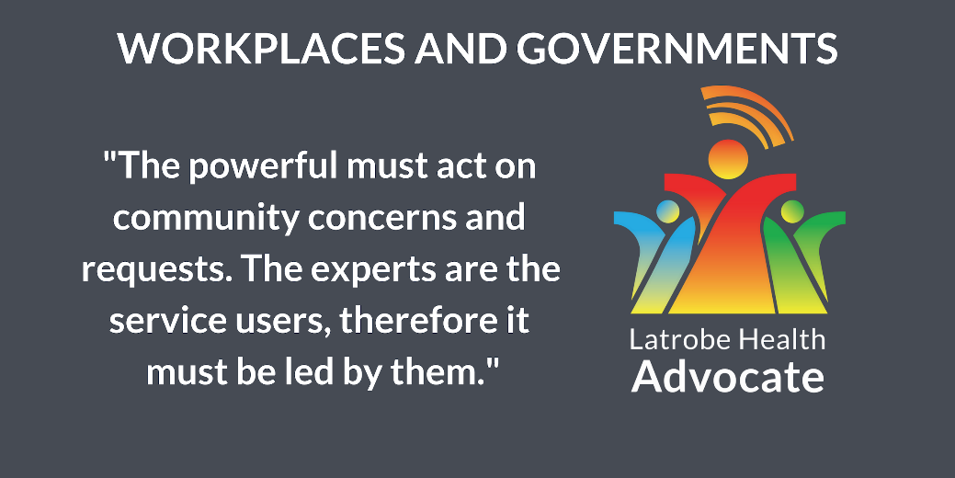How might workplaces, decision makers and government support people in Latrobe to enjoy good mental health?

The Productivity Commission issues paper recognises there is a role for all levels of government, along with non-government organisations, employers, industry associations and community groups. The establishment of the Latrobe Health Innovation Zone is intended to shift the ways in which governments, health services and other key stakeholders work with each other and with communities.

People in Latrobe have consistently expressed their expectation that decisions that affect them should involve them. They are looking to be engaged and to be heard. They want to participate in the design and delivery of reformed health services that are responsive to their needs. They also want to contribute, in their own ways to improving the health of their community.

People in Latrobe have described a health system that is based on a medical, rather than a social model. They have expressed concerns that the way government policy and funding is designed, results in a fragmented delivery of care that does not take into account a holistic view of a patient or allow for consideration of carers, family and friends.

Local workers recognise the influence that their workplace can have on mental health and wellbeing, noting that this impact could be either positive or negative. They are looking for employers to provide a workplace culture that promotes good health and wellbeing and for employers to have the knowledge and capacity to provide supports for people experiencing or supporting someone experiencing mental ill health.

|  |  |
| --- | --- |
| Latrobe Community Voice | |
| “The powerful must act on community concerns and requests. The experts are the service users, therefore it must be led by them. Funding is an obvious key issue, but it cannot be put before community safety and health.” | “Workplaces, decision makers and government need to be inclusive in their presentation of social and environmental perspectives and build on the diversity in the community, rather than representing only the hegemony - keeping balance and harmony whilst upholding a true reflection of that diversity is good for mental health.” |
| “Workplaces also need to ensure that they are fostering an inclusive workforce which does not tolerate bullying, harassment and discrimination.” | “Workplaces have a large role to play in supporting good mental health. This can be done by providing stable work opportunities (over-casualised workforces do not provide this stability) …. I believe this a key contributor to the poor mental health experienced in Latrobe City.” |
| “By assisting to reduce stigma associated with mental health conditions and making workplaces a safe place to be for everyone, regardless of how they are feeling on any given day.” | “Be sensitive to worker’s needs, especially family needs and circumstances.” |
| “Create policies and projects which are cohesive, locally and community focussed, sustainable, effective, easy to understand, in consultation with the community, inclusive, targeted, suitable, dynamic, proactive not reactive, positive, realistic, welcoming.” | “Have strong policies and procedures in place to ensure/encourage supportive, healthy working environments. Provide education around health and wellbeing, prevention rather than cure.” |

Recommendations

1. **Recognise the value of local communities and bring them into decision making processes. Design policies and funding models that enable organisations at all levels to be responsive to communities putting them at the centre of interventions and solutions.**
2. **Reflect on the mental health impacts of workplace culture on both individuals and societies. Consider ways for company directors and businesses to measure their culture and the impact that it has on mental health and welling of workers, families and communities.**
3. **Identify, from a national perspective, ways to embed policies, practices and support mechanisms within Australian workplaces that raise awareness of early warning signs and prevent or minimise the impacts of mental ill health.**

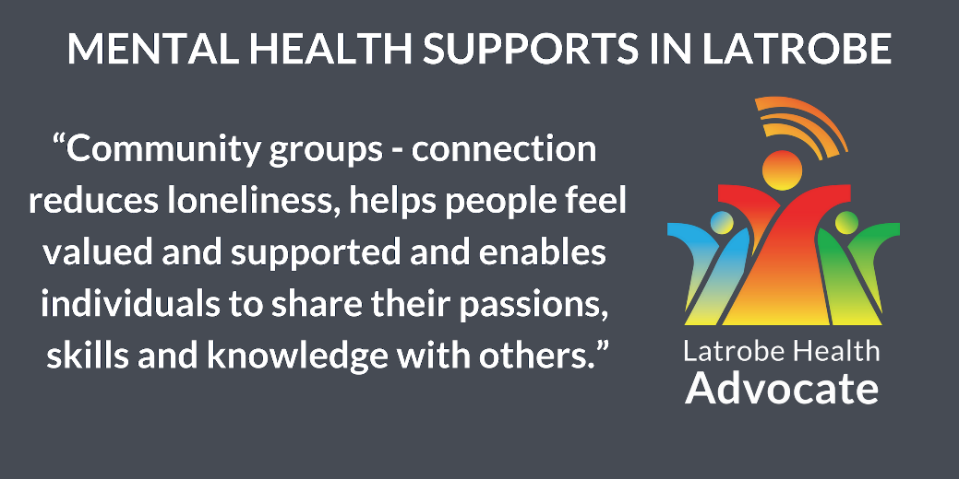Besides traditional service providers, who else might support people in Latrobe to enjoy good mental health and why?

This question is based on both the Productivity Commission issues paper and the voice of Latrobe communities, and has two components. Firstly, there is consideration for existing mental health services providers, who they are, how they are designed and funded and how well they work with each other and with communities. Secondly, there is consideration for who isn’t recognised as part of the mental health system but may have a role to play. Understanding this would enable a broader understanding of the possibilities to improve mental health outcomes in Latrobe and across Australia.

People in Latrobe have shared their concerns about the accessibility of health services. They talk about not knowing where to go or who to talk to. They talk about having to retell their story too often and the importance of having someone to go to that they can trust. They have expressed an expectation for health services and organisations to engage with each other and to provide a more coordinated response to community needs.

There is a consistent voice from Latrobe communities that they are looking for health professionals, services providers, organisations and governments that are approachable and have the capacity to demonstrate empathy. Latrobe communities are looking for services that are available to them at times, locations and in ways that are meaningful for them. One person said that “*we need someone in our towns and schools that we can go to, but don’t call them a doctor or social worker*” and another person said that one day they accessed a service “*because the door was open”* and they felt comfortable walking in.

The fabric of Latrobe communities, like many other Australian communities, is such that there is a diversity of people, places and interests that provide opportunities for people to interact and participate in society. There are numerous community groups, clubs and associations, schools, workplaces, professional and social networks where people interact on a regular basis.

People in Latrobe have spoken of their connections to grass roots organisations and networks. This is what they understand and can relate to. They struggle to understand and participate in health services that are becoming increasingly complex and difficult to navigate.

Often, when people talk to the Advocate about their aspirations and suggestions for improved health and wellbeing outcomes, they talk about local solutions and services that are grounded in communities, fit-for-purpose and fit-for-place. Suggestions include having health professionals available in schools, local exercise programs run by exercise therapists, community events designed for specific age groups and demographics, more accessible and inclusive clubs and facilities and greater flexibility in government funding to achieve more relevance and localisation.

Both the Productivity Commission issues paper and the World Health Organisation Social Determinants of Health, highlight the individual lifestyle factors, social and community factors and broader socio-economic, cultural and environmental conditions that can impact on a person’s health and wellbeing.

Further, the World Health Organisation Social Determinants of Mental Health go beyond this and recognise that there are factors across all ages and stages of lifespan that can impact mental health and wellbeing, noting the importance of life before birth and early childhood. It is noted that social inequalities are associated with increased risk of many common mental disorders and that action needs to be universal: across the whole of society and proportionate to need in order to level the social gradient in health outcomes.

It is in this context and against these frameworks that current investment into mental health should be assessed. It may be that existing funding models, performance measures, health workforce challenges and orientation of services inhibits their capacity to respond to community needs and aspirations, and ultimately hinder their ability to help the very people that they are there to help.

|  |  |
| --- | --- |
| Latrobe Community Voice | |
| “The only alternatives are seeking GP referral to non-existent psychologists/psychiatrists who are "not taking new clients" or self-referral to an inadequate counselling service.” | “GP’s. As the gateway resource for ‘any’ sort of health…. Talk to the visitors, get to know what worries them and treat them as people.” |
| “It is encouraging to note that Neighbourhood Houses are very proactive in ensuring their programs are relevant and the facilitators welcoming.” | “I have no idea. I just know the way it is in Latrobe, it is not helping.” |
| “There are people who also need to be supported on lower incomes. The voluntary work requirements of Centrelink are often unrealistic because of the amount of time and money and stress that's often involved in doing or getting to voluntary workplaces.” | “There needs to be more done in this area to ensure that this work actually leads to sustainable, well paid jobs.” |
| “Indigenous leaders - sharing their traditions, stories, bush food and how to use it.” | “Chefs and nutritionists (mood and food) - cooking and sharing a meal, empowering individuals and families to value healthy food and its importance and connection to mental health.” |
| “Community groups - connection reduces loneliness, helps people feel valued and supported and enables individuals to share their passions, skills and knowledge with others.” | “Support just about every club or sport or activity as best you can…People need to be included, have projects, challenge themselves, just getting them out into social situations is a huge start, so help to make that possible.” |

Recommendations

1. **Assess existing investments into mental health, looking beyond the traditional health and government sector. Broaden the definition of the mental health system taking into account the positive mental health benefits generated at a local community level.**
2. **Understand more deeply the existing pressures and expectations on GPs and consider ways to boost mental health supports in the GP setting and ways to reach out to communities with GPs and mental health professionals available at times and places convenient to them.**
3. **Identify a broader range of national, state, regional and local economic and social policies, strategies and plans that have the potential to positively impact on mental health outcomes. Articulate their benefit from a mental health perspective and design funding models accordingly.**

