1. A Circular Economy approach should adhere to international principles of a CE economy. Those being (1) the elimination of waste and pollution (2) the management of products and materials through the economy, according to their highest resource value and (3) the restoration of nature through enhancing and mimicking natural processes
2. An obvious opportunity to establish a circular economy is through a focus on takeaway packaging. This problematic packaging, given its single use and lack of effective collection and recovery, is a prime candidate for a circular economy approach.
3. Applying the principles of a CE means designing out any waste and pollution from the manufacture of products, introducing products that can be reused, recovered or recycled to avoid any waste.
4. A circular economy approach would manage these products through the economy through their entire lifecycle. From design, to use, discard, collection, processing and return as secondary resources.
5. The most effective means to achieve this, would be to require producers of packaging to be responsible for the entire lifecycle of their products. To be responsible, not just for design, but the costs associated with use, collection, recovery and return to manufacture.

Collection and recovery services should be designed to achieve

highest resource value-not simply lowest resource value such as

recycling

1. Producers would be responsible for the whole lifecycle and to ensure their products were managed effectively and efficiently.
2. A Product Stewardship Scheme should set targets for product reduction, reuse, recovery and recycling and use of recycled content.
3. Product standards should include a requirement that products are recovered in practice and at scale.
4. An example of product stewardship is the Container refund schemes currently operating around the country. In these schemes the beverage industry is responsible for collecting and recovering their discarded products, with allowing those products to go to landfill.

The Commonwealth government is currently designing a Product Stewardship for Packaging Scheme which should be designed to deliver an effective circular economy approach for those products.

**An Example Approach**

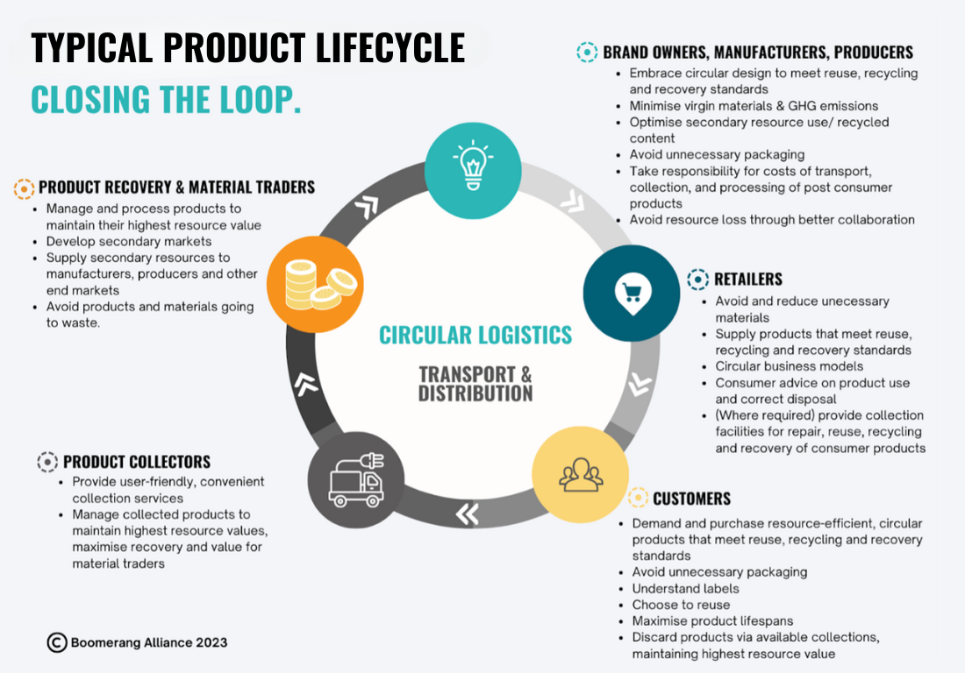

Further Details are in an attachment.

Toby Hutcheon

Boomerang Alliance