1 November 2024

Submission: Productivity Commission inquiry into opportunities in the circular economy
The Australian Pipelines and Gas Association (APGA) represents the owners, operators, designers, constructors and service providers of Australia’s pipeline infrastructure, connecting natural and renewable gas production to demand centres in cities and other locations across Australia. Offering a wide range of services to gas users, retailers and producers, APGA members ensure safe and reliable delivery of over 1,500 PJpa of gas consumed in Australia alongside over 4,500 PJpa of gas for export. We are at the forefront of Australia’s renewable gas industry, helping achieve net-zero more quickly and affordably.
APGA welcomes the opportunity to provide a submission to the Productivity Commission’s inquiry into opportunities in the circular economy. APGA’s comments are specific to the opportunities for renewable gases and gas infrastructure in the circular economy.
APGA supports a net zero emission future for Australia by 2050. Renewable gases represent a real, technically-viable approach to lowest-cost energy decarbonisation in Australia. APGA sees renewable gases such as hydrogen and biomethane playing a critical role in decarbonising gas use for both wholesale and retail customers. APGA is the largest industry contributor to the Future Fuels CRC, which has over 80 research projects dedicated to leveraging the value of Australia’s gas infrastructure to deliver decarbonised energy to homes, businesses, and industry throughout Australia.

Opportunities of renewable gas in the circular economy
Renewable gases, particularly biomethane, are emblematic of the opportunities of circular economies to directly contribute to Australia’s decarbonisation.
Biomethane is a product of the circular economy. Waste product, such as landfill gas, wastewater, and waste agricultural residue, is prevented from decomposing naturally – emitting methane into the atmosphere. Instead these products are collected and digested with a bacteria to produce a captured methane product. This product is refined and combusted, with far fewer emissions.
Biomethane and to a certain extent green hydrogen can be used in existing natural gas infrastructure, today. It can be combusted in natural gas turbines to produce electricity, it can be used as a chemical and industrial feedstock, and can be used in homes and commercial spaces for heat and cooking.
Not only can renewable gases provide a secondary decarbonisation option for gas use, alongside electrification, it can reuse and extend the life of Australia’s extensive gas transmission and distribution networks.
APGA’s submission below discusses:
- The nature of biomethane and green hydrogen as circular products, reusing and adapting waste into a new energy source;
- The opportunity to reuse billions of dollars worth of gas infrastructure to support gas use decarbonisation; and
- What governments need to do to help support the renewable gas industry.

To discuss any of the above feedback further, please contact me.
Yours sincerely,

CATRIONA RAFAEL
National Policy Manager
Australian Pipelines and Gas Association

The circular renewable gas economy

What are renewable gases?
Renewable gas refers to gases which do not produce any additional carbon emissions when combusted. Common forms of renewable gas include renewable hydrogen and biomethane.
Biomethane is produced through the transformation of waste biomass into energy (closing and narrowing loop), which is transported in existing natural gas infrastructure (slowing loop). Certain instances of renewable hydrogen production also reuse what otherwise would be a waste product – excess renewable electricity production.

Biomethane
Biomethane is produced from biogas – a mix of methane, CO₂ and other remnant gases. Biogas and other biofuels are generally produced through a biological process known as anaerobic digestion, where microorganisms break down raw materials such as agricultural waste, manure, landfill and plant material in an oxygen-free environment.
The type of biomass generally dictates which type of biofuel it is best suited to create. Woody materials and biological solid and liquid waste – including sewage –are particularly suitable for creating biogas. Biogas can also be directly captured from landfills. Oils and energy crops are more suitable for creating liquid biofuels.
‘Upgrading’ is the process of refining biogas into biomethane. It involves treating biogas to remove water, CO₂, and other remnant gases, resulting in a near-pure methane product. A range of upgrading technologies are commercially available, with variation in the treatment technology, capital and operation costs, and scalability.
The leftover biomass from upgrading biogas to biomethane – called digestate – can be reused as fertiliser or animal feed. The separated CO2 is highly concentrated, and valuable as a chemical or industrial feedstock.
While biomethane does produce the same emissions as natural gas when combusted, that combustion of biomethane releases the carbon absorbed by the biogenic material from the atmosphere during its life. On this basis it is considered to have net-zero carbon emissions.
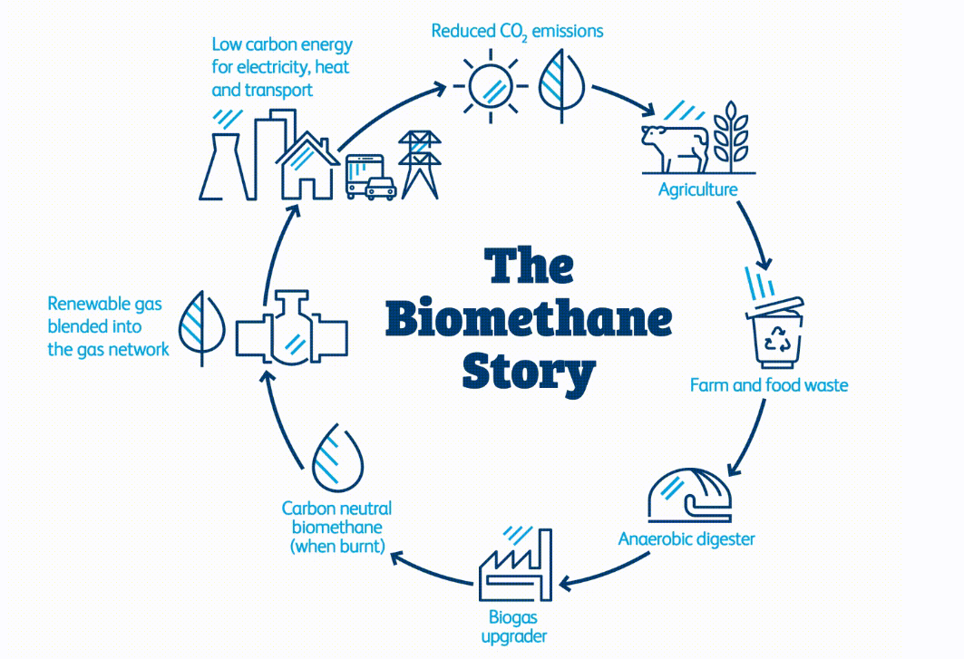
Biomethane is indistinguishable from and essentially interchangeable with natural gas. It can be used in existing gas networks and appliances without modification, and can substitute for natural gas in industrial manufacturing processes. This means that these already-long-lived assets can effectively be reused to carry this carbon neutral form of gas energy. This is already being done in Jemena’s biomethane facility at Sydney Water’s Malabar wastewater plant.
Case study: Malabar Biomethane Injection Plant
Malabar Biomethane Injection Plant is a collaboration between Jemena and Sydney Water with funding from ARENA. This pioneering venture is converts biogas from organic waste at Sydney Water’s Malabar Water Resource Recovery Facility into biomethane. This biogas was previously combusted to provide electrical power generation and water heating on site.
Once upgraded, the biomethane is injected directly into Jemena’s reticulated gas network. The project has an initial capacity of 95 terajoules of renewable gas per annum. This is about equivalent to the average annual gas usage of 6,300 NSW homes.
Origin Energy has signed an offtake agreement with Jemena to purchase all the biomethane produced at the plant in the first 18 months of operation.

Renewable hydrogen
Hydrogen can store energy as a gas or liquid. This energy can be used directly as a fuel for transport or heating, or a feedstock in industrial processes.
Hydrogen energy can be stored as a gas and blended for transport into existing natural gas pipelines. When converted to a liquid or utilised to produce another suitable material such as ammonia or alumina, hydrogen can also be transported on trucks and in ships.
When hydrogen is produced using renewable energy or processes, renewable or ‘green’ hydrogen is an emissions free fuel and becomes a way of storing renewable energy for use when it is needed.
Renewable hydrogen is typically produced through electrolysis using renewable electricity, generated from wind and solar. Water is pumped into an electrolyser and separated into hydrogen and oxygen using electricity. Renewable hydrogen can also be produced through gasification of biomass, although this technology has yet to be deployed in Australia.
REZ
hydrogen
electrolyser
green hydrogen pipeline
water pipeline
population
centre
When hydrogen is produced using excess renewable electricity – that would otherwise cause electricity grid instability – it can be considered part of the circular economy. One such facility is currently being built in Whyalla.
Case study: Whyalla hydrogen power facility
In 2022 the South Australian Government committed to building a 250 megawatt hydrogen production facility, 200 megawatt hydrogen power plant and fit for purpose hydrogen storage infrastructure in the Whyalla area by December 2025.
This plant is intended to be a new source of flexible power to provide grid stability. It is designed to ‘soak’ excess renewable energy generated from large-scale wind and solar farms. This hydrogen will then be used in a hydrogen power station to provide firming services to the electricity grid.
Approximately 100 tonnes of hydrogen produced will be stored to fuel the power station, and to provide industry with a sustainable and renewable energy source.

Adaptive reuse of Australia’s pipeline infrastructure
Australia’s extensive infrastructure networks transport over 560 petajoules of energy per annum, across 42,000kms of high-pressure transmission pipelines and over 88,000kms of low-pressure distribution pipelines. These assets represent billions of dollars of investment – the regulated asset base of the Victorian Transmission System alone is over $1 billion, and Jemena Gas Networks in Sydney over $3 billion.
As Australia transitions to a net zero economy, decarbonisation of gas use is coming into greater focus, alongside challenges in both gas volume supply and gas supply capacity. Some governments are choosing to address these issues through electrification and gas demand destruction, particularly in the residential and commercial sector. APGA presents an alternative pathway – reuse of these valuable assets with renewable gases.
Gas customers largely obtain their gas through existing gas distribution networks. The fixed costs of operating these networks are shared across all customers – in AGIG’s network in Victoria, approximately 98% of network costs are funded by residential customers.
Should residential and commercial customers be forced off gas and hence cease their effective subsidy of the network, the cost to deliver gas to the industrial customers would increase by about 43 times. These customers generally have no option to electrify.
Decarbonisation of gas use through renewable gases provides an alternative pathway. As detailed in the Malabar case study above, biomethane is already decarbonising the reticulated gas network in Sydney. In Adelaide green hydrogen is being blended into the networks, with Albury/Wodonga and Gladstone soon to follow.
This is possible as biomethane can be used in all existing gas infrastructure today. Green hydrogen presents slightly more of a challenge, however much of Australia’s transmission pipeline networks will be able to be safely converted for hydrogen service. A large proportion of the distribution network has been replaced with polyethylene pipes, and is already hydrogen-capable.

Government’s role in a circular economy
The renewable gas industry in Australia is nascent. There are both supply and demand side barriers, but it is not technological feasibility that stands in the way of growing the industry. The barriers are largely due to government policy, and there are many relatively simple actions governments could take to accelerate the development of the industry.

Certification and emissions accounting recognition
Currently, the National Greenhouse and Energy Reporting Scheme (NGERS) does not recognise the emissions reduction potential of renewable gases when they are transported in shared user infrastructure – pipelines. As pipelines are the cheapest and easiest form of transport for gases, this is a considerable barrier.
DCCEEW is currently developing a market-based method for renewable gases to address this issue, and we look forward to this being implemented.
Certification of renewable gases is also piecemeal. The GreenPower Green Gas Certification currently certifies renewable gases, including the biomethane injected into the Sydney network. Unfortunately it restricts end use to commercial and industrial customers. The Federal Guarantee of Origin Scheme will initially only certify green hydrogen.
APGA echoes AGIG’s comments that robust certification of renewable gases is critical to putting a financial value on the emissions reduction and allows an explicit value to be put in business cases for renewable gases.

Implement a national renewable gas target
APGA has been advocating for a national Renewable Gas Target (RGT) to provide a strong demand signal for investment. This has precedent in the successful Renewable Energy Target, which supercharged the roll-out of renewable electricity by derisking investments.
To explore this, APGA commissioned ACIL Allen to design an RGT. This work demonstrated how an RGT would boost investment in renewable gases and contribute to least-cost economy-wide decarbonisation.
APGA anticipates that once the renewable gas market is enabled through a market-based method and an RGT, similar to the renewable electricity market since the year 2000, the renewable gas market will develop to multiple times its current size.
Australia will need access to renewable gas as part of an efficient transition, and to enable other ‘green economies’ such as green metals. Governments will need to implement mechanisms to develop renewable gas and ensure it is available for hard-to-electrify sectors and as a feedstock for other sectors, in a timely manner. An RGT offers a viable and cost-effective approach to deliver these benefits.

Support biomethane production through aggregation of feedstock
Aggregation of feedstocks will be an important factor in the economic viability of producing biogenic fuels, including biomethane. Transporting biomass long distances is expensive relative to the cost of transporting the biogenic fuel product. Governments should explore biomass aggregation opportunities at existing regional facilities such as wastewater treatment plants, large agricultural sites and landfills.
Existing distribution and transmission pipeline networks can readily support this. Lateral pipelines to and from existing transmission lines are regularly constructed to supply small towns, and these can also be used for biomethane.
Financial incentives may also support the aggregation of feedstock. This could be explored through measures such as incentives for waste producers to sell their feedstocks to biogas or biomethane producers, or mandating waste recovery rates or targets for waste producers.

Commit to dual decarbonisation pathways
Governments’ “electrification only” approach to decarbonisation has many implications, which are beyond the scope of this submission to address. Accepting that renewable electricity cannot deliver the energy transition alone, governments should commit to dual decarbonisation pathways that puts electrification alongside the decarbonisation of gas.
Australian energy consumers have the opportunity to decarbonise via parallel renewable electricity and renewable gas pathways which provide energy security to each other. This approach permits reuse of Australia’s extensive gas infrastructure network, and lessens the need to invest in expensive electricity transmission infrastructure.

DCCEEW, 2024, Australian Energy Update 2024, Figure 3, https://www.energy.gov.au/sites/default/files/2024-08/australian_energy_update_2024.pdf
APGA, Climate Statement, available at: https://www.apga.org.au/apga-climate-statement
ACIL Allen, 2024, Renewable Gas Target – Delivering lower cost decarbonisation for gas customers and the Australian economy, https://apga.org.au/renewable-gas-target
Future Fuels CRC: https://www.futurefuelscrc.com/
Clean Energy Regulator, 2022, Emissions Reduction Fund: Biomethane Method Package 2022 – Simple Method Package, https://cer.gov.au/document/biomethane-method-package-simple-method-guide
Jemena, 2024, Malabar Biomethane Injection Plant, https://www.jemena.com.au/future-energy/future-gas/Malabar-Biomethane-Injection-Plant/
Australian Renewable Energy Agency, 2023, Malabar Biomethane Injection Project, https://arena.gov.au/projects/malabar-biomethane-injection-project/ https://jemena.com.au/about/innovation/renewable-gas/key-projects/malabar-biomethane-project
ARENA, 2024, Hydrogen Energy, available at https://arena.gov.au/renewable-energy/hydrogen/
SA Government, 2024, Whyalla hydrogen power facility, https://www.hydrogenpowersa.sa.gov.au/projects/hydrogen-jobs-plan/whyalla-hydrogen-power-facility
AER, 2022, State of the Energy Market 2022, Chapter 5 – Regulated Gas Pipelines, https://www.aer.gov.au/system/files/State%20of%20the%20energy%20market%202022%20-%20Chapter%205%20-%20Regulated%20gas%20pipelines%20.pdf
The ACT Government has banned new gas connections ban across the majority of the Territory, and aims to phase out gas entirely by 2045. The Victorian Government has implemented a new residential/commercial gas connections ban, and is looking at options to ban new gas appliances.
Frontier Economics analysis for AGIG.
AGIG, 2024, Hydrogen Park South Australia, https://www.agig.com.au/hydrogen-park-south-australia
AGIG, 2024, Hydrogen Park Murray Valley, https://www.agig.com.au/hydrogen-park-murray-valley
AGIG, 2024, Hydrogen Park Gladstone, https://www.agig.com.au/hydrogen-park-gladstone
APA Group, 2024, Parmelia Gas Pipeline – Hydrogen Conversion Technical Feasibility Study, https://www.apa.com.au/globalassets/our-services/gas-transmission/west-coast-grid/parmelia-gas-pipeline/3419_apa_public-pipeline-conversion_v6.pdf
Parliament of Australia, 2024, Future Made in Australia (Guarantee of Origin) Bill 2024, https://www.aph.gov.au/Parliamentary_Business/Committees/Senate/Environment_and_Communications/GuaranteeofOrigin
ACIL Allen, 2024, Renewable Gas Target: Delivering lower cost decarbonisation for gas customers and the Australian economy, https://apga.org.au/renewable-gas-target
APGA has addressed this extensively, for example: APGA, 2023, Victorian Renewable Gas Consultation, https://apga.org.au/submissions/victorian-renewable-gas-consultation; APGA, 2023, Senate Inquiry into Residential Electrification, https://apga.org.au/submissions/inquiry-into-residential-electrification; APGA, 2023, Future Gas Strategy, https://apga.org.au/submissions/future-gas-strategy; APGA, 2024, Electricity and Energy Sector Plan, https://apga.org.au/submissions/electricity-and-energy-sector-plan; APGA, 2024, NSW Renewable Fuels Strategy, https://apga.org.au/submissions/nsw-renewable-fuels-strategy

