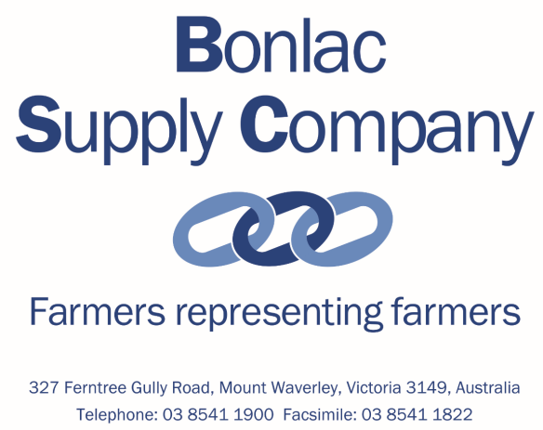

Submission 33 - Bonlac Supply Company - Murray-Darling Basin Plan: Five-year assessment - Public inquiry
Submission to:
Productivity Commission
Submitted online via http://www.pc.gov.au/inquiries/current/basin-plan

19 April 2018

Contacts for submission
Anthony Marwood – Chairman, Bonlac Supply Company

Will Kermode – Company Secretary, Bonlac Supply Company

Version: Bonlac Supply Company Submission to PC _ MDBP five-year assessment 20180419

Who we are
Bonlac Supply Company (BSC) is a farmer representative body representing the 1,200 dairy farmer suppliers to Fonterra Australia (throughout Victoria, Tasmania and NSW).
Of these suppliers, over 250 are located in the Murray-Darling Basin region, supplying over 300 million litres of milk annually with a farm-gate value of A$170million.
The Bonlac Supply Company Board, five of whom are dairy farmers, provide active representation of all supplier interests at a local, industry and government level.
Our other key activities include development of the next generation of dairy industry leaders through the BSC Leadership program, oversight of the BSC Fonterra Supplier Forum which provides direct farmer feedback to the BSC Board and Fonterra Australia, and the development of other initiatives in conjunction with Fonterra to support farmers.
Fonterra collects and processes this milk at its Stanhope site where it’s made into household dairy brands such as Bega and Perfect Italiano cheeses. A portion of Fonterra’s Australian dairy products from the Murray Darling Basin (primarily cheese and milk powders) are also exported.
Bonlac Supply Company and Fonterra are part of the Australian Dairy Industry Council and fully supportive of the Productivity Commission review.

Key points
The introduction of the Murray Darling Basin Plan, particularly reductions in Sustainable Diversion Limits (SDLs) has had a dramatic socio-economic effect on dairy farmers and the dairy processing companies that they supply, notably in the southern part of the MD Basin.
With 50% of water used in dairy being temporary water, dairy’s exposure to water market volatility is immense. The reductions in the level of water available (and high costs) has had broad adverse consequences for milk production and on farm investment.
This uncertainty around water supply and cost is leading to reduced on farm incomes and investment, with reduced direct employment, with multiplied related socio economic effects our Basin communities.
Our key concern is that the Basin Plan is in fact limiting growth in Dairy, when compared to national trends. Dairy is one of the largest economic drivers within the Southern Basin . The value of Agriculture in the Basin has only grown by 4% in real terms, compared to 11% nationally. Using this analysis, irrigated agriculture would have grown by another $770 million in 2017 alone, had its value grown with the 11% national trend.
ABS data shows the gross value of irrigated Dairy has fallen by 24% ($283 million) in real terms since 2001. With dairy as one of the largest economic drivers within the Southern Basin, these reductions in output affect every community as much of this value is not being replaced.
Please also note that we support all the recommendations put forward in the ADIC Water Taskforce submission (of which we have been a contributor) and we do not intend to duplicate in any detail the points raised in that submission.

Proposed Assessment Approach
The cost of production for many of the dairy farmers in the Basin has increased dramatically, and the value of dairy output, in relative terms has fallen. When combined with continued future uncertainty around water availability, this makes milk production less competitive in this region.
This uncertainty also reduces the ability of the region to attract further investment in dairy processing. This is particularly problematic given there are many other good reasons to invest in dairy farming and dairy processing in the Southern Basin, provided the water inputs are reasonably well managed.
We believe the deep social and economic impacts of the Plan on the dairy communities have become evident as water scarcity increases in a drying period as has been experienced. The dry periods in the Southern Basin have on many occasions meant that current market forces have led to significantly increased water prices. In some cases the costs of irrigation water rights have risen by 300% .
As noted by the AIDC submission, the Basin Plan has caused a significant reduction in milk supply in the Murray Region when compared to Gippsland and the Western Region – despite the three regions being exposed to similar influences other than the Basin Plan.
Whilst we support the environmental outcomes sought we believe the current reliance on a largely “volume based” solution is difficult to justify in light of the increasing social and economic impacts of SDL reductions.
Based on the increasing social-economic issues developing, we agree with and support the points raised by the ADIC Water taskforce that the coverage for the proposed PC Assessment framework include a framework to at least qualitatively assess and evaluate progress on each of the objectives and outcomes of section 5.02 of the Basin Plan (BP 5.02).
Broadly we would like to see greater consideration of the socio-economic effects of reducing irrigation water volumes and especially the adaptive capacity of basin communities to respond.

Basin Institutional and governance arrangements
Again, as per the ADIC submission, we would also like to confirm our ongoing concerns regarding the lack of a wholistic body to oversee and control the Murray Darling Basin Plan.

We too believe that the institutional arrangements of the Commonwealth Water Act confuse the role of state governments and state water agencies, in addition to the many conflicting roles held by the MDBA.

We agree with the ADIC recommendation that the institutional and governance arrangements be reformed to align with clause 74 of the 2004 National Water Initiative that requires the roles of water resource management, standard setting and regulatory enforcement and service provision to be separated institutionally.

Internal Fonterra analysis on Norther region suppliers
AITHER review report 2016/17
Waterfind pricing reports at www.waterfind.com.au

