**Submission to the Productivity Commission’s Philanthropy Inquiry**

My main motivation for donating to charity is that I want to do as much good as I can. Because of that motivation, I care about which charities have the most impact. When I know the charity I’m giving to is highly effective and endorsed by organisations I trust, it gives me the confidence to donate more.

I think government policies that focus on impact and increase confidence that impact is being achieved are the key to achieving the goals of this inquiry.

This submission discusses:

1. Expanding DGR status to the high impact cause areas that align with the values of modern Australians (2.ii, 3.ii, 5, 6)
2. Allowing Public Benevolent Institutions to work across causes areas (2.iii, 3.i)
3. The benefits of rigorous charity evaluation (3.ii, 6.iii)

I am concerned about animal welfare, including in our agricultural sector. I know, both from public polling and from interactions with my friends, family and community, that this concern is widely shared by Australians and only growing.

I think the phrasing of the charitable purpose regarding animals in the Charities Act makes sense. “Preventing or relieving the suffering of animals” is a clear and laudable concept. However, the way that 4.1.6 of the Tax Act narrows that down to organisations whose principal activity is “providing short-term direct care to animals (but not only native wildlife) that have been lost, mistreated or are without owners” or “rehabilitating orphaned, sick or injured animals (but not only native wildlife) that have been lost, mistreated or are without owners” is obviously unreasonable.

The more impactful way to help animals is a holistic approach that seeks to prevent cruelty from occurring, pursues sensible regulation about how society at large treats animals, and also provides direct care to animals that fall through the cracks. Complex problems have complex solutions. Limiting DGR – a significant boost to the efficacy of charities who can access it – to only “bandaid solutions” limits the impact of the cause overall.

I sympathise with concerns that a dramatic expansion of DGR status could have impacts on the tax base. I think, if DGR is going to be expanded gradually, prioritisation should be based on where the most positive impact can be achieved per dollar, and with a view to aligning DGR status with the values of modern Australians.

Charity evaluators, in their work assessing the potential good that could be achieved by working on different causes, consistently agree that animal welfare is one of the most impactful ways to do good. As a proxy for interest in the community, Roy Morgan has found that the trend in vegetarian eating continues to grow, with 2.5 million people in Australia (over 12% of the population) now eating all or almost all vegetarian. About 1 Australian decides to go meat-free every 5 minutes. Obviously, not everyone who cares deeply about animal welfare is a vegetarian, but this indicates that a very significant portion of the Australian population is motivated by this concern. Despite how widespread this view is, the community is currently underserved by charity law. This limits the extent to which we can make tax-deductible donations and limits the positive impact we can achieve through our donations.

The way Public Benevolent Institutions are regulated is outdated and should be absorbed into the Charities Act. The Law Council of Australia and the ACNC are regularly debating the meaning of the cases from the 1930s and 1940s that define how PBIs can operate. This is not helpful for organisations, communities, or their ability to do charity in an impactful way. The legal conversation has lost track of the policy intent.

An obvious example of this lack of focus on outcomes is the dispute over the meaning of “dominant purpose”. Without re-stating legal arguments, the ACNC seems to think that a charity that is a PBI has to have its PBI-purpose as its “overriding” purpose, and therefore it can’t also have other purposes from the Charities Act. The Law Council thinks this reading is a misunderstanding of the meaning of “dominant purpose” and that having a purpose from the Charities Act shouldn’t disqualify a PBI.

This is just one example, and who is “right” doesn’t matter. What matters is that having critical definitions about how a charity can do its business buried in arcane case law that doesn’t have a clear reading and isn’t aligned with the Government’s policy intent is not efficient or effective.

In the case of “dominant purpose”, it’s clear that Government policy has no concern with a charity pursuing multiple purposes. This is clear because the Charities Act allows a charity to have multiple purposes. This is common sense – no public policy purpose is served by requiring separate organisations for separate charitable purposes (indeed, the administrative inefficiencies that it creates are contrary to good public policy). And this has real-world implications for how PBIs can engage in fundraising, do impactful work, and support their communities.

“Dominant purpose” is just one example of common law that is no longer helpful. There is also confusion around other phrases like “direct relief”.

The Productivity Commission should recommend amendments to the Charities Act to override the common law and create a new charity type that is not mutually exclusive with other charity types. The precise details can be resolved by ACNC-led consultation and Government decision.

I’m excited by the terms of reference about charity evaluation. I think people can be cynical about charity because it’s hard to know if your donation has actually had an impact. I’ve valued the work of overseas charity evaluators because they provide trusted rigour around impact. This is important because high-impact charities can be 10 or 100 times more impactful than average charities. Some charitable programs can even do harm.

I would encourage the Productivity Commission to review:

* Donors vastly underestimate differences in charities’ effectiveness by Caviola, L; Schubert, S; Teperman, E; et al. available online at <http://hdl.handle.net/10871/122268>, and
* Don’t Feed the Zombies by Kevin Star in the Stanford Social Innovation Review, available online at <https://ssir.org/articles/entry/dont_feed_the_zombies>

The research is usefully summarised in two illustrations that depict how different the view of the impact of charity is between lay people and experts:

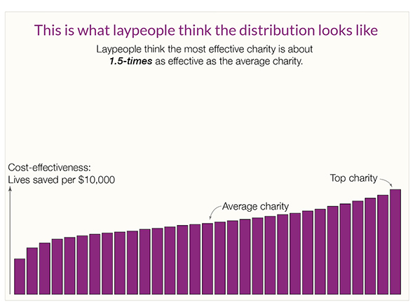

Kevin Star’s article usefully explains that there’s a kind of market failure in the charity sector, where donors aren’t part of the feedback loop and often have no meaningful way of knowing how much value beneficiaries get from their donations. The article outlines how an approach to impact-focused evaluation which he persuasively explains could achieve a “quantum leap toward a better world”.

While the above two sources focus on global health, the same effect occurs across countries and across causes. By way of illustration, Benjamin Todd’s recent article on 80,000 Hours shows a similar distribution of the impact of climate interventions (<https://80000hours.org/2023/02/how-much-do-solutions-differ-in-effectiveness/>) :

This insight is essential. While donors don’t and can’t understand how impactful their donation is, and charities have to raise funds in a market that doesn’t function, the sector will struggle. This problem is long-standing, but progress in the last 10 years on charity evaluation means it doesn’t have to continue.

Australia funding and promoting charity evaluation has the potential to fix the market failure, help Australian charities do far more good, and potentially make us a world leader.

Overall, Australian charity regulation has become outdated. Charities with DGR status are the lion’s share of the sector, but DGR status is not aligned with my values or the values of my peers. This means that charities aren’t focusing on many of the things I care about, and aren’t providing the community support and volunteering opportunities that are meaningful to me.

The Productivity Commission has a chance to make recommendations that realign the sector with the values of today’s Australians. Applying the lens of impact could greatly increase the amount of good that the sector can achieve, which in turn would drive donations and build the community supports that younger Australians need. I’ve seen too many talented Australians whose values align with mine leave for the UK or USA to do high-impact charity work because Australia doesn’t have a workable ecosystem for their values. This is hurting our community, our democracy and our future.