Dear Government,

I feel like charity law has fallen out of step with what my peers and I care most about, and that my generation doesn’t have the same kinds of philanthropic organisations supporting us and our values as older generations do.

To achieve goals like growing donations and increasing community engagement, charity laws should build incentive structures that foster organisations that work on the kinds of issues that younger generations of Australians care the most about.

My submission discusses:

1. Expanding DGR status to the high impact cause areas that align with the values of modern Australians *(2.ii, 3.ii, 5, 6)*
2. Allowing Public Benevolent Institutions to work across causes areas *(2.iii, 3.i)*
3. The benefits of rigorous charity evaluation *(3.ii, 6.iii)*

**Animal Welfare as a whole should be a DGR class, not just short-term direct care of animals (Information request 4)**

I am concerned about animal welfare, including in our agricultural sector. I know, both from public polling and from interactions with my friends, family and community, that this concern is widely shared by Australians and only growing.

I think the phrasing of the charitable purpose regarding animals in the *Charities Act* makes sense. “Preventing or relieving the suffering of animals” is a clear and laudable concept. However, the way that 4.1.6 of the *Tax Act* narrows that down to organisations whose principal activity is “*providing short-term direct care to animals (but not only native wildlife) that have been lost, mistreated or are without owners*” or “*rehabilitating orphaned, sick or injured animals (but not only native wildlife) that have been lost, mistreated or are without owners*” is obviously unreasonable.

The more impactful way to help animals is a holistic approach that seeks to prevent cruelty from occurring, pursues sensible regulation about how society at large treats animals, and also provides direct care to animals that fall through the cracks. Complex problems have complex solutions. Limiting DGR – a significant boost to the efficacy of charities who can access it – to only “bandaid solutions” limits the impact of the cause overall.

I sympathise with concerns that a dramatic expansion of DGR status could have impacts on the tax base. I think, if DGR is going to be expanded gradually, prioritisation should be based on where the most positive impact can be achieved per dollar, and with a view to aligning DGR status with the values of modern Australians.

Charity evaluators, in their work assessing the potential good that could be achieved by working on different causes, consistently agree that animal welfare is one of the most impactful ways to do good. As a proxy for interest in the community, Roy Morgan has found that the trend in vegetarian eating continues to grow, with 2.5 million people in Australia (over 12% of the population) now eating all or almost all vegetarian. About 1 Australian decides to go meat-free every 5 minutes. Obviously, not everyone who cares deeply about animal welfare is a vegetarian, but this indicates that a very significant portion of the Australian population is motivated by this concern. Despite how widespread this view is, the community is currently underserved by charity law. This limits the extent to which we can make tax-deductible donations and limits the positive impact we can achieve through our donations.

**PBI rules should not hamper community building (Information request 6)**

I support Effective Altruism Australia and the work they’re doing to help effective altruism groups in universities and major cities. These EA groups are getting people excited about doing good, helping them think about impactful donations, running reading groups, and giving advice about impactful careers. But Effective Altruism Australia’s status as a “Public Benevolent Institution” limits the work of its community builders to align with EAA’s work on global health and poverty and “incidental” topics.

For instance, EAA community builders probably can’t facilitate a reading group on animal wellbeing because the wellbeing of animals isn’t “incidental or ancillary” to global poverty. I find it hard to understand why the law would stop the peak body of effective altruism in Australia from properly supporting effective altruism clubs in universities. I understand that a charity shouldn’t just be able to do anything, because that would open up the system to abuse, but supporting university clubs and city groups with the same philosophy and philanthropic goals is well within the normal operation of philanthropy. Given the Terms of Reference are framed around building social connection, it would seem a simple change for a big improvement to recommend to Government to remove narrow, PBI-specific rules around “dominant purpose” that prevent PBIs from doing work in their communities.

A change to allow PBIs to also pursue other charitable purposes would help me and my group be more involved in our community and find more ways to do good. I think effective altruism clubs and similar groups, like One For The World, have the potential to be life-long sources of connection for younger Australians. But we need regulatory changes now so that we and these organisations can grow together.

**Australian charity evaluation would build confidence (Information request 7)**

I’m excited by the terms of reference about charity evaluation. I think people can be cynical about charity because it’s hard to know if your donation has actually had an impact. I’ve valued the work of overseas charity evaluators because they provide trusted rigour around impact. This is important because high-impact charities can be 10 or 100 times more impactful than average charities. Some charitable programs can even do harm.

I would encourage the Productivity Commission to review:

* *Donors vastly underestimate differences in charities’ effectiveness* by Caviola, L; Schubert, S; Teperman, E; et al. available online at  <http://hdl.handle.net/10871/122268>, and
* *Don’t Feed the Zombies* by Kevin Star in the Stanford Social Innovation Review, available online at <https://ssir.org/articles/entry/dont_feed_the_zombies>

The research is usefully summarised in two illustrations that depict how different the view of the impact of charity is between lay people and experts:

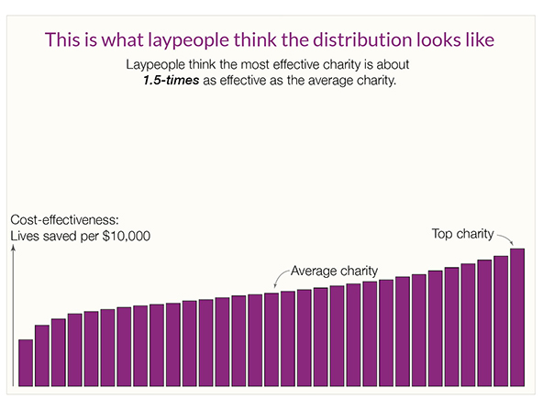

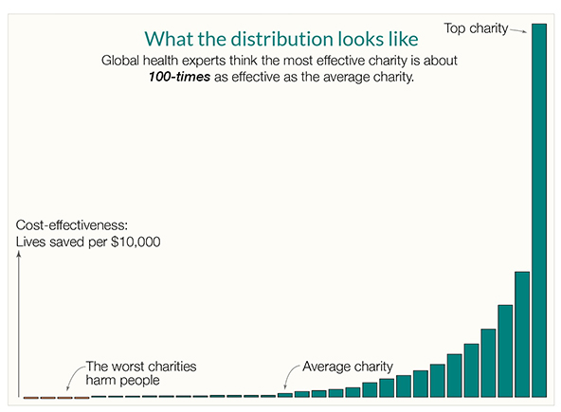

Kevin Star’s article usefully explains that there’s a kind of market failure in the charity sector, where donors aren’t part of the feedback loop and often have no meaningful way of knowing how much value beneficiaries get from their donations. The article outlines how an approach to impact-focused evaluation which he persuasively explains could achieve a “quantum leap toward a better world”.

While the above two sources focus on global health, the same effect occurs across countries and across causes. By way of illustration, Benjamin Todd’s recent article on 80,000 Hours shows a similar distribution of the impact of climate interventions (https://80000hours.org/2023/02/how-much-do-solutions-differ-in-effectiveness/) :

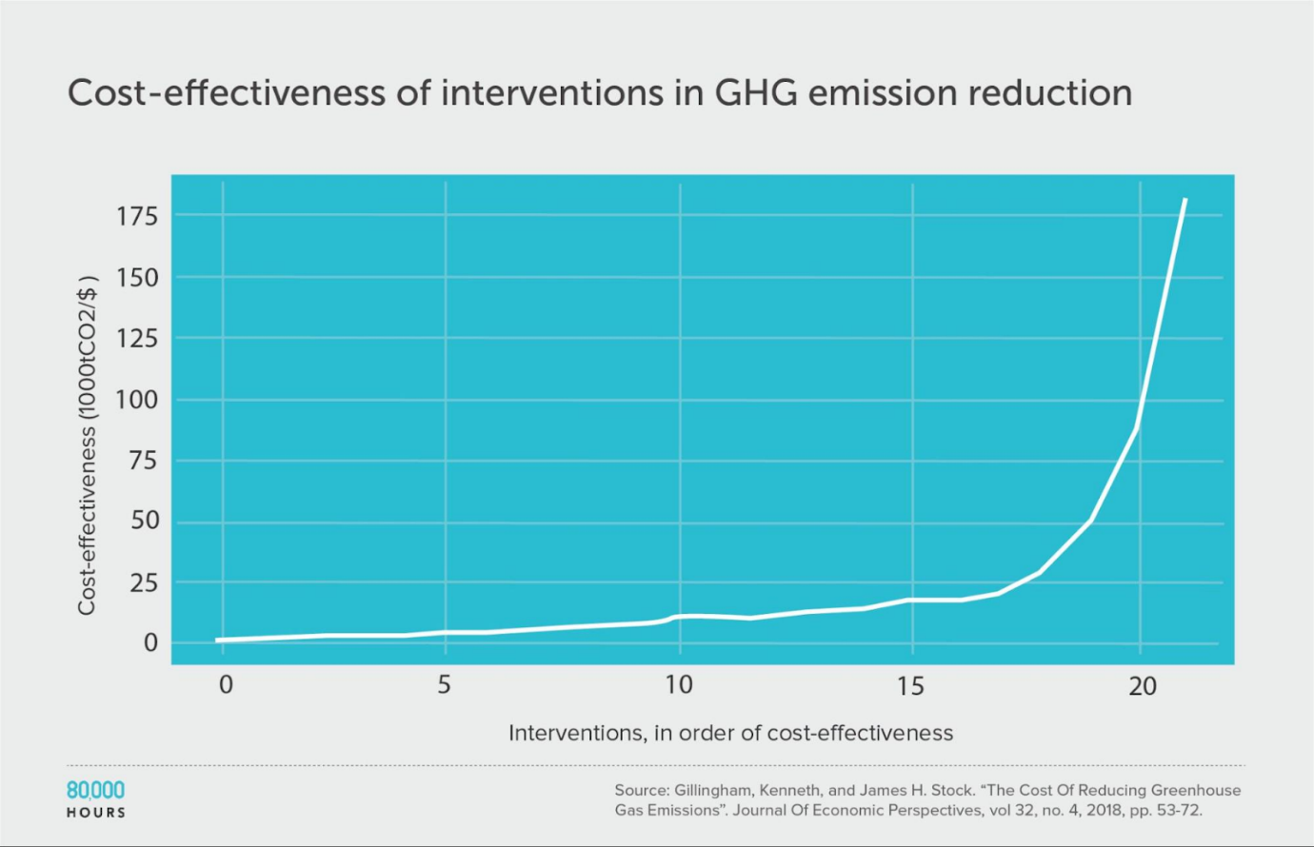

This insight is essential. While donors don’t and can’t understand how impactful their donation is, and charities have to raise funds in a market that doesn’t function, the sector will struggle. This problem is long-standing, but progress in the last 10 years on charity evaluation means it doesn’t have to continue.

Australia funding and promoting charity evaluation has the potential to fix the market failure, help Australian charities do far more good, and potentially make us a world leader.

**Summary**

Overall, Australian charity regulation has become outdated. Charities with DGR status are the lion’s share of the sector, but DGR status is not aligned with my values or the values of my peers. This means that charities aren’t focusing on many of the things I care about, and aren’t providing the community support and volunteering opportunities that are meaningful to me.

The Productivity Commission has a chance to make recommendations that realign the sector with the values of today’s Australians. Applying the lens of impact could greatly increase the amount of good that the sector can achieve, which in turn would drive donations and build the community supports that younger Australians need. I’ve seen too many talented Australians whose values align with mine leave for the UK or USA to do high-impact charity work because Australia doesn’t have a workable ecosystem for their values. This is hurting our community, our democracy and our future.