As someone who cares a lot about improving people’s lives and reducing suffering, I want to do as much good as I can with my donations. That means I am significantly more motivated to donate when I know that the positive impact of my donations has been evaluated by organisations I trust. In my view, governments have a role to play to ensure that Australians have confidence their generosity will make a meaningful difference. Furthermore, donors will have a stronger democratic voice if they are informed about the impact of their philanthropy. Donors may also feel more connected to the communities they are supporting. I think that government policies focused on the impact of donations will be crucial to the success of this inquiry.

This submission discusses:

1. Expanding DGR status to the high impact cause areas that align with the values of modern Australians *(2.ii, 3.ii, 5, 6)*
2. The benefits of rigorous charity evaluation *(3.ii, 6.iii)*

**Global catastrophic risk reduction and animal welfare should have DGR status**

A major focus for this inquiry should be the ability of certain charities to receive DGR status. Several highly effective charities working in the global catastrophic risk reduction and animal welfare cause areas are unable to receive DGR status, despite their contributions to the wellbeing and security of the Australian community.

On the issue of global catastrophic disasters, after COVID-19 and the war in Ukraine, many experts and people in my community are worried about the risk of worse future pandemics and nuclear war. These concerns motivate me to work with my community to bring about valuable policy change. However, community organisation around disasters is typically limited to localised risks such as flood response. While these organisations are to be commended, I and many of my peers believe we can leverage our skills and time to do even more good. If organisations working on reducing the risk of catastrophic disasters had DGR status, I would have more opportunities to volunteer and connect with my peers. Global catastrophic risks are modern concerns that need to be appropriately acknowledged through DGR regulation.

My peers and I also care deeply about the welfare of animals, and I know that many people in my community feel a sense of discomfort about living in a world with significant animal suffering. I believe that improvements in animal welfare would not only improve the lives of the animals themselves, but also communities who encounter or hear about animal suffering. Unfortunately, while many highly cost-effective animal charities can be “charities” under the *Charities Act*, they are excluded from DGR status under the *Tax Act*. I understand that this is because DGR status is limited to interventions such as the short-term direct care and rehabilitation of lost or mistreated animals. Although these charities are beneficial for the animals they support, it is typically more cost-effective to prevent abuse or mistreatment rather than cure the symptoms. Charities preventing harm should therefore also receive DGR status.

I think the exclusion of these two cause areas from DGR status needlessly limits the impact of our volunteering time and donations. These causes are at the forefront of the minds of modern Australians and are recognised by well-respected charity evaluators as being high-impact. They are allowed to accept tax-deductible donations internationally, but are excluded here in Australia. If Government is committed to increasing donations and building social connections through charity, it needs to provide DGR status to these cause areas.

**Charity evaluation could build confidence and improve effectiveness**

I feel far more motivated to donate to charity when I have information about the likely benefits of my donations. When I discuss philanthropy with friends, family, and colleagues, they often express concerns about donating without having information on the impact of Australian charities. They’re often excited to learn about international organisations like GiveWell, Animals Charity Evaluators, Giving Green, and Founders Pledge, but are disappointed to learn they haven’t evaluated many Australian charities. A similar organisation is needed in Australia to make robust, evidence-based assessments about the actual impact of Australian charities and their initiatives.

Research by academics and charity evaluators suggests that some charities have several times more impact than others. For example, this chart produced by not-for-profit 80,000 Hours shows that some climate change interventions are far more cost-effective than others (https://80000hours.org/2023/02/how-much-do-solutions-differ-in-effectiveness/):

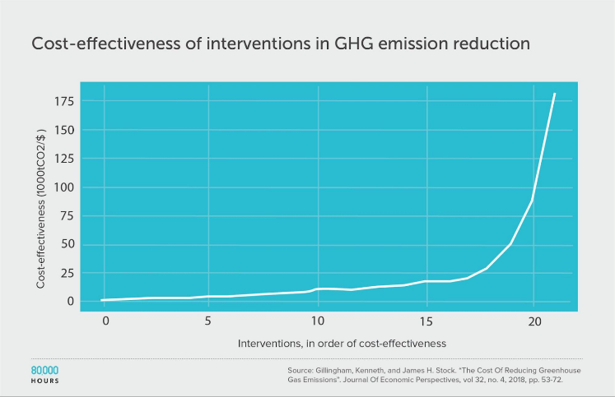

I worry that the most well-known charities in Australia are supported not because they have the most impact on the issues they care about, but because they have successfully built a strong brand.

An Australian charity evaluation system would decrease cynicism around charity and lead to a higher overall degree of trust and support for charity in the community. Just as people typically only re-purchase goods and services when they enjoy the product, donors need similar feedback when they decide to use their money to do good. A charity evaluation system would also reward charities who aim to improve their own effectiveness by robustly testing different interventions.

I think an Australian Government funded or endorsed charity evaluator could transform philanthropy in Australia.

There are some potential practical concerns with charity evaluation, but these can be alleviated with careful consideration:

* **Feasibility.** While widespread charity evaluation in Australia is a substantial endeavour, the charity evaluators listed above have demonstrated its feasibility and have developed mature models to conduct evaluation. The Australian Government now has several practical options to implement charity evaluation, including building on existing expertise in the field or contracting with a proven company.
* **Resourcing requirements.** Based on public materials, and converted to Australian dollars, Charity Navigator's budget is in the order of $6m per year and GiveWell’s is in the order of $15m per year. ACNC reports that donations to Australian charities increased to $12.7b dollars in 2022, and Government aspires to double giving. On that basis, Australia could have a well-resourced charity evaluator for roughly 0.1% of the value of the sector. Given the potential for an Australian charity evaluator to make users’ donations several times more impactful, this passes a simple cost-benefit evaluation.
* **Opt-in model**. If evaluation was opt-in, charities that don’t think they have the resources to measure their impact, or otherwise have concerns about evaluation, could choose not to participate. This could facilitate a graduated rollout of evaluation.

Charity evaluation is well-established field, is affordable for the Australian Government, and could greatly increase the good work done by philanthropy in Australia. Just as the Australian Government strives to implement evidence-based policy, it can also help Australians do evidence-based charity.

**Government can spark a new generation of philanthropy**

The Productivity Commission has a chance to make recommendations that realign the sector with the values of today’s Australians and reflect the impact of charities. Appropriate allocation of DGR status will motivate communities to volunteer and contribute to issues that are important to them.

Charity is not a perfect market. Those who pay for charity are not the beneficiaries, and so government-led charity evaluation is crucial to help fill this information gap. Applying the lens of impact could greatly increase the amount of good that the sector can achieve.

Furthermore, if the Australian Government wants to double philanthropic giving and increase impact, it should lead from the front. Australia’s Overseas Direct Aid as a proportion of Gross National Income (GNI), the official measure of development assistance, is expected to remain at the 2021–22 level of 0.20%, well below the OECD Development Assistance Committee (DAC) country average of 0.32%. The Australian Government should set an example by doubling its own giving and using evidence to improve its impact.

I trust this information and perspective has been valuable to the Productivity Commission.