Dear Productivity Commission,

My main motivation for donating to charity is that I want to do as much good as I can. Because of that motivation, I care about which charities have the most impact. When I know the charity I’m giving to is highly effective and endorsed by organisations I trust, it gives me the confidence to donate more.

I think government policies that focus on impact and increase confidence that impact is being achieved are the key to achieving the goals of this inquiry.

I would like to raise with the Inquiry:

1. The need to realign DGR status with the values of today’s Australians *(2.ii, 3.ii, 5, 6)*
2. The maturity of international approaches to charity evaluation (3.ii, 6.iii)
3. The way in which DGR-status charities shaping Government policy can make democracy work better for communities (3.i, 5, 6.iii)

I have donated to effective charities, and work to support local philanthropic and community groups. I’d like to do more of this over time. I think the changes I recommend in this submission would make it easier for me to be involved, and also help other Australians to donate more and participate more in their communities. The changes could almost dramatically increase the good we achieve through this work.

**Animal Welfare as a whole should be a DGR class, not just short-term direct care of animals (Information request 4)**

I am concerned about animal welfare, including in our agricultural sector. I know, both from public polling and from interactions with my friends, family and community, that this concern is widely shared by Australians and only growing.

I think the phrasing of the charitable purpose regarding animals in the *Charities Act* makes sense. “Preventing or relieving the suffering of animals” is a clear and laudable concept. However, the way that 4.1.6 of the *Tax Act* narrows that down to organisations whose principal activity is “*providing short-term direct care to animals (but not only native wildlife) that have been lost, mistreated or are without owners*” or “*rehabilitating orphaned, sick or injured animals (but not only native wildlife) that have been lost, mistreated or are without owners*” is obviously unreasonable.

The more impactful way to help animals is a holistic approach that seeks to prevent cruelty from occurring, pursues sensible regulation about how society at large treats animals, and also provides direct care to animals that fall through the cracks. Complex problems have complex solutions. Limiting DGR – a significant boost to the efficacy of charities who can access it – to only “bandaid solutions” limits the impact of the cause overall.

I sympathise with concerns that a dramatic expansion of DGR status could have impacts on the tax base. I think, if DGR is going to be expanded gradually, prioritisation should be based on where the most positive impact can be achieved per dollar, and with a view to aligning DGR status with the values of modern Australians.

Charity evaluators, in their work assessing the potential good that could be achieved by working on different causes, consistently agree that animal welfare is one of the most impactful ways to do good. As a proxy for interest in the community, Roy Morgan has found that the trend in vegetarian eating continues to grow, with 2.5 million people in Australia (over 12% of the population) now eating all or almost all vegetarian. About 1 Australian decides to go meat-free every 5 minutes. Obviously, not everyone who cares deeply about animal welfare is a vegetarian, but this indicates that a very significant portion of the Australian population is motivated by this concern. Despite how widespread this view is, the community is currently underserved by charity law. This limits the extent to which we can make tax-deductible donations and limits the positive impact we can achieve through our donations.

**Australian charity evaluation would build confidence (Information request 7)**

I’m excited by the terms of reference about charity evaluation. I think people can be cynical about charity because it’s hard to know if your donation has actually had an impact. I’ve valued the work of overseas charity evaluators because they provide trusted rigour around impact. This is important because high-impact charities can be 10 or 100 times more impactful than average charities. Some charitable programs can even do harm.

I would encourage the Productivity Commission to review:

* *Donors vastly underestimate differences in charities’ effectiveness* by Caviola, L; Schubert, S; Teperman, E; et al. available online at  <http://hdl.handle.net/10871/122268>, and
* *Don’t Feed the Zombies* by Kevin Star in the Stanford Social Innovation Review, available online at <https://ssir.org/articles/entry/dont_feed_the_zombies>

The research is usefully summarised in two illustrations that depict how different the view of the impact of charity is between lay people and experts:

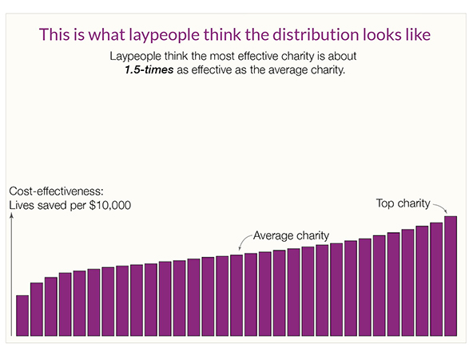

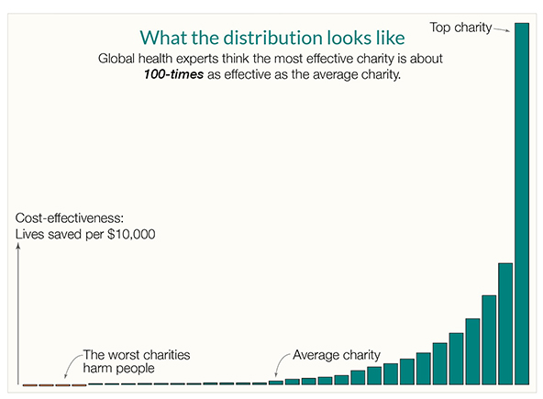

Kevin Star’s article usefully explains that there’s a kind of market failure in the charity sector, where donors aren’t part of the feedback loop and often have no meaningful way of knowing how much value beneficiaries get from their donations. The article outlines how an approach to impact-focused evaluation which he persuasively explains could achieve a “quantum leap toward a better world”.

While the above two sources focus on global health, the same effect occurs across countries and across causes. By way of illustration, Benjamin Todd’s recent article on 80,000 Hours shows a similar distribution of the impact of climate interventions (https://80000hours.org/2023/02/how-much-do-solutions-differ-in-effectiveness/) :

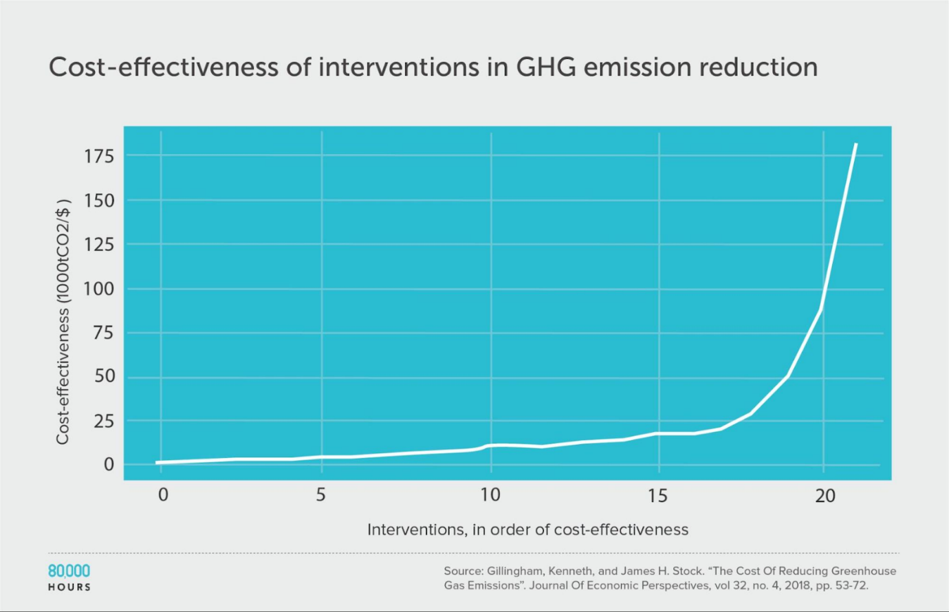

This insight is essential. While donors don’t and can’t understand how impactful their donation is, and charities have to raise funds in a market that doesn’t function, the sector will struggle. This problem is long-standing, but progress in the last 10 years on charity evaluation means it doesn’t have to continue.

Australia funding and promoting charity evaluation has the potential to fix the market failure, help Australian charities do far more good, and potentially make us a world leader.

**The DGR Status Barrier: Why Advocacy-Focused Charities Are Left Out (Information request 4, 5)**

I understand that the ACNC’s view is that a charity can promote or oppose a change to law, policy or practice, provided its advocacy is aligned with a charitable purpose.

That is a good policy, but it largely misses the real problem. The real problem is that DGR status is almost essential to effectively being able to raise funds and employ talented staff, but the gateways to DGR status are narrow and typically exclude any framings around policy or advocacy.

So, while it’s technically true that a charity can engage in advocacy, DGR charities largely monopolise fundraising and staff attraction, and DGR status is not available to organisations that prioritise advocacy.

In practice, this hamstrings advocacy-focused charities and creates an asymmetry in our democracy. For-profit companies have significant amounts of money to spend on lobbying and often get tax advantages for doing so. But people in the community who are passionate about certain causes often lack the bodies to organise around and certainly don’t get tax advantages. This should change, specifically by broadening out DGR classes so that advocacy-focused organisations can get DGR status. This problem is most obvious in the space of animal welfare, where DGR status is limited to certain kinds of animal rehabilitation. Charities that want to advocate for rules and approaches that mean animals don’t need rehabilitation in the first place don’t get DGR and are therefore limited in their ability to advocate.

This change would make democracy fairer, help connect communities around the things they care about, and encourage donations. I know I’d feel more confident in our democracy if there were organisations whose values I aligned with that had active and powerful voices in the policy conversation.

**Government must lead the way**

In addition to the above arguments, if the Australian Government wants to double philanthropic giving and increase impact, it should lead from the front.

Australia’s Overseas Direct Aid as a proportion of Gross National Income (GNI)—the official measure of development assistance—is expected to remain at the 2021–22 level of 0.20%.

This continues to place Australia well below the OECD Development Assistance Committee (DAC) country average of 0.32%.

In 2020 Australia ranked 21 out of 29 OECD DAC countries on the generosity of its aid, measured by the ODA-to-GNI ratio. On current estimates, Australia’s ODA-to-GNI ratio is expected to tail off to 0.17% by 2025–26.

The UN’s ODA target is to spend 0.7 per cent of GNI on ODA every year. If the Australian Government wants to double giving by its citizens, it should show that it means business by doubling its own giving and focusing on using evidence to double the impact of the giving that it does do.

I trust this information and perspective has been valuable to the Productivity Commission.