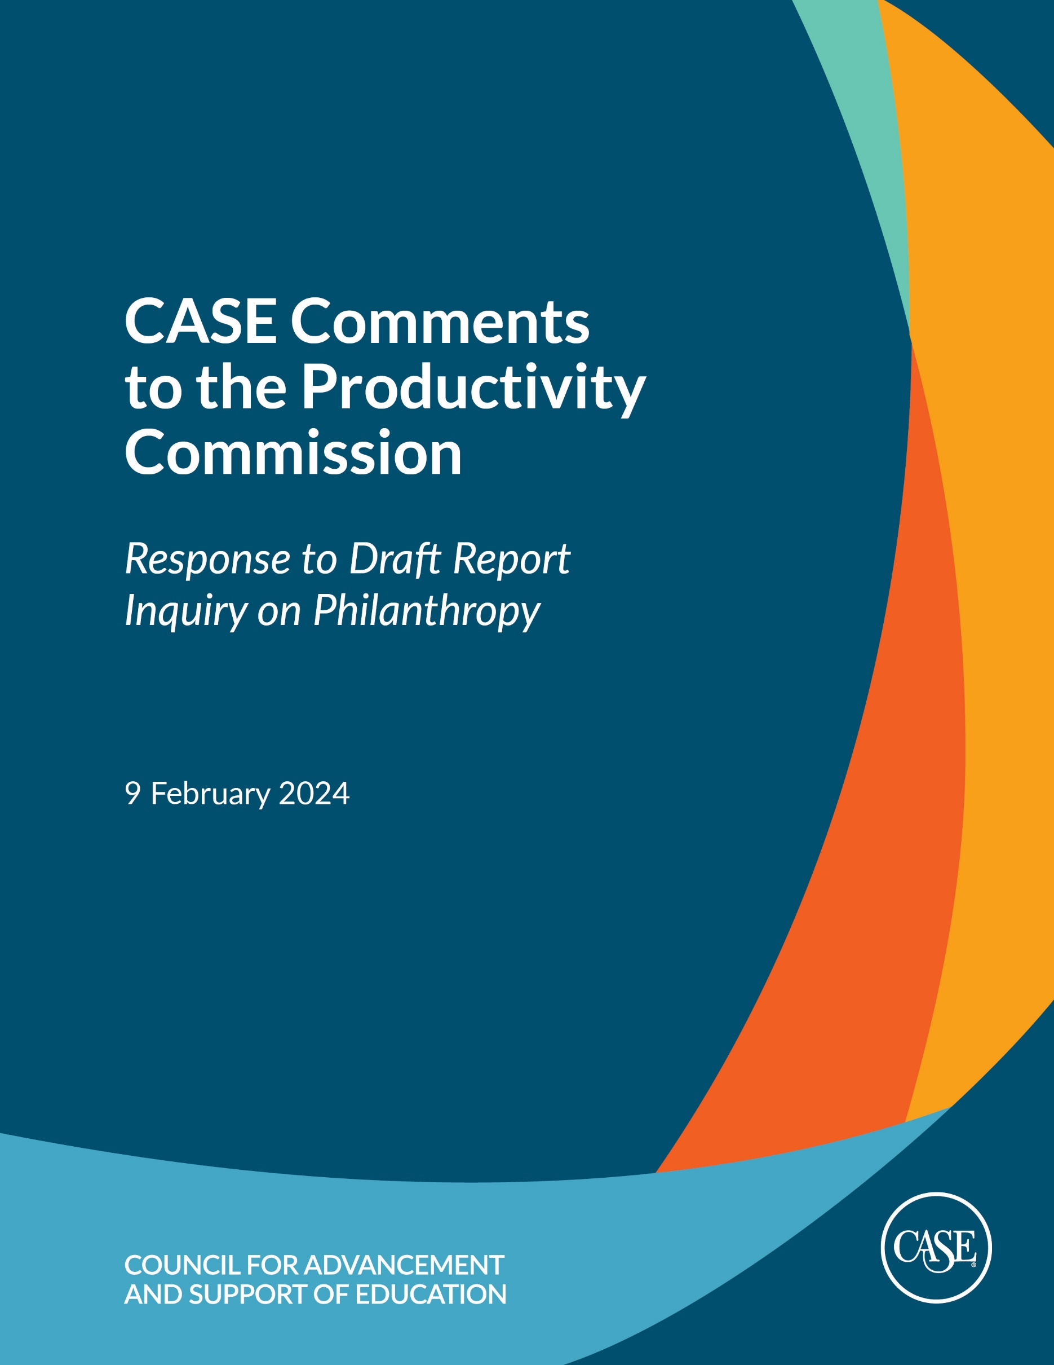

**Summary**

The Council for Advancement and Support of Education (CASE) welcomes the opportunity to provide additional comments and feedback to the Productivity Commission on its draft report *Future Foundations for Giving*, which sets out draft findings and recommendations on how the Australian Government can increase philanthropic giving and meet the goal of doubling giving by 2030. We also appreciate the Commission’s consideration of our initial set of comments and recommendations and for the inclusive and consultative process of the Inquiry on Philanthropy.[1]

CASE is the global professional association for the advancement of education, working with schools, colleges, and universities to advance their institutions through philanthropic and broader community engagement. CASE has 3,000 member institutions in 80 countries with circa 98,000 professionals supported through CASE’s myriad resources. We stand ready to provide support to the Commission, and ultimately the Australian Government, in meeting the goal of doubling philanthropic giving by 2030.[2]

Our comments will focus on four key areas:

* Urging the Commission to reconsider its recommendation to withdraw Deductible Gift Recipient (DGR) status from school building funds.
* Support for specific recommendations in the draft report.
* Reiteration of our recommendation for a matched funding scheme and other key giving incentives to significantly increase giving to educational institutions and other not-for-profit organisations (NFPs).
* The need to build fundraising capacity by growing, developing, and attracting top talent.

Before discussing these specific areas, we want to share two overall observations about the report.

First, while we appreciate the Commission’s detailed work and recommendations around rethinking the regulatory framework for charities and philanthropy in Australia, we strongly urge the Commission to recommend policies that accelerate and incentivise additional giving to educational institutions and other charities and NFPs, in line with the Australian Government’s goal to double philanthropy by 2030. In the draft report, proposals such as a matched funding scheme and further enhancements to the tax deduction for giving were dismissed as too costly without much discussion nor exploration by the Commission. Our data and experience around the world provide evidence that matched funding and similar policies can significantly grow philanthropic giving. We understand and appreciate the Commission is seeking additional information and guidance on tax concessions and other incentives in its final report. We outline a few potential recommendations in our comments below.

Second, while the Commission speaks to the value of giving to a variety of charitable activities in its draft report, we were surprised at the lack of attention and focus on the clear, significant, and positive benefits of giving to educational institutions. Universities, primary, and secondary schools play a vital role in educating and developing Australia’s leaders, artists, scientists, teachers, healthcare professionals, visionaries, and other agents of change. While universities and schools provide direct and life changing benefits to students, they also provide significant public benefits to Australian communities and society. Donations by supporters to educational institutions help fund scholarships and staff bursaries, research, and capital projects.

The most recent CASE Insights Survey on Philanthropy (Australia and New Zealand) found that the 30 universities who participated in the survey raised A$1.042 billion in new funds committed, the highest figure in the history of the survey. This total included a A$250 million gift for medical research, one of the largest single gifts in Australia’s history.[3]

Given these significant benefits, we had hoped the draft report would include discussion and endorsement of policies that would increase giving to universities and schools as outlined in our initial submission. Instead, the draft report includes a recommendation that would decrease giving to primary and secondary schools. There is also no mention or discussion of how to incentivise additional giving to universities. Supporting policies that incentivise giving to educational institutions will help the Australian Government achieve its goal of doubling philanthropy by 2030. We hope the Commission will recognise and address the importance of giving to schools and universities in its final report.

**Reconsideration of Recommendation on DGR Status for Primary and Secondary Schools**

While the draft report includes several recommendations we support, as outlined in the next section, we begin our comments with a fulsome discussion of the most concerning draft recommendation made by the Commission – the recommendation to withdraw Deductible Gift Recipient (DGR) status for primary and secondary school building funds (Draft Recommendation 6.1).

In our initial submission, CASE discussed the need to liberalise fundraising rules for schools, and we urged the Commission to recommend that all primary and secondary education schools in Australia automatically receive DGR status. Currently, schools do not have DGR status and are required to seek DGR endorsement for separate funds, including school building funds and scholarship funds. Changing this policy to provide schools with DGR status as an entity would assist schools in attracting increased philanthropy for support programs such as STEM (Science, Technology, Engineering and Math), art and culture, and sport. It would also help the Australian Government achieve its doubling goal of doubling goal.

To our surprise, the Commission’s draft report includes a recommendation that DGR status be withdrawn from school building funds, stating donations to non-government schools provide private benefits to donors and do not benefit the wider community.

CASE disagrees with the Commission’s draft recommendation and urges the Commission to reconsider this recommendation in its final report for the reasons detailed below.

Unlike other areas and recommendations of the report, the Commission did not reference specific data or research in its recommendation to withdraw DGR status from school building funds. To help fill this gap, CASE partnered with Educate Plus[4] on an immediate survey of our primary and secondary school members. We heard from 26 institutions--4 Independent secondary schools and 22 independent K-12 schools. While the sample size is small, the results referenced below help demonstrate that giving to primary and secondary schools, including school building funds, meets the Commission’s three tests to determine whether a class of charitable activity should be within the DGR system.[5] The findings from this survey align with CASE’s global data on philanthropy in educational institutions.

The Commission’s first test is “there is a rationale for taxpayer support because the activity is expected to generate net community-wide benefits and would otherwise likely be undersupplied by the market.” Primary and secondary schools play a vital role in educating Australians and in providing access, equity, and opportunity. Donations by supporters to schools, including parents and alumni, help fund scholarships, capital projects, and libraries – key priorities that are not typically covered by either government funding or school fees. The fruits of these generous donations are enjoyed by the entire school, and often by the broader community. And, as we stated above, the benefits of education extend far beyond the individuals who enroll in schools. Universities, primary, and secondary schools play a vital role in educating and developing Australia’s leaders, artists, scientists, teachers, healthcare professionals, visionaries, and other agents of change. While schools and universities provide direct and life changing benefits to students, they also provide significant public benefits to Australian communities and society.

Our immediate survey found that over 80% of responding schools make their facilities available to the broader community, and additional schools have plans to expand community use with future projects. Examples of community use include information sessions and workshops at a science and technology centre, use of sports facilities, a senior studies centre, access to classrooms, an early learning centre, theater and arts projects, and bookable venues such as conferences.

The Commission’s second test is *“*there are net benefits from providing government support for the activity through subsidising philanthropy using a tax deduction for giving (as opposed to other government funding mechanisms, like grants).*”* In its rationale for recommending withdrawal of DGR status for school building funds, the Commission states, “providing indirect government support through school building funds means government funding is not prioritised according to a systemic assessment of the infrastructure needs of different schools.”[6] However, as we outlined in our initial submission, the Schooling Resource Standard (SRS) funding model provides base funding which is dependent on the capacity of a school community to contribute to the cost of education. Government funding and school fees cover the cost of education, but do not always cover major capital projects or scholarships and bursaries for students in financial need, hence the need to encourage philanthropic support.[7]

Additionally, the Australian Government will continue to face increasing demands for funding education in the coming years from both the schools and university sectors, the latter related to recommendations in the Australian Universities Accord.[8] The removal of DGR status for school building funds will place a further burden on government funding for education.

The Commission’s third test is “the activity is unlikely to be a material risk of converting tax deductible‑ donations to private benefits for donors*.”* The Commission expresses the most concern about this test when it comes to giving to primary and secondary education, stating, “potential donors are most likely to be people directly involved with the school and benefit directly from donations, such as students, their parents or alumni.”[9]

As those most invested in the success of a particular school, it is not surprising nor is it problematic that students, parents, and alumni tend to give most to primary or secondary schools. Donors often give to charitable organisations where they have a personal connection or experience such as their alma mater, whether a school or university. The Commission specifically highlights personal experience and family as motivations for giving in the draft report.[10] For example, donors often give to hospitals after receiving life-saving treatment for themselves or a family member. Additionally, donors make donations to fund art museums, community parks, environmental concerns – all causes in which they have a personal experience and an affinity. Giving to education is no different in this regard.

When a donor makes a gift to support a school building fund, the building that results benefits the wider school community and as indicated above, the broader community in some cases. It is not a benefit limited solely to the donor or a donor’s child or family member(s). In addition, most capital projects take years to complete. Parents donating today to a school building fund may have children who will have completed schooling before a new building is built and used. And alumni donors are unlikely to have any direct benefit from said buildings and are investing philanthropically because they care about the school at which they studied.

CASE is particularly concerned at the Commission’s assertion that donors to primary and secondary schools are at a “material risk” of converting a tax-deductible donation into a private benefit because schools charge fees. The Commission states, “The transaction here is closer to a market exchange of donations for lower fees and this could incentivise recipients to make tax deductible donations to lower the ‑non-tax-deductible‑ price they are charged for the good or service.”[11]

We disagree with the Commission’s rationale for two reasons. First, many donors to primary and secondary schools do not currently attend school nor have children attending the school. Business and community leaders and non-parent alumni are examples of such donors. Among respondents to our immediate survey, the average percentage of donors to the building fund who were parents or current families was 67.8%; on average, 32.2% of donors were outside these groups. The Commission’s recommendation would eliminate an incentive for these donors to give to primary and secondary schools.

Second, donors who make philanthropic gifts to schools do not pay lower fees. CASE’s [Global Reporting Standards](https://www.case.org/case-insights/case-global-reporting-standards) (the professional standards for advancement professionals worldwide) provide a framework in which schools can build philanthropic engagement while at the same time providing guardrails for undue influence or private benefit for individual donors. The definition of educational philanthropy in the Standards specifically states that donors should receive no private benefit from their contributions. The Standards support schools in ensuring that philanthropy is truly an act of giving back in support of society and the broader community.[12]

Donations to building funds, scholarships, or libraries are treated separately by schools than fees to pay for the cost of education. Parents who make donations do not pay less in fees than other parents who choose not to make donations. If anything, parents who make significant donations are likely to pay full fees (as opposed to receiving any scholarship funding for their child) because of their financial capacity to do so.

Beyond the three tests, the Commission’s draft recommendation to withdraw DGR status from school building funds would make Australia an outlier in its treatment of donations to primary and secondary schools compared to most economies with philanthropic cultures around the world. For example, donors who give to primary and secondary schools in the United Kingdom and the United States are eligible for gift aid and tax deductibility. No restrictions are applied where philanthropic support is concerned.

The Commission’s draft recommendation would also lead to decreased giving. As the draft report points out, school or college building funds are the second highest category of DGR endorsements, numbering roughly 5,000.[13] More than 90% of schools in our immediate survey said that donations would decrease by 50% or more to school building funds if the Commission’s recommendation went into effect; over 80% believed the decrease would be at least 75%.

For all these reasons, CASE encourages the Commission to reconsider its draft recommendation to withdraw DGR status for school building funds. As we stated in our initial submission, the Commission should instead recommend policies to help all schools raise more private funds to support education, particularly at a time when government funding has been declining and in alignment with the Australian Government’s goal of doubling philanthropy by 2030.

If the Commission would like additional data related to this recommendation, we would welcome an opportunity to collaborate with Educate Plus and the Commission on a more comprehensive data set.

If the Commission decides to proceed with its recommendation to withdraw DGR status from school building funds, CASE urges the Commission to provide at least a five-year transition period (Information Request 6.3). Our immediate survey found that over 90% of participating schools have building projects underway or planned.

**Support for Specific Commission Recommendations**

While we disagreed with the Commission’s draft recommendation on school building funds, CASE supports several of the Commission’s other recommendations outlined in the draft report.

We support the Commission’s decision to remove the A$2 threshold for tax-deductible donations (Draft Recommendation 4.1). CASE supports the removal of arbitrary limits on giving to educational institutions and other charitable entities. As the Commission states in its draft report, removing the A$2 threshold would have negligible impact on giving and increase simplicity.

CASE also supports the Commission’s recommendation to maintain a personal income tax-deduction versus transition to a tax credit regime for giving (Draft Recommendation 4.2). A flat tax credit regime would reduce giving by high income donors who would face a higher price of giving. A tax credit regime would also introduce more complexity to the tax system.

CASE supports the principle framework for DGR status outlined in the Commission’s Draft Recommendation 6.1, though we disagree with the Commission’s application of the framework to school building funds as discussed above. The Commission’s three principles, or tests, are a helpful framework for determining charitable activities eligible for DGR status.

We also generally support the Commission’s Draft Recommendation 7.2 which outlines a set of reforms to strengthen the Australian Charities and Not-for-profits Commission (ACNC). Our initial submission urged the Commission to recommend a single, national fundraising regulatory regime for Australia. However, we recognise the Commission’s point that it would be difficult to achieve a referral of powers by State parliaments to the ACNC. The Commission’s Draft Recommendation 7.2 would at least help the ACNC be a more effective, central regulator.

Finally, CASE supports the Commission’s Draft Recommendation 10.1 to establish an Aboriginal and Torres Strait Islander philanthropic foundation. These communities face many barriers to accessing philanthropy. The creation of such a foundation would help bring needed philanthropic resources to Aboriginal and Torres Strait Islander people, allowing these communities to build critical partnerships, including with educational institutions and other NFPs.

**Matched Funding Scheme**

In its draft report, the Commission requests additional information on government policies to support giving, including matched giving (Information Request 4.2).

Our initial submission suggested the Commission recommend the introduction of a Matched Funding scheme for universities and schools. A matched funding program, modeled after the successful United Kingdom (UK) Matched Funding Scheme in which CASE partnered with the UK government, would send an important public signal of the importance of philanthropic giving to educational institutions while also helping the Australian Government reach its doubling goal.

Note that our recommendation for a matched funding scheme is distinct from the UK’s Gift Aid program. As we stated above, CASE supports Australia’s current personal income tax deduction regime for giving. A matched funding scheme for universities and schools would involve the Australian Government creating a time-limited pool of funds that would match the gifts made by donors. While all universities and schools would be eligible for the program, the match could be structured to be larger for institutions with less fundraising experience and/or resources.

The UK Matched Funding Scheme helped build philanthropic support for UK universities, with a particular focus on increasing the number of donors to the sector. During the period of the scheme (2008-2011), the UK government made a total of £143 million match payments to universities, with most going to low-resourced institutions in Tier 3.[14] Additionally, the number of donors to participating institutions increased from 115,787 in 2007-08 to 157,788 in 2010-11 during the years of the scheme.[15] The 2012 Review of Philanthropy in UK Higher Education report to the Higher Education Funding council of England (HEFCE) provides a more detailed analysis of the evidence and impact of the UK Matched Funding Scheme.[16]

Additionally, across our benchmarking surveys on Philanthropy, we have found that increased investment in supporting philanthropy yields greater donations. On average one dollar invested yielded 20 in return. In Australia, the return was even greater—21X.

We encourage the Commission to follow this proven model and recommend a similar matched funding scheme to help generate additional giving to universities and schools in Australia. This program could also be extended to other NFPs as well. CASE stands ready to support the shaping of such a scheme, as we did with the UK government.

**Additional Tax Concessions: Superannuation, Endowed Giving**

The Commission is also seeking information on how the Australian Government can make bequests through superannuation easier (Information Request 8.4). As we stated in our initial submission, Australia is poised to see a significant transfer of wealth in the next decade, but legacy giving remains low versus other parts for the world. Policies that simplify the superannuation bequest process could help generate additional giving to schools, universities, and other NFPs, as would reducing or eliminating the tax paid by those leaving superannuation benefits to charity upon death. CASE encourages the Productivity Commission to consider and support such policies in its final report.

The Commission did not address giving to or building endowments in its draft report. There is a strong tradition of endowed giving and endowed bequests in Australia, including an endowed bequest to the University of Sydney dating back to the 1880s that benefits students, staff, and researchers at the university to this day.[17]

As we suggested in our initial submission, the Commission should recommend a tax concession that incentivises donors to create endowed funds at universities, schools, and other NFPs. Many universities and schools around the globe, particularly in the US and UK, have successfully built significant endowments, with many funding a sizable portion of their annual operating budgets through spending from endowed funds. More Australian universities, schools, and other NFPs would benefit from building and growing their endowments. Additionally, philanthropic gifts to create endowed funds also happen to be significantly larger than other gifts since they are meant to be invested and distributed over the long-term. We encourage the Commission to consider such a proposal for inclusion in its final report.

**Building Fundraising Capacity and Attracting Talent**

We want to reiterate the recommendation from our initial submission that Australia invest in training and professional development so educational institutions and other NFPs have fundraisers with the skills to seek and secure philanthropic gifts. Without such training, institutions and organisations will not have the talent they need to raise significant funds.

The inclusion of funding for training was a key factor to the success of the UK’s Matched Funding Scheme in building philanthropic support and engagement for higher education. CASE can model the success of our partnership with the UK government to bring more training and professional development directly to universities and schools in Australia building on the programs we already deliver in person and online.

The Australian Government should also make it easier for educational institutions and other NFPs to attract the best fundraising talent. Universities and schools in Australia have a strong tradition of bringing in top fundraising talent from the UK, Canada, US, and other countries around the globe. Any barriers to attracting talent from abroad should be lowered alongside building the profession in country.

**Conclusion**

We appreciate the thorough and detailed work of the Productivity Commission and the opportunity to share our comments and feedback on its draft report. We stand ready to assist the Commission as it prepares its final report. Please reach out to Cara Giacomini, CASE’s Interim Executive Director for Asia-Pacific, if you have any questions or need further information.

Thank you again for pursuing this inquiry and for your consideration of our comments herein.

1. CASE’s initial submission to the Productivity Commission, 5 May 2023. <https://www.pc.gov.au/__data/assets/pdf_file/0008/359486/sub124-philanthropy.pdf>.
2. For additional information on CASE, please visit our website [www.case.org](http://www.case.org).
3. CASE Insights Survey on Philanthropy (Australia and New Zealand), 2022 findings, released August 2023. <https://www.case.org/system/files/media/inline/CASE%20Insights%20on%20Philanthropy%20%28Australia%20and%20New%20Zealand%29%202022%20Key%20Findings_0.pdf>.
4. Educate Plus is a membership organisation committed to serving, supporting, and assisting professionals in the pursuit of Educational Advancement in schools and colleges, universities, professional training institutes and various consultancies <https://www.educateplus.edu.au/>.
5. The Commission’s three tests are outlined in its Future Foundations for Giving Draft Report, page 17.
6. Future Foundations for Giving Draft Report, page 15.
7. See CASE’s initial submission to the Productivity Commission, 5 May 2023, pages 8-9. <https://www.pc.gov.au/__data/assets/pdf_file/0008/359486/sub124-philanthropy.pdf>.
8. Australian Universities Accord <https://www.education.gov.au/australian-universities-accord>.
9. Future Foundations for Giving Draft Report, page 18.
10. Future Foundations for Giving Draft Report, Figure 2, page 5.
11. Future Foundations for Giving Draft Report, page 18.
12. More information on CASE Global Reporting Standards can be found at [www.case.org/standards](http://www.case.org/standards).
13. Future Foundations for Giving Draft Report, page 15.
14. Appendix 7 to the Review of Philanthropy in UK Higher Education Report, known as the Pearce Report, and authored by More Partnership, September 2012. <https://dera.ioe.ac.uk/id/eprint/15466/2/HEFCE%20Philanthropy%20Report%20appendices.pdf>.
15. Appendix 7, Review.
16. Review of Philanthropy in UK Higher Education Report, known as the Pearce Report, and authored by More Partnership, September 2012. <https://www.morepartnership.com/library/Review_of_Philanthropy_in_UK_Higher_Education.pdf>.
17. John Henry Challis Bequeathes His Estate to the University of Sydney, University of Sydney School of Medicine Online Museum. <https://www.sydney.edu.au/medicine/museum/mwmuseum/index.php/John_Henry_Challis_bequeathes_his_estate_to_the_University_of_Sydney>.