**Circular Economy: The Future of Construction**

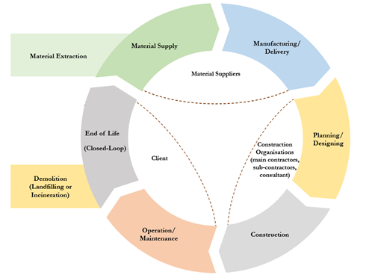Circular Economy research is getting a wider attention all over the world and is growing fast in various disciplines. In par with these developments, at the Centre for Smart Modern Construction [c4SMC](https://www.westernsydney.edu.au/c4smc), at Western Sydney University, we have initiated multiple research projects addressing some niche areas of Circular Economy (CE) to improve CE implementations within the construction industry. Some key research focuses have been on improving stakeholder collaboration in CE implementation; assessment of the CE implementation and their economic, social and environmental impacts; and, application of digital technologies to enhance circularity in industrialised construction and road infrastructure projects. These projects will support the construction industry in various ways, for example, guide organisations in evaluating current level of success and further improvement in CE implementation; support construction industry practitioners to adopt the most impactful CE options in their projects; and, apply blockchain and related technologies to enhance circularity.

Below are some of our publications on these on-going CE research projects that offer opportunities to enhance circularity in the built environment:

* Shashini Jayakodi, Sepani Senaratne, Srinath Perera, Keivan Bamdad, [Circular economy assessment using project-level and organisation-level indicators for construction organisations: A systematic review](https://www.sciencedirect.com/science/article/pii/S2352550924001556), Sustainable Production and Consumption, Volume 48, 2024, Pages 324-338
* Guo, M., Senaratne, S., Almeida, L., and Perera, S. (2024), ‘[Towards Circularity in Roads Infrastructure: A Critical Review](https://link.springer.com/chapter/10.1007/978-3-031-56241-9_20)’, In: Zuo, J., Shen, L., Chang, R. (eds) Circular Economy for Buildings and Infrastructure. Sustainable Development Goals Series. Springer, Cham.
* Gamage, I., Senaratne, S., Perera, S. and Jin, X. (2024), ['Implementing circular economy throughout the construction project life cycle : a review on potential practices and relationships'](https://www.mdpi.com/2075-5309/14/3/653), Buildings, vol 14, no 3.
* Jayakodi, S., Senaratne, S. and Perera, S. (2024), ['Circular economy business model in the construction industry: a systematic review'](https://www.mdpi.com/2075-5309/14/2/379), Buildings, vol 14, no 2.
* Senaratne, S., Rodrigo, N., Almeida, L., Perera, S. and Jin, X. (2023), ['Systematic review on stakeholder collaboration for a circular built environment : current research trends, gaps and future directions'](https://www.sciencedirect.com/science/article/pii/S266737892300041X), Resources, Conservation and Recycling Advances, vol 19. No. 200169.
* Senaratne, S., Gamage I., Jayakodi S. and Perera, S. (2024), ‘[Taxonomy of circular economy terminologies](https://ciobwcs.com/downloads/papers24/S16008.pdf)['](https://researchdirect.westernsydney.edu.au/islandora/object/uws%3A60584), World Construction Symposium, Colombo, Sri Lanka.
* Senaratne, S., Gamage I. and Perera, S. (2024, September), [Quantity surveyor’s role towards a circular construction industry](https://issuu.com/aiqs_be/docs/bee24sep_digital), Built Environment Economist - Australia and New Zealand, Australian Institute of Quantity Surveying.
* Jayakodi, S., Senaratne, S., Perera, S. and Bamdad, K. (2023), ['Digital technology enabled circularity in the construction industry : a bibliometric study'](https://researchdirect.westernsydney.edu.au/islandora/object/uws%3A71812), World Construction Symposium, Sri Lanka.
* Ishan, M., Gamage, I. and Lingasabesan, V. (2023), ‘[Highly effective circular economic practices for the life cycle of a construction project](https://researchdirect.westernsydney.edu.au/islandora/object/uws%3A72057)’, World Construction Symposium, Sri Lanka.
* Senaratne, S., KC, A., Perera, S. and Almeida, L. (2021), ['Promoting stakeholder collaboration in adopting circular economy principles for sustainable construction'](https://researchdirect.westernsydney.edu.au/islandora/object/uws%3A60584), World Construction Symposium, Colombo, Sri Lanka.