20 August 2019

Australian Government

Productivity Commission

Indigenous Evaluation Strategy

SUBMISSION

Dear Commissioner,

On behalf of the committee of Regional Development Australia Fitzroy and Central West, please find following our submission to the Issues Paper dated June 2019.

This submission is general in nature, and specifically addresses the fundamental question of  Which monitoring and evaluation approaches and methods should be used to ensure the better delivery of outcomes for projects and initiatives for Aboriginal and Torres Strait Islanders.

As a starting point, all project design, pre-implementation evaluation and subsequent monitoring and review should be against the UN Sustainability Objectives.

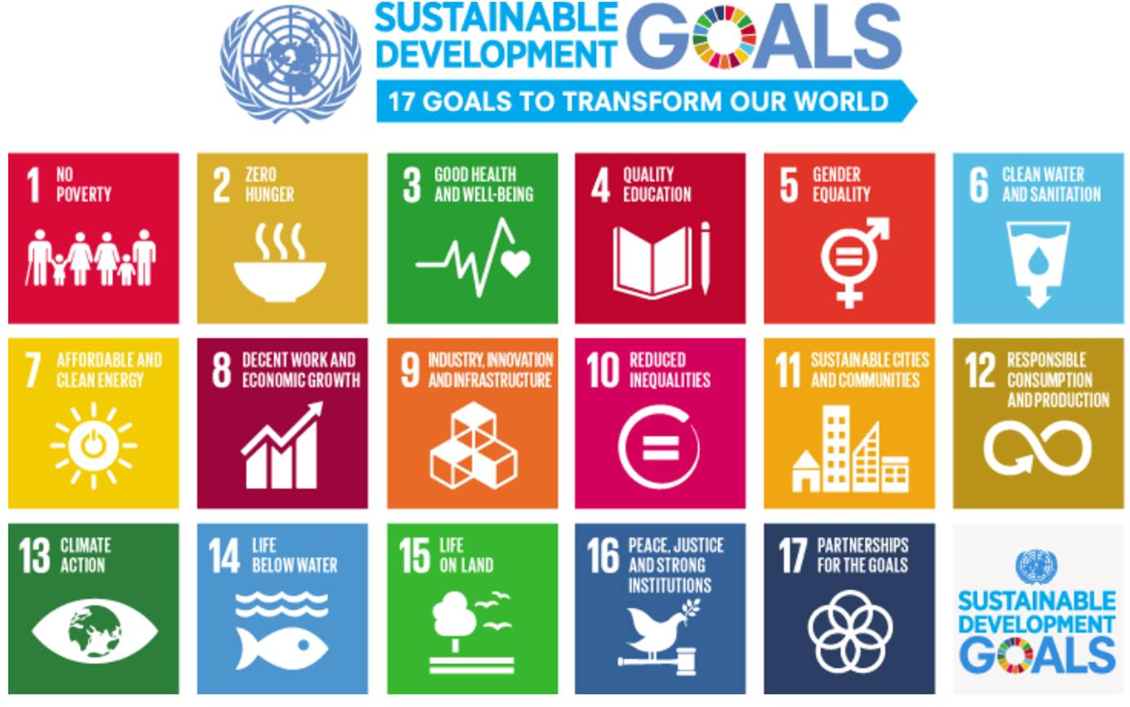

Whilst most of these goals are applicable, in evaluation of projects and initiatives, achievement against the following 3 priority goals should be paramount:-

Goal 4. Quality Education.  Education is a fundamental building block to development and advancement

Goal 8. Decent work and economic growth.  This is a critical component for projects and initiatives in non-urban and remote indigenous communities

Goal 11. Sustainable Communities.  Whilst this goal is closely linked to the success of goals 4 and 8, the initiatives and actions to achieve it different.

As a general proposition the Evaluation and review processes should include: –

* Every project should have a clear business case;
* The business case should include the anticipated achievements against the sustainability goals;
* This business case should have very clear and measurable objectives;
* The objectives should be SMARTA (Specific, Measurable, Relevant, Time bound and Aligned);
* There should at minimum be four major reviews -  Pre-implementation (front end loading), on initial implementation, then post implementation (specified in business case, but default would be 1 and 3 years)

Specific Evaluation Inclusions:-

* Given that the Indigenous population is 65% in regional and remote (R&R) areas, and these R&R areas have significantly less opportunity for advancement than metropolitan areas, that the specific evaluation processes should measure both the cost invested and the benefits in the R&R areas. These Costs and benefits should represent at least the 65%, and desirably more than 65%.
* It is known that advancement of individuals and communities does not happen without education.  Specific whole of programme evaluation (not just each individual project) should be required to include and deliver education and training.  (e.g. there is little societal benefit from providing a prefab house to a community compared to a community being shown and supported to learn and then build prefab houses for themselves and other communities)
* Specific whole of programme evaluation (not just individual projects) should be required to demonstrate the ability to develop annuity (i.e. ongoing income or revenue streams) to ensure the programme and the community is self-sustaining.  This definition of sustainability is one of the key UN Sustainability goals

We thank you for giving us the opportunity to make this submission and welcome any queries you may have.

Yours faithfully

Tony Gambling

Director of Regional Development